Reading Private Sculptures:

Opening 21st Century Eyes to Egyptian Sensibilities

© Rena Tobey

Hunter College

May 2012

Ancient Egyptians had no word for art. Yet art and architecture were essential for the smooth functioning of Egyptian society, as tools to perpetuate religious ideas and leadership hierarchy. Hieroglyphics used small pictures for language, which may explain why no separate word for art existed. Regardless, the aesthetics of statuary, reliefs, and tomb wall painting were secondary to their function. Preparations for well being after death was a major life task for both royals and elite non-royals, and art played essential roles in funerary rituals to facilitate rebirth in the afterlife. Statues were produced for the tombs of the Kings, but also for non-royals for use in these same rituals. Some examples of this private statuary have survived from being buried deep in the owners’ tombs, protected until 19th and 20th century excavations.
Because the skill of the craftsmen was so advanced, viewers of private statuary today are compelled by the living presence of the person portrayed. After thousands of years of Western art inculcation, the viewer wants to read these images as portraits, which provide an understanding not only of the appearance of the sitter, but also the personality. But whether or not these statues reveal insights into the person portrayed, in addition to serving their funerary function, is a complex issue, with only murky answers, requiring new definitions.
By early in the Old Kingdom, increasingly elaborate rules and structures for servicing the ka, or spiritual essence, of the king after death had enmeshed with the Egyptian religious belief system. For non-royals, emulating the practices performed for the king became equally crucial. High-ranking officials, usually related to the king, were honored with tomb sites, or mastabas, located in the royal necropolis. Being close to the king, physically and professionally, provided the private person’s best chance for immortality. Non-royals hoped to achieve the same blessings for their spirit, along with the honor of performing the identical roles and offices after death, in eternal service to their god-king.
Because of these embedded beliefs, conventions developed for creating each art form, including statuary. Sculptors had less interest in showing true physical appearance than in stressing the godlike nature of the king, and his officials emulated the king’s facial features in their statuary to demonstrate absolute loyalty and hopes of attaining some of the king’s power and magic for eternal life. Examples of the idealistic aesthetic included depicting trim torsos, muscular arms and legs, and youthful faces. Sculptures, whether moving, standing, seated, or kneeling, were rigidly frontal, so that the figure faced forward to see and receive offerings of food and drink, serving as sustenance in the afterlife. The function the statue served drove the artistic choice of pose.
While the form of statuary stayed the same, variances occurred in different Dynasties. Facial features could be idealistic, naturalistic, or stylized, even exaggerated. Fashions shifted. Experiments were tried, and abandoned, or absorbed into the conventions. Style changes could be applied to constant artistic forms, acknowledging the permanence of belief as well as the cyclical nature of the rise, popularity and decline of particular styles, much like the seasons and human life.
This analysis begins with a detailed exploration of the relationship of style and convention and the implications for whether private statuary served as portraiture as well as a funerary function. 21st century sensibilities will be exposed to clarify the differences of ancient Egyptian understandings of the world and its images. Then by studying two sculpture sets from the Old Kingdom thoroughly—one statue of a couple, Memi and Sabu, from the Fourth Dynasty; the other three statues of one man, Metjetji, from the late Fifth or early Sixth Dynasties—the distinction between convention and style, likeness and portrait can be explored in all their subtleties.
Private sculpture depicts figures standing, seated, or kneeling, similar to the king’s poses, and sculptures would have been placed in tombs in similar ways. While royal statuary was recognized by iconography such as a crown, nemes headdress, and false beard, much of how the rest of the figure was depicted was copied by non-royals in their statuary. Naturalism was not as important as a clear, easily understood body form that best served the deceased. Restrained, defined poses left little room for variation. Standing and walking three-dimensional statues borrowed visual conventions from hieroglyphs, which were two-dimensional. Scribes wrote from right to left, so hieroglyphs faced right; for striding figures, the far, or left leg, advanced to make it visible. Sculpture of walking figures, generally men until the New Kingdom, therefore show the left foot forward.
Similarly, hair and clothing styles were standardized, pragmatic for the intense climate. The Egyptians had high standards of hygiene and wore clothing, mostly of linen and often quite sheer, that promoted cleanliness. Wigs, placed over hair shaved or clipped for coolness, provided dignity and insulation from the sun. Even with the evolution of fashion, change happened very slowly for over two thousand years. Conventions of fashion were carved and painted onto statuary.
Even though Old Kingdom sculpture was highly conventionalized, expert craftsmanship lent lifelike qualities that have fueled arguments over whether the funerary sculptures were also portraits. Considering statuary through ancient Egyptian eyes, the statue had a purpose to fulfill first—performing particular religious function and demonstrating that the individual had led a good life.
The goddess Ma’at represented the world order, equilibrium, and justice, and the need to appease her by living a life of virtue defined representation on sculpture. No one would admit to living outside of ma’at, so being presented in idealizing ways in sculpture demonstrated living a virtuous life. In light of ma’at, physical resemblance to the person portrayed in statuary was less important. A patron could be identified by the inscription on the statuary base, no matter how much variation in appearance occurred from work to work. To serve Ma’at, little to nothing need by revealed about the inner self of the deceased.
Striving for ma’at defined acceptable group behavior and individual conformity that was rewarded over individualism. Artists were trained and valued for their ability to replicate such idealizations, not for individualized creativity. Artist and patron collaborated in creating a magical advertisement for eternity. Some then argue that this absence of aesthetic choice made portraiture irrelevant. In fact, deviation from the norms might have endangered the magic needed for rebirth and eternal life. Others suggested that likeness could be used in conjunction with ma’at.
Confusion about the definition of portrait and likeness, beyond the Egyptian worldview, is also at the crux of the arguments. Portraiture is not universal to all cultures, but occurs as a marker of the development of a culture that is concerned with specific individuals at particular historical moments. Portraits represent a definite person, with distinctive qualities, including inner essence, so that the person is not confused with someone else. This 21st century definition would seem to apply to a specific image of a king or an identified, non-royal, elite official.
But adding understanding of the ancient Egyptian worldview complicates the portraiture question. First, since uniformity of behavior and representation was the norm, distinctive features were left for “foreigners” such as Libyans or Africans. For example, foreign captives and slaves were shown with distinctive physical features, similar to how plants and animals were distinguished. Further, the religious belief system suggested that statuary was a container waiting to be occupied and animated by the ka, through the work of ritual magic that was non-aesthetic. The argument continues that portraiture in general is not about magic or ritual, but much more concerned with earthly self-presentation.
Yet this argument is circular. Ancient Egyptian patrons wanting to prove their ma’at were as concerned with self-presentation to the gods as Emperor Augustus was in his carefully crafted Roman portrait to the people made in 20 BCE (Fig. 1) or merchant Nicholas Boylston in his 1767 portrait by John Singleton Copley (Fig. 2). These men’s portraits offer measured clues to the inner life of the sitter, with much more focus on how the image advertises the sitter’s status. They share the serene optimism of the Egyptian statuary, of being above mundane hopes and fears. Each of these portraits works as a magical advertisement in its particular cultural context.
Portraits are responsive to society then, just as funerary statuary is. Each follows a set of visual language rules, style, and attitudes. However, portraits do call for the artist’s judgment, not just replication of stylistic necessities. Facial features and facial expressions are particular to an individual. While Egyptian artists copied notable physiognomy of the ruling king, as ideals of that period’s beauty and ma’at, evidence of individual likenesses exist, too. In these cases, the viewer feels in the presence of the person depicted, a more esoteric definition of a portrait. Yet because other visual records are not available for comparison, whether or not a sculpture faithfully represents how the ancient Egyptian sitter looked is ultimately unknowable. Even comparisons to mummies, when available, are problematic. But the intangible sense of being in the presence of a sentient person is an essential quality of portraiture. Following this line of thinking, the statue may or may not have likeness, but can still be a portrait.
Further complicating the issue, non-royal statuary was not intended for public display. It was placed in a tomb, at most accessible by cult priests who performed a rite called The Opening of the Mouth to bring the image magically to life. Then the sculpture could receive offerings of incense and nourishment to sustain the ka of the deceased through eternity. The statue lived out of worldly time, in service of the spirit. Because they were hidden away, over 900 statues of non-royals survived, compared to only a small number of royal sculptures. So the comparison to public portraits of Augustus and the merchant Boylston, both clearly meant to be seen and interpreted, seems to breakdown.
Likeness to the deceased was essential though. The identity of the non-royal needed to be maintained, so that he could continue to serve the King in his defined roles. Equally important, the individual’s ka needed to recognize its statue’s representation to know where to house. The likeness was not made for the world to see, but for the ka. The statue’s likeness must also reinforce the deceased as an upholder of ma’at.
Therefore, statuary can be understood as portraits that take on a particular ancient Egyptian understanding, different from the Greco-Roman worldview of portraiture that has influenced subsequent Western definitions. Different standards are required to evaluate the works. Ancient Egyptian statues may have been portraits, doing Egyptian cultural work.
Ancient Egyptian statuary also reflects the political, social, and economic realities of the reign—the spirit of the age—another qualifier for portraiture. Even as Egyptian statues served the magical spirit, they were created in the world of the living. During periods of stability, such as the Fourth Dynasty of the Old Kingdom, greater leisure time and wealth meant creating more works and employing more skilled artists. Those artists were motivated to depict human reality, correct anatomical structure, and expressions most reflective of the values and ideals of the culture. Now the encounter of the patron’s desire for a particular depiction and the artist’s skill meet the temper of the age: severity of the Third Dynasty develops into the optimism of the Fourth Dynasty; the mature, austere Fifth Dynasty melts into the serene Sixth Dynasty.
Private individuals also had their own iconographic identifiers. Looking at two specific sets of non-royal sculptures and their distinctive features provoke the portrait question further. Created during the height of Old Kingdom sculpture, the Royal Acquaintances Memi and Sabu (Fig. 3) at the Metropolitan Museum of Art has been classified as dating to the Fourth Dynasty. Three statues of the official Metjetji (Fig. 4), at the Brooklyn Museum of Art, were found in his tomb at Saqqara dating to the end of the Fifth Dynasty or early Sixth Dynasty.
Naturalistic figures emerged, and some say even peaked, in the Fourth Dynasty. Memi and Sabu both conform to and play with convention, demonstrating this naturalism. The convention of the back pillar, a residual from earlier periods, developed when the literal stability for the figure was necessary; physical breakage of the statue would have also broken the magic of the rites. The pillar was attached to the temple wall and suggested strength. In Memi and Sabu, both figures are separated from the back pillar, so it no longer functions as support. Even when no longer needed, the pillar is used and obeys convention. In general, the standing post also suggests the figures would be walking, but neither Memi nor Sabu advances a foot.
Their clothing and wigs express convention. Both Memi and Sabu are barefoot, typical of all Egyptians in Old Kingdom statuary, including royalty. Memi wears a short skirt, called a gala skirt, wrapped around his body one and a half times, with a pleated section over his right hip. The squared-off top of the belt looks like a tab carved in relief, extending above the tied square knot. Memi’s wig is helmet-like, conforming to his head, covering his ears, and tapering along the side of his face just below ear level. The horizontal rows with vertical markings indicate short curls. Beards were hot and hard to keep clean, so Memi is clean-shaven, as was typical.
Sabu’s fashions are conventional as well. She wears a sheath gown, with just a hint of a tapered strap over her shoulders, and the dress extends down to her mid-calf. Concealment is not an issue. As with other portrayals of women, Sabu’s breasts, ribcage, navel, and pudendum are clearly outlined. The convention was to show the unseen, as well as the visible, and Egyptians admired the revealed figure. Like Memi, Sabu’s wig is similarly curled, and as was more typical for women, parted in the middle. Young girls wore short, close wigs made of horizontal rows of small, tight curls, indicating Sabu’s possible youth. The difference is noticeable in comparison to the wife in the Dynasty 4 royal Menkaure and His Wife (Fig. 5), who wears the tripartite wig. Sabu’s natural hair is clearly revealed under the wig, horizontally depicted across her forehead.
Each body is shown with limited modeling, following conventional modes of beauty and ma’at. Memi is broad shouldered with a slim waist and hips. Interest in the folds of his navel stand out on his otherwise smooth torso. His right arm is down by his side, with his fist clutching a truncated rod, an emblem referencing the staff, a symbol of earthly power. The rod extends to the back slab. With the exception of his shinbones and knees, his legs are chunky and only minimally defined. Sabu is large breasted, but similarly has narrow hips, with a slight swelling in her thighs. As with Memi, her legs are trunk-like.
Their faces resemble each other in bone structure. Both have broad faces with slightly pointed chins, although Sabu’s face is more squared off than Memi’s. She has plump, rounder cheeks. Both have indications of jowls. The brow-bridge is defined, as seen on Menkaure. Their noses are broad, readable even though the tip of Sabu’s nose has been broken off. Her lips are more linear and broader than Memi’s, whereas his lips are curvier. For both, the lower lip protrudes enough to create a shadowed indentation below it.
Their eyes are almond-shaped, with heavy upper-lidding and defined inner canthus, the inside corner of the eye. These details accentuate the eyes that are already very large for their face size, Sabu’s especially so. While Memi’s eyes are missing paint, Sabu’s irises are well defined, giving her a strong presence.
Approaching the statue from the side, Sabu directly gazes at the viewer, almost at eye level, given the height of the base. Most figures in statuary gaze directly forward, looking toward the funerary offerings, including Memi. Sabu clearly looks off to the side. The choice is distinctive and arresting, without clear meaning. Women were considered full members of and contributors to ancient Egyptian society, and the statue of Sabu demonstrates a sentience and presence congruent with that status.
Very little paint on the pair has been preserved, but the remnants suggest how colorful the statues once were. His skin was painted the typical male red-brown, suggesting life conducted outside and connection with the sun. His wig and around his eyes would have been painted black with white eyeballs, as seen on Sabu. His lips, fingernails and toenails were painted brown, his skirt yellow, and the cylinder in his right hand red. Sabu had yellow skin and nails, conventions for the portrayal of women, representing the yellow-gold of the sun. Her dress had some red on the shoulder strap. Hints of a blue-green beaded necklace remain, as do red and black anklets. Although no color is left, Sabu probably wore matching bracelets as well. The pillar and base were painted red, and the inscription featured some yellow. The space between the figures and the top of the pillar were painted gray.
As typical of historical study, the statuary pair has been interpreted and reinterpreted. Earlier analysis read the inscription as Memi-Sabu and His Wife, but now Memi is understood as the man and Sabu as the woman, possibly husband and wife, the usual subject for paired statues. Paired statues were frequently placed in the serdab, or hidden chamber in non-royal tombs. As with other statuary, the ka of the deceased used the stone statue as a home, benefitting from offerings. In essence, the statue secured a shared home for the spirits of Memi and Sabu through eternity. The statue was re-dated as well. More in keeping with Fourth Dynasty characteristics, the date was shifted from Dynasty 5.
The distinctive pose also suggests the paired statuary is from Dynasty 4. The pose and placement of Memi’s hand has only two other corollaries, one royal and the other private, both from the Fourth Dynasty. Their existence helps explain the significance of his hand resting on Sabu’s breast. Memi’s taller size and slightly advanced figure suggest he is the dominant one of the pair. His inscription indicates that he served as Wab Priest of the King. These elements, plus the convention of the man having a higher status, would suggest that he is the principal member of the pair.
But they do not stand in a conventional pose. Menkaure and his wife demonstrate the pose, which non-royals would want to emulate. She has her right arm around Menkaure’s waist. Sabu has her right arm around Memi’s waist. Menkaure’s wife’s left hand touches Menkaure’s left arm. Sabu’s left arm is by her side. Menkaure does not embrace his wife. Here is a major difference. Memi returns Sabu’s embrace—reaching behind her head, bending at an awkward right angle at the elbow, then descending to her breast. This returned embrace is very distinctive, calling for a different interpretation.
Several meanings have been suggested. The pose has been described as restrictive and as an aesthetic method for filling in space left by the curve of Memi’s waist and Sabu’s neck. A more convincing explanation derives from two other known examples of the distinctive hand-on-breast pose from the Museum of Fine Arts in Boston.
The non-royal statuette (Fig. 6) may have been sculpted in the same workshop or by the same artist as Royal Acquaintances Memi and Sabu. Because the woman is nearly as tall as the man, he has to raise a shoulder to embrace her, with his forearm dangling oddly to her waist. The figure of Sabu has been adjusted, as if learning from that experiment. Sabu is considerably shorter than Memi. Her widest part, across her shoulders, fits in to his narrowest part, his waist. Memi’s arm can go around Sabu’s shoulders somewhat more naturally.
Queens Hetepheres II and Meresankh III (Fig. 6) have eternal togetherness as mother and daughter. Queen Hetepheres was the daughter of Khufu and wife of Djedef-Re and embraces her daughter Queen Meresankh, with a forearm described as dangling to her daughter’s waist, but actually appearing to rest on her daughter’s breast. Most important, the statue was found in the tomb belonging to the daughter, making her the significant figure of the pair. The daughter-queen receives the embrace of her statuary partner as a sign of recognition of the daughter’s status.
By inference, Royal Acquaintances Memi and Sabu would suggest the same. Memi offers the embrace to Sabu. Sabu is the figure of importance in the pair. A second statue represents a seated Sabu alone (Fig. 8), further indicating her importance. Memi clings to her status, rather than advancing his own. Memi neither strides forward, nor is the recipient of his wife’s full, conventional embrace. Rather they embrace each other, with his deferral suggested in relation to the royal Boston example.
The anomalies in the sculpture raise many questions. Since Memi is so much taller than Sabu, and Sabu wears a young girl’s wig, could their relationship be other than husband and wife? Might they be father and daughter? The queenly pair as a precedent suggests the possibility. If so, why would Memi’s hand rest on Sabu’s breast? Does the significance of the hand-on-breast gesture rest with an explanation other than sexual? Could it be related to fertility or maternity? A symbol of the power of the woman? In writing about the three sculptures with this unique pose, scholars, rather oddly, do not mention the hand resting anywhere other than dangling at the waist or wrapped around the shoulder. Why has no scholar speculated about the meaning of Memi’s hand clearly placed on Sabu’s breast?
Whether the hand-on-breast gesture suggests anything more begs for interpretation. But the psychological interiority and emotional lives of Memi and Sabu will likely remain sealed in the tomb, or perhaps with their ka at the Metropolitan Museum of Art. Still, to 21st century eyes, the gesture suggests affection at a minimum and easily something more tender, erotic, or symbolically significant. Sabu’s deep-set eyes convey intelligence and knowing, and her profoundly distinctive, turned head and averted gaze engage the viewer in 21st century conversation about her portrait-like sentience.
The statues of Metjetji (Fig. 9) beg for contemporary portrait interpretation as well. The wooden statues represent the three ages of man: youth, middle age, and elderhood. Ironically, from a portrait-reading perspective, the statue of the youngest Metjetji is the tallest, followed by the middle aged; the smallest statue is of the eldest Metjetji. Contemporary readings of the faces and costumes of the statues create affinity with the youthful innocence, the slightly hardened and more careworn mid-life maturity, and the confident serenity of the elder Metjetji.
Reasserting ancient Egyptian eyes allows new layers of meaning. Five wooden statues were found in Metjetji’s tomb, and three are at the Brooklyn Museum, while one at the Museum of Fine Arts in Boston and another at the Nelson Atkins Museum of Art in Kansas City, MO provide additional insight in comparison to the Brooklyn examples. By the late Fifty Dynasty or early Sixth Dynasty, having more than one statue, particularly wood statuary, in the tomb had become more common—a kind of insurance in case one statue did not survive.
The finest art-making materials were difficult to access and involved a network of officials, traders, laborers, and artists to get materials from quarries and forests. The majority of wooden statues, including those of the younger and middle-aged Metjetji, would have been made from native trees like sycamore and acacia. The wood of elder Metjetji figure is fine grained, dark, and hard and likely made of a more expensive imported wood like cedar or ebony. The base of each is made of coarse wood and was not as skillfully worked. Each material had its own meaning, with wood connected to Nut, Hathor, and Isis, mother goddesses. Trees provided shade and sustenance to the deceased, perhaps another reason for their prevalence as wood statuary in tombs.
But wood is not a permanent material, as ancient Egyptians were well aware. Unlike enduring stone, wood was susceptible to drying out during summer heat, too much moisture in flood seasons, and insect damage from termites and white ants. Not many wood statues have survived, making the five statues of Metjetji extraordinary. Due to the material’s known impermanence, wooden statues were used for private statuary only and did not serve the function of home for the ka until the Middle Kingdom. They were not designed to receive offerings. Because wooden statues appeared in two poses, walking and sitting, perhaps they served as substitutes for the physical body in active and passive stances in the afterlife. The passive stance was more suited to block-like stone, while the striding figure shows how the deceased continued to perform his roles in service to the king.
The skill and sophistication of the artist is evident in these works. However, identifying specific workshops of artists was difficult, although speculations from similarities, as seen in the Metjetji works, have been made. Stone carvers had to consider breakage and weight, so created blocky forms, but wood carvers could be more daring in composition. Special tools, like the adze, were developed for carving wood. Carvers mastered the ability to extend appendages and stabilize with a staff, which stone sculptors could only hint at. Some wooden statues were made from a single piece of wood, such as the extraordinary torso, arms, and legs of the elder Metjetji. Others used dowels to attach limbs and mortise and tenon joints at the shoulders, front of the feet and left forearm that holds a staff. Each of these joins is visible on the three Brooklyn Metjetji statues.
The works are in differing states of preservation and appearance. Damage to the torso and arms of the middle-aged Metjetji (Fig. 13) reveals the construction technique: the figure was rough-carved in soft wood; then a coat of hard, gray material was applied to cover the joins, followed by the light-red coat of gesso, thick enough to be molded; and finally, a deep red gesso was painted on as the surface for additional colors for the garment, jewelry and other modeled details. The more naturalistic elder Metjetji has lost much of its paint, so more detail is readable, supporting the feel of naturalism. Paint obscures detail, so color becomes a tradeoff for specifics. The two painted statues may have more detail carved in underneath.
Inscriptions on the base with his name and title ensured the figures were associated with Metjetji and reinforced his high rank. He was a royal bureaucrat, although which king he served is unclear, possibly Unas or Pepy I. He held the office of Overseer of the Office of the Palace Tenants, the title that appears in each wooden statue inscription. As a member of the elite honored by the king, he also held the ranks of Liege of the King of the Great Palace and Chief Keeper of Fabrics, titles interpreted from his tomb, which served as a kind of biography of the deceased. The tomb depicts him officially, as well as showing him as a courtier, patron, and aesthete. It features mural paintings and wall reliefs, and together with the presence of the statuary, it suggests Metjetji invested heavily in the provisions for his afterlife. The inscriptions also state that he was a generous employer, paying artists and craftsmen copper, food, and clothing, explicitly stated as coming from his own wealth.
On the “false door” of his tomb at Saqqara, where priests and visitors presented offerings, he is depicted eight times, a comparatively large number. He portrays himself with emblems of authority such as holding a long staff and seated on an elegant chair with lions’ paw feet by a well-stocked offering table. The depictions also provide additional insight into his personality. He is shown listening to musical concerts and playing board games, leisure activities demonstrating his status and interests. He had a pet dog, a spotted greyhound. Given his title connected to garments and a tomb depiction of himself wearing sandals and a feline pelt, Metjetji was proud not only of his status and estates, but also his taste. He seems a bit of a fashionista. Regardless, he was clear about the role images of himself played in his self-representation, one of the inherent propagandizing qualities of portraiture.
In comparison to his tomb depictions, Metjetji’s wooden statues seem simple, but a closer read shows similar personality characteristics. One convention for depicting the deceased was showing him at various stages of life, and Metjetji’s statues follow that convention, but with a twist. The two statues representing Metjetji from his youth (Fig. 10) and middle age (Fig. 11) reflect the idealizing tradition of the Fifth Dynasty. The older Metjeti (Fig. 12) displays a new style, the Second Old Kingdom Style, suggesting it was carved in the Sixth Dynasty and implying a greater portrait-like quality. Variation among likenesses of the same person was not commentary on the skill level of the artist, as earlier thought. A wealthy patron like Metjetji would not have commissioned a less than competent artist. Since private individuals were responsible for provisioning their own tombs, the demand for statues increased. Links with royal workshops weakened, and this new style emerged. After examining the two idealized sculptures of the fashion-oriented Metjeti, how the older version in the Second Style performs a different kind of representational work will be explored.
The young and middle-aged Metjetji follow the idealizing convention of the Fourth and Fifth Dynasties. Their skin is typical of male statues, painted red-brown, referencing time in the sun, while their eyes are rimmed in black. Against these darker hues, the white of the eyes pop out, exaggerating the size of the eyes in the face. Especially for the young Metjetji, the contrast of the inlaid stone to the white of the eye, plus the slight smile on his soft face, makes the representation seem all wide-eyed innocence to 21st century interpreters. Though still handsome, the slightly furrowed brow and downturned lips in the over-large head make the middle-aged Metjeti appear more seasoned, striding forward to directly confront his cares. In comparison to the youth, the middle-aged statue’s face is narrower, as if drawn with worry, next to the plumper, puffy-faced, boyish Metjetji.
Both statues have almost non-existent necks, ringed by the short echelon-curl wig on top of well-proportioned torsos. The rows of curls on the wig have been modeled in a topcoat of gesso. The thickness of the wig may be a structural device to provide girth around the neck and prevent breakage. The short, smooth wig covers the ears, with bangs straight across the forehead. The two statues have broad stiff shoulders forming a T-shape with the body. Both torsos are drawn in at the waist, making the hips rounded, almost feminine in proportion. The curved-in waist also creates negative space between the straight right arm and the body. Again, the middle-aged Metjetji appears thinner, despite the similar body profile. In a kind of brash confidence of youth, the youngest representation holds a staff of authority extended from his bent left arm. The middle-aged statue holds pegs in each hand, with arms pendant, or straight, at his sides. The young Metjetji holds the peg in his straight, undifferentiated right arm. The legs and arms seem crudely carved, with some defined musculature in the calves. The arms were carved separately and attached by dowels.
What distinguishes these statues is the way Metjetji is dressed and adorned in each. In life, men wore beaded collars and necklaces, but were seldom portrayed in sculpture wearing jewelry. For example, Memi is shown without jewelry in his paired sculpture with Sabu. But both the young and middle-aged Metjetji statues feature elaborately detailed jewelry, in skillfully applied gesso and paint. The jewelry might have served as magical charms for additional protection in the often-dangerous world of the dead. The broad collar or wesekh was the most common form of necklace. The young Metjetji sports a collar with a second necklace of a beaded cord with a blue x- or butterfly-shaped amulet. That same design became popular in the Middle Kingdom and may have been a stylized version of a ritual object. For the middle aged Metjetji, a different piece of jewelry is depicted, with two painted beaded forms dangling from the wesekh.
The kilt, too, is more elaborate than typical, such as Memi demonstrated. Metjetji wears the same gala skirt with its pleated section curved, as carved on Memi’s stone depiction. Metjetji again makes a fashion distinction from the conventional representations of males. He shows the besaw or bead apron, which had the protective power of an amulet, but was rarely shown on statues. The apron was important, listed on offering lists as an essential for the wealthy deceased. The besaw was probably constructed of semiprecious stones, with glazed faience, then strung with spacer beads of feldspar yellow, lapis lazuli blue, green, and red. The conventionalized statue at the Museum of Fine Arts (Fig. 14) resembles these two younger depictions of Metjetji.
The elder Metjetji statue is remarkably different from the younger versions, but the evidence suggests they were made at the same time. Each has the same inscription, detailing the one title as Director of Office of Tenants of the Palace, depicted with an awkwardness that suggests the same scribe made each. Depicting the different ages of the patron was more common in relief sculpture in the tomb, less so in three-dimensional sculpture. The representations may have had ritual purpose, again suggesting that Metjetji would have commissioned them at the same time. Most officials ordered idealizing sculpture. The naturalistic portrayal of elderhood was more unusual.
The statues from the Brooklyn Museum and Nelson Atkins Gallery of Art (Fig. 15) both show the older Metjetji, but with key differences. The Kansas City version shows the older Metjetji wearing jewelry, the third wesekh to be recreated. The paint and detailing is also better preserved on this statue, showing black painted, short-cropped hair and diagonal modeling in the gesso of the skirt, perhaps representing boning to give the skirts its structure.
Focusing on the Brooklyn Museum example, the elder Metjetji clearly demonstrates the Second Old Kingdom Style, in contrast to the conventional style of the younger depictions. The diminutive stature of the elder in comparison to the younger renditions is typical of the Second Style. Rather than use natural proportions, Second Style torsos and arms are elongated. Evident on the elder Metjetji, Second Style hands are enlarged with thin, lengthened fingers, made moreso by the slightly pointed nails painted white. The hands are held stiffly, the left resting in the pendant position at his side, while the right hand awkwardly clasps the front of the triangular-shaped skirt.
The radical departure from the younger representations of body type, clothing, and adornment indicates Metjetji’s age and possible deterioration of the paint surface. Older male figures were typically depicted as corpulent, suggesting wealth and abundance of food, or emaciated. The elder Metjetji statue’s torso, as well as his face, is thin, suggesting the presence of a skeletal structure beneath taut skin. Little musculature is defined.
The long skirt could also hide the evidence of age. The elegant, long-pleated skirt with the triangular projection was unknown before the reign of Pepi II, late in the Old Kingdom. The angular form, reminiscent of a pyramid, was perhaps held in place by stiff or bulky fabric or a bone framework. It makes the skirt longer in the front than in the back. Like the Kansas City example, Brooklyn’s Metjetji may have worn a striped version of the skirt, created in gesso. With the right hand holding the skirt, the gesture may have shown deference to a superior or suggest the presence of the king. Older men may have worn it in court ceremonies. From inferring about Metjetji’s temperament, he was concerned about self-presentation, and that costume played an important role in displaying his status.
Part of what also makes the elder Metjetji so compelling is the portrayal of energy in his body and face. Wiry, tense, and delicate all at once, the elder Metjetji has a springy energy, lacking in the weightier, more staid, younger statues. The older Metjetji has a sense of forward motion and purpose missing in the idealized calm of the younger versions. With no wig to distract attention, his closely cropped hair leaves him exposed. The natural, wigless head might have been another indication of age. His slightly downcast eyes formed of copper rims and pupils of obsidian, set in sharp-white alabaster, are enormous in his waif-like, thin face. Slightly asymmetrical, his eyes are intense and would stare if not downcast. The folds that extend from his nostrils and his tapered, Second Style chin together emphasize his well-defined lips, which protrude slightly, creating a shadow beneath. In general, eyes and lips communicate the mood of the portrayed and here provide a lifelike quality that is compelling.
The elder Metjetji combines the new Second Style attributes with the naturalism of the earlier periods. The shift from more naturalistic proportions shown on the younger Metjetji statues to the more mannerist, elongated features of the Second Style was once criticized as inferior and linked to a decline in the Old Kingdom. Instead, now the Second Style is understood to value expressiveness over naturalism in communicating with the gods for sustenance in the afterlife. The elder Metjetji is considered the masterwork of the three, capturing a sense of wisdom with an air of individuality.
The Second Style represents an innovation to the formula and was used for centuries to come. The style created a tension for evoking the individuality achieved in early examples like the elder Metjeti. Sculptors utilized a workshop system for production. When a sculpture had a standardized body, apprentices could mass-produce the form, and the master would carve the individualized head. Some sculptures, like those of Metjetji, had both individualized heads and body features and may have been sculpted in their entirety by the master sculptor to achieve aesthetic unity. The similarity of the five Metjetji wooden statues suggest they may have been made not only at one workshop, but by one master carver, who then was also an innovator in the Second Style.
The sustaining offerings made to Metjetji probably stopped a few decades after his death, leaving his tomb undisturbed until its excavation in the early 1900s. The tomb and its exceptional paintings, reliefs, and statuary have been praised for the taste of the patron, which Metjetji, no doubt, would have loved. But ancient Egyptian art, including statuary, was never considered art in the contemporary sense, and public displays of sculpture as seen in ancient Greece and Rome did not exist. The production of statuary centered on its essential religious function, not its aesthetics.
Since private individuals were responsible for outfitting their tombs, discussions with artists about depictions must have taken place. How else can the representational choices about the Memi, Sabu, and Metjetji statues have been made? Choices must have been thought through, discussed by patron and artist, and planned. As non-royals creating private sculpture for ritual use in their tombs, neither the patrons, nor the artists had to follow the strictest of royal conventions. The departure from the royal style for the Second Style in the elder Metjetji, and seen only in private statuary, allowed artistic expression, a rare moment in ancient Egyptian art.
The distinctive choices—Memi’s hand, Sabu’s gaze to the size, Metjetji’s jewelry and apron—suggest something more personal than the creation of hollow shells for ritual. Is the representation more than a likeness, but actually insightful about the person portrayed? In what ways have the patron and artist collaborated to craft an image for consumption? That Memi does not stride forward has a meaning. The experiment of the hand to the breast may have been too unconventional, even for the experimental Fourth Dynasty, to gain approval and become part of the convention. The decision to try it certainly had meaning. That Metjetji had a sense of self-importance and fashion can be inferred. Appearance mattered to him.
Portraiture is a loaded term, imbued with Greco-Roman-inspired meaning, informing 21st century interpretations. Contemporary viewers need to look through the ancient Egyptian lens. Sculpture may have served a purpose in addition to its funerary function, but only if terms are redefined incorporating ancient Egyptian belief systems. Individualized features were necessary to be recognized by the ka, but conventional likeness was crucial for suggesting the patron lived a life in conjunction with ma’at. Balancing both naturalism and idealization was a feat accomplished by Old Kingdom sculpture. Over time, though, variations became less evident as the desired representation that best served funerary purposes hardened.
While exact facial features may not have been copied and the deepest of psychological revelations are not available, the private statues of Memi, Sabu, and Metjetji are distinctive, individualized, and logically, the result of artist-patron choices. The ancient Egyptian context and resulting definition of portrait then is distinctive. At a minimum, the funerary portrait is an act of creation, by serving the rebirth of the vital life force of the deceased. Whether or not the statues present a portrait, a likeness, or merely individualized features, no one can seem to agree. “It is perhaps noteworthy that their lifelike qualities are usually most appreciated by those who are not Egyptologists. Specialists tend to be more cautious about acknowledging the degree of specificity actually present in the image.”
Contemporary viewers want to project meaning, personality, and particularity on to ancient works. They have been trained to do so by thousands of years of public sculpture, painted portraiture, and museum exhibitions. Scholars cannot agree to what extent ancient Egyptian private statuary also serve as personal records and even portraits. Regardless, these captivating depictions of Memi, Sabu, and Metjetji suggest something more than the schematic, but their secrets remain in the tomb.
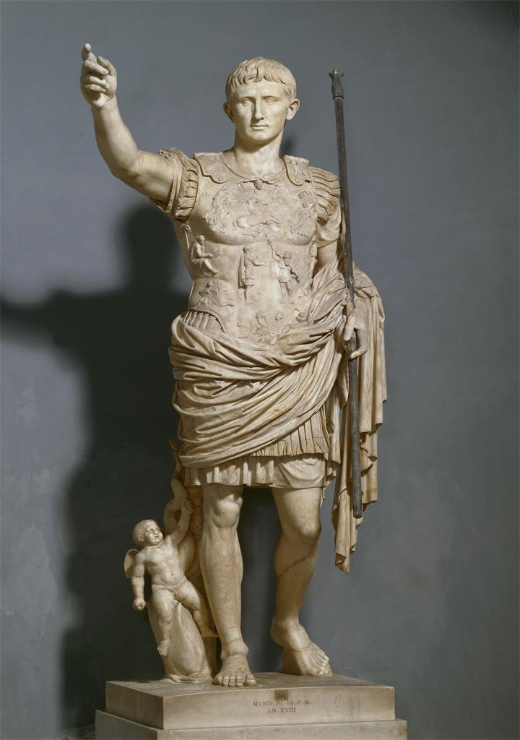
Fig. 1 Augustus, Ancient Rome, Early Empire, 20 BCE

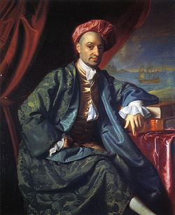
Fig. 2 Nicholas Boylston, John Singleton Copley, 1767

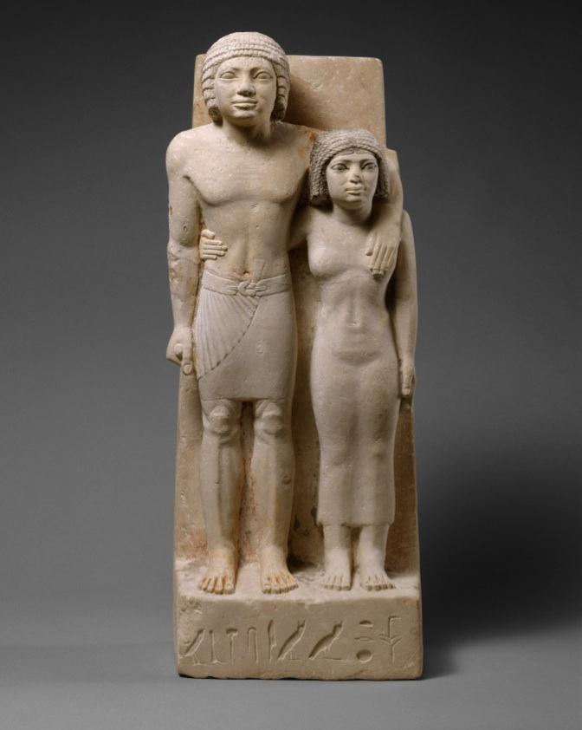
Fig. 3 Royal Acquaintances Memi and Sabu, Old Kingdom, Dynasty 4, ca. 2575-2465 bce
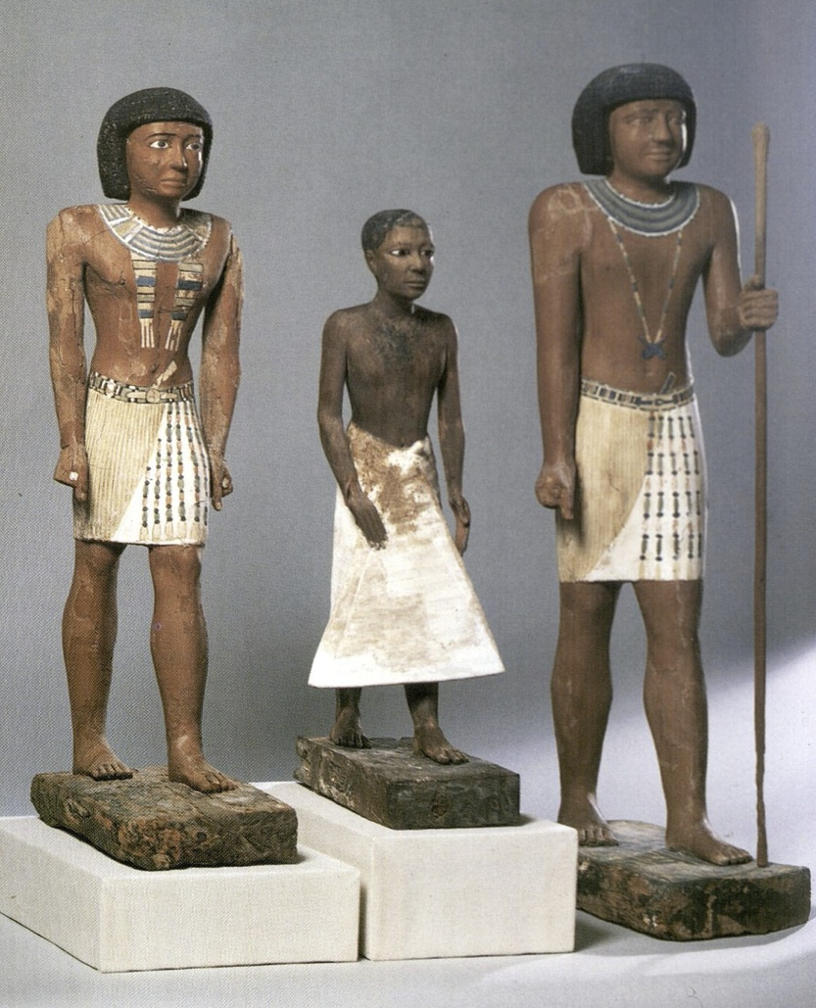
Fig. 4 Three Statues of Metjetji, Old Kingdom, late Dynasty 5-early Dynasty 6, ca. 2371-2288 bce

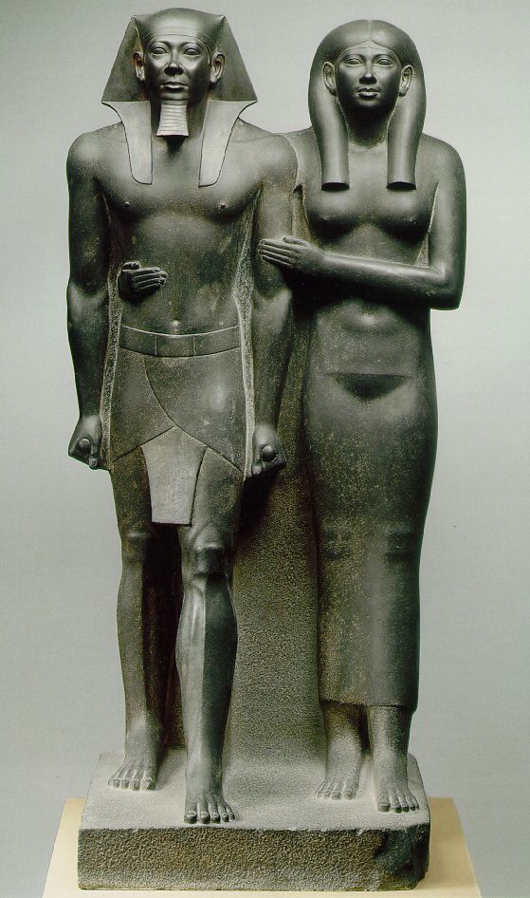

Fig. 5 Menkaure and His Wife, Old Kingdom, Dynasty 4, ca. 2490 bce
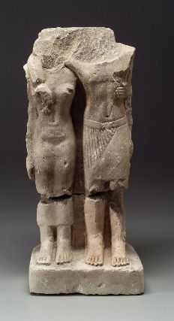
Fig. 6 Fragmentary Paired Statuette, from Giza, Old Kingdom, Dynasty 4
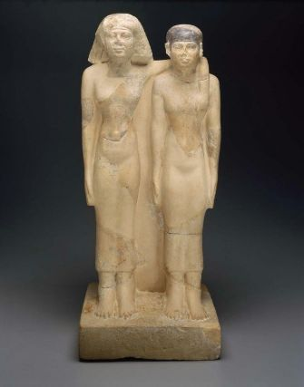
Fig. 7 Paired statuette of Queens Hetepheres II and Meresankh III, Old Kingdom, Dynasty 4
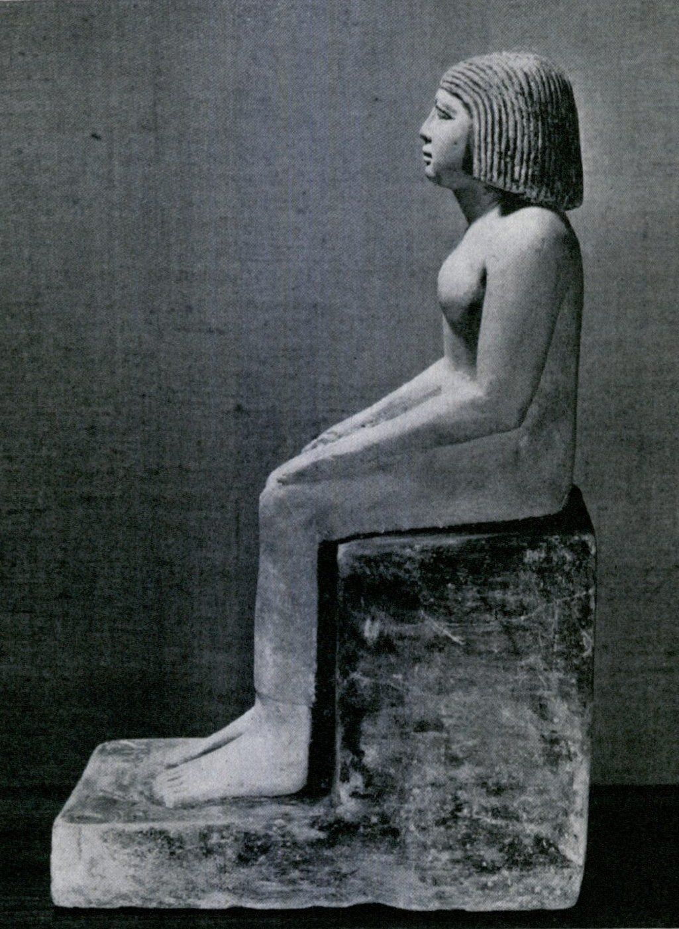
Fig. 8 Sabu, Height 19 in, Collection of Louis E Stern
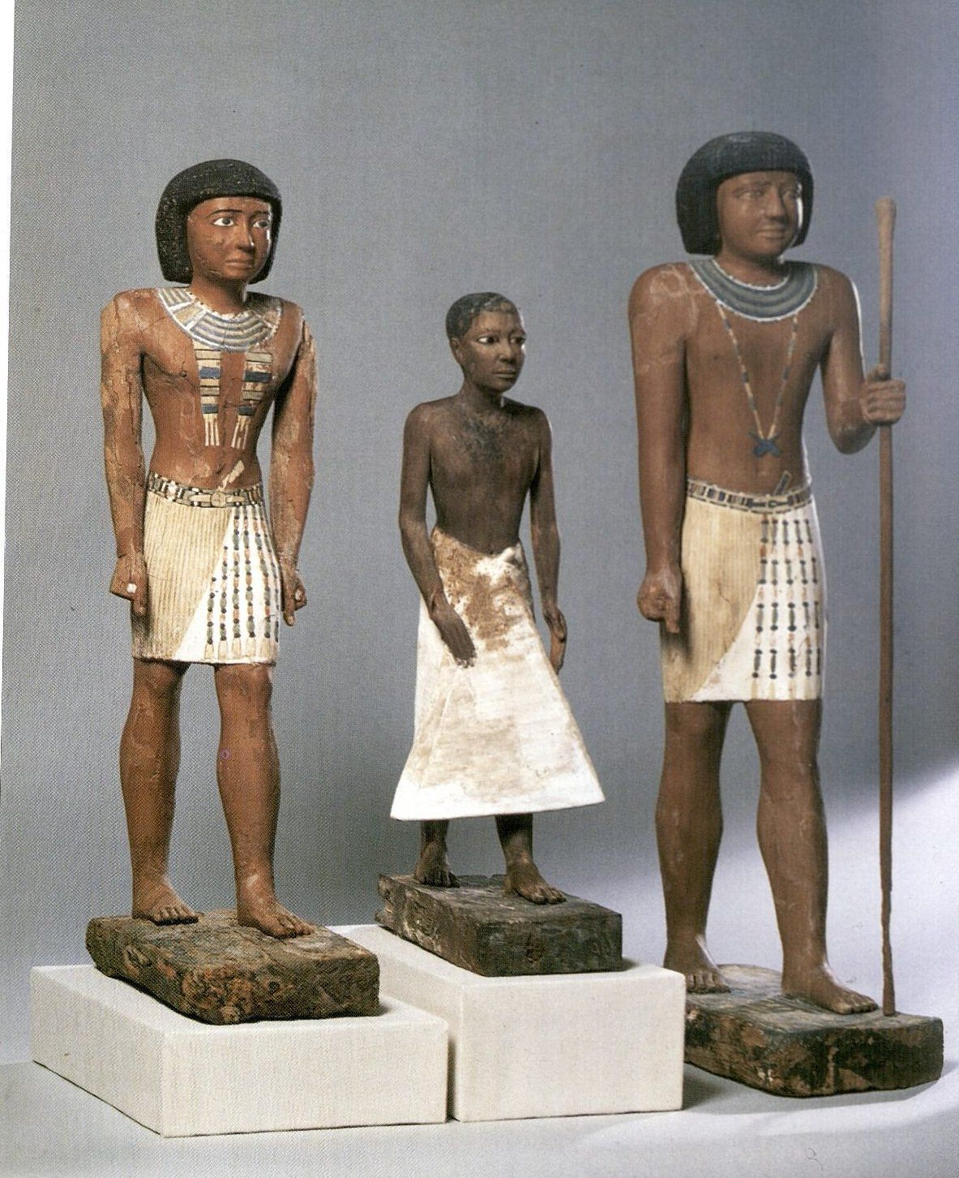
Fig. 9 Three wooden statues of Metjetji, Old Kingdom, Late Dynasty 5-Early Dynasty 6
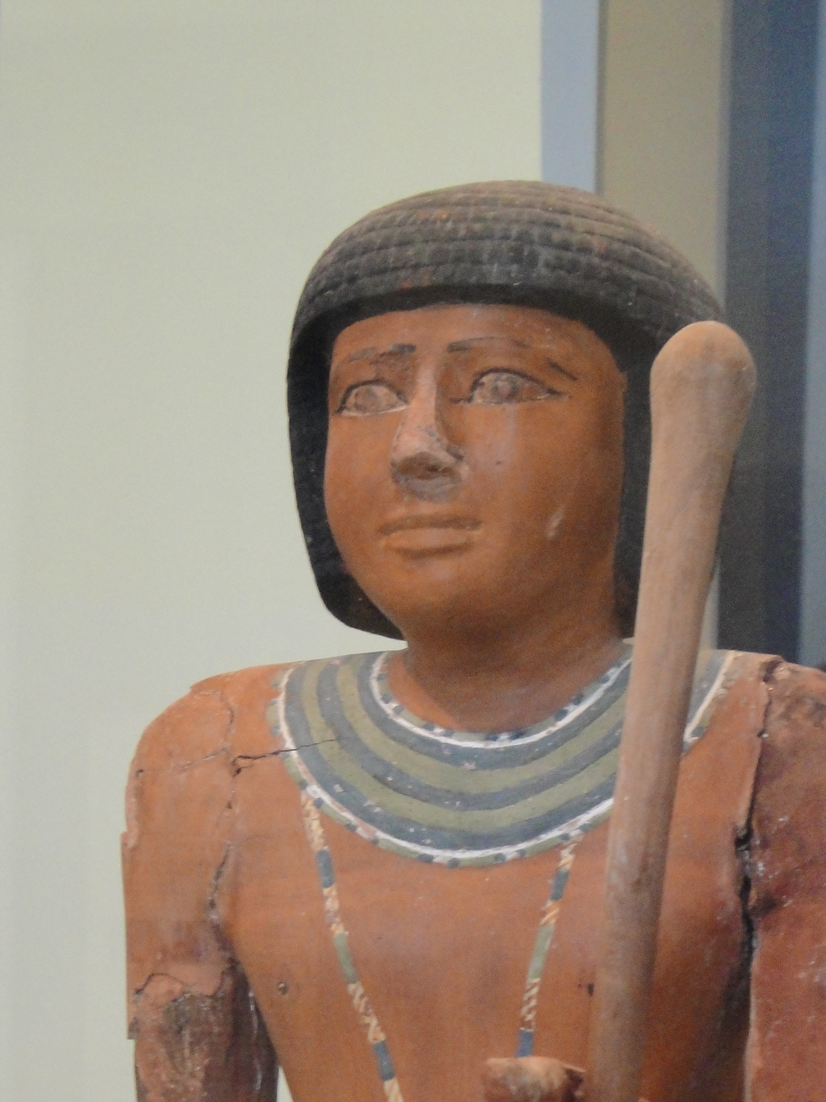
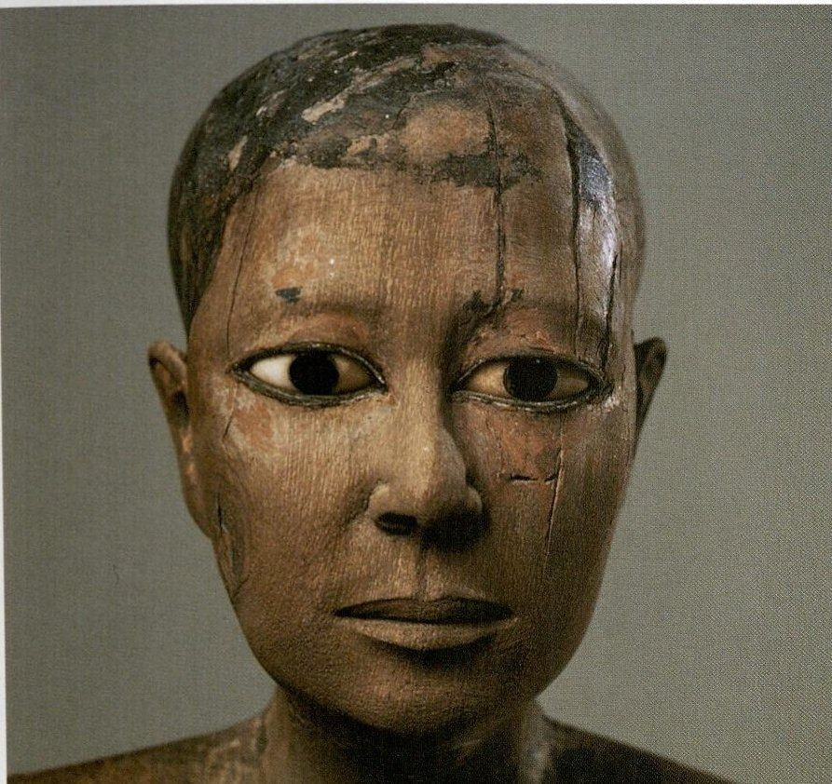
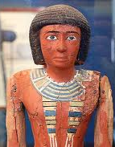

Fig. 10 Youthful Metjetji Fig. 11 Middle Aged Metjeti Fig. 12 Elder Metjetji

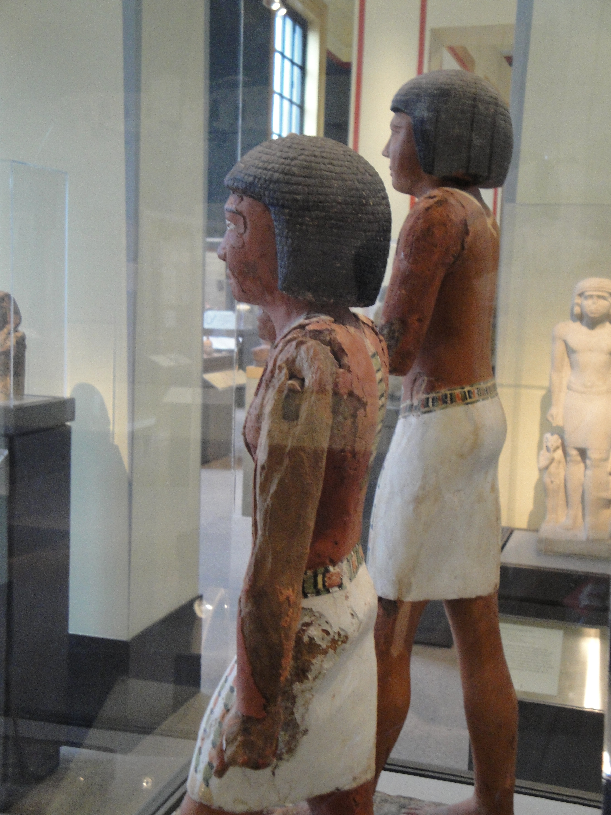
Fig. 13 Detail of the middle-aged Metjetji, with damage allowing study of the creation process
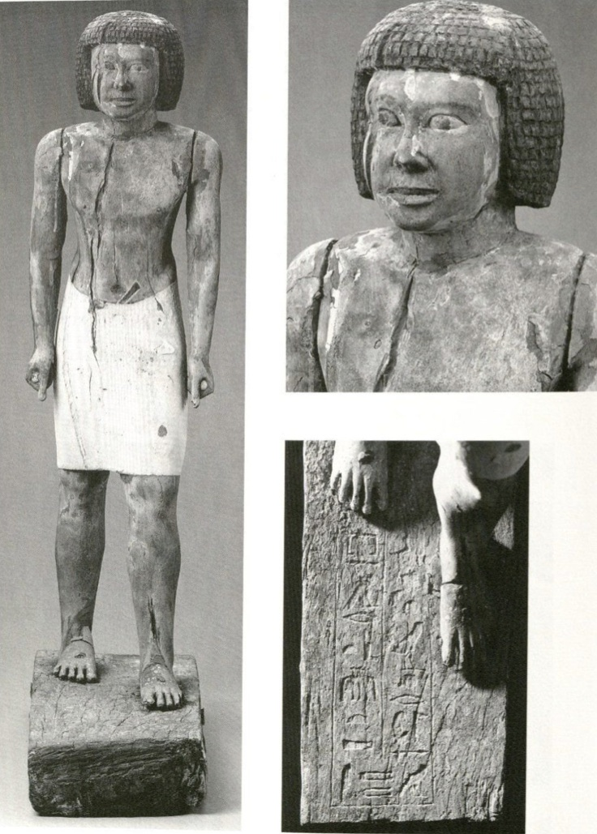
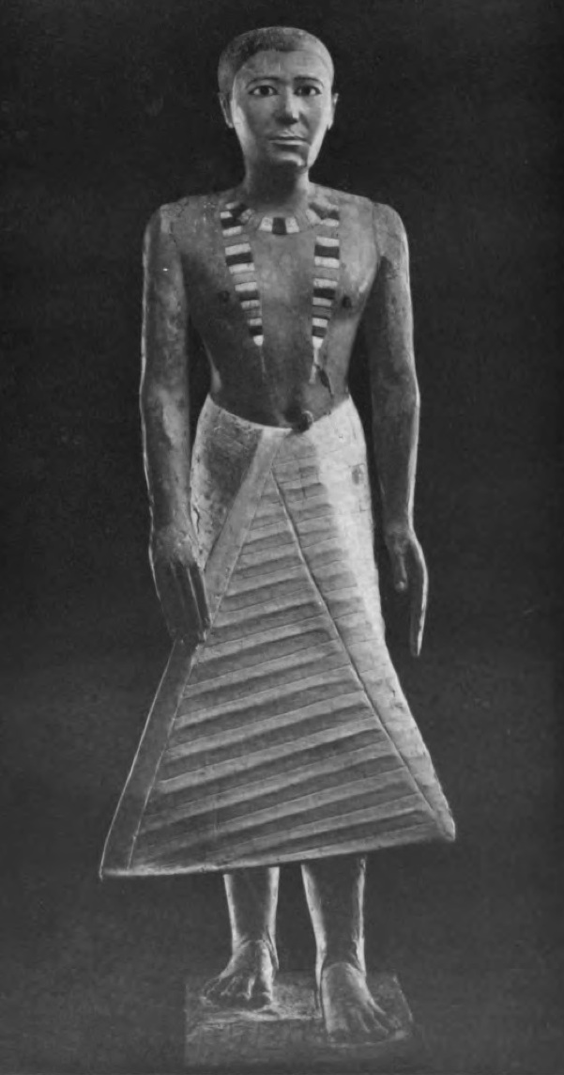

Fig. 14 Metjeti Statue, MFA, Boston Fig. 15 Metjetji Statue, Nelson Atkins Gallery

Fazzini et al., 15.
Ibid, 25; Malek, 2003, 7.
Breckenridge, 44.
Fazzini, et al., 23.
Ibid, 21-22; this introduction acknowledges information gathered from several sources including Breckenridge, 1968; Fazzini, et al., 1999; Jánosi, 1999; Malek, 2003; Malek, 1986; Tefnin, 2001; Tooley, 1995; and Wilkinson, 2007.
Fazzini, et al., 25-27.
Payne, et al., 1992; Tefnin, 236-238.
Breckenridge, 42.
Breckenridge, 1958; Fazzini, et al., 23-25; Harvey, 31-34; Malek, 2003; Spanel, 1988; Ziegler, 5.
Breckenridge, preface-15.
Breckenridge, 11; Spanel, 35, argues that mummification was the origin of naturalistic art, because likeness of the deceased help avoid any confusion over identity.
Breckenridge, 1968, references E. Panofsky, Tomb Sculpture, New York, 1964, p. 15.
On pages 10-11, Breckenridge, 1968, refers to E.H. Gombrich’s Art and Illusion: A Study in the Psychology of Pictorial Representation, New York, 1959, 87.
This overall discussion is carried across several sources, including Breckenridge, 1968; Cherpion, 1999; Fazzini, et al., 1999; Tefnin, 241; Ziegler, 1999.
Breckenridge, 14, 42-43; Ziegler, 57.
Cherpion, 1999; Fazzini, et al., 23-25; Harvey, 21, 30-37, 219.
Tefnin, 241.
Cherpion, 1999, conducts a stylistic study of statuary from each Dynasty, drawing conclusions about distinctive facial expressions found in each reign.
Fazzini, et al., 25.
Harvey, 222; Spanel, 33, 35.
Fazzini, et al., 21; Tefnin, 235-236.
Ibid., 238.
Payne, et al., 33; this source provides detailed descriptions of attire and wig and hair styling for all classes and ages of men, women, and children.
Ibid., 35-39.
Ibid., 39-40; Scott, 95; women were generally shown as slim, youthful, and beautiful.
Ibid., 40.
Fischer, 1975, 11-12.
Egyptian Art in the Age of the Pyramids catalogue entry pp. 294-296.
Scott, 97-98.
Rzepka suggests that Memi-Sabu has his name and titles, not hers; on March 1, 2012, Edward Bleiberg commented that the reinterpreting the name is a “problem with a language that doesn’t make spaces between words.”
Egyptian Art in the Age of the Pyramids catalogue entry pp. 294-296.
Scott, 95.
Egyptian Art in the Age of the Pyramids catalogue entry pp. 294-296.
Egyptian Art in the Age of the Pyramids, 283; Malek, 1986, 73-74.
Scott describes how the pillar tapers in at the top and that Memi’s elbow rests in an indent in the pillar, both intended to lighten the weight of the stone above her, especially as a smaller figure, 98.
Ibid., catalogue entry, pp. 294-296.
Scott, 98.
Ibid.
Fischer, 1973, 14; Scott, 98-99.
Ibid.; Egyptian Art in the Age of the Pyramids catalogue entry pp. 294-296.
Dieter, 45; Fazzini, et al., 53; Harvey, 4-5; Malek, 2003, 86; Ziegler discusses how during and after the Fifth Dynasty, the number of non-royal tombs increased and consequently, so did the number of statues, 63.
Cooney speculates that the wood is ebony; Ed Bleiberg, curator of the Brooklyn Museum of Art Egyptian collection says the wood is more likely cedar, given that ebony is nearly black in color.
Cooney, 4; Harvey, 219.
Cooney, 15; Harvey, 2, 219; Tooley, 11.
Harvey in Redford offers additional detail such as the active role that could include references to hunting and fishing and the passive role of receiving offerings or managing servants, 248.
Ibid; Tefnin, 246-247.
Cooney, 15.
Harvey, 2-4; Spanel, 21-22
Several sources informed this introduction including Aymar, 5; Harvey, 2001; Malek, 1986, 74; Wilkinson, 64-66; Egyptian Art in the Age of the Pyramids, 408-417; dating which Pharaoh Metjetji served was complicated by Munro, 1994 showing how the inscription “esteemed by Unas” appeared after the Pharaoh’s death.
Ibid.
Harvey, 223; Russman, 1995; Wilkinson, 53.
Breckenridge, 38-39, 41; Malek, 2003, 86.
Harvey, 9; Payne, et al., 37-38.
Cooney, 16.
Payne, et al., 39.
Russman, 11.
Cooney, 16-17.
Cooney, 16.
Cooney, 23; Egyptian Art in the Age of the Pyramids, 413.
Cooney, 23, 25.
Cooney, 9-10; Russman discusses that Second Style hands can also be undersized, as well as enlarged, 270; the characteristics of Second Style described in this introductory session come from Russman’s and Cooney’s articles.
Cooney, 23.
Cooney, 21.
Payne, et al., 34-35.
Cooney, 10.
Payne, et al., 34-35.
Russman, 275.
Cooney, 4-5; Harvey in Redford; Russman, 275; Cooney discusses that the style continued for many dynasties, but the early examples were among the best in sculptural quality, 25.
Cooney also argues that one scribe was used for each inscription on the base and that the scribe was less skilled than the sculptor.
Cooney, 1.
Dieter, 48.
Russman discusses how the stylistic change is remarkably not pressured by cultural upheaval or foreign conquest; the meaning of and impetus for the style change may have been religious, but is still unclear, 273.
Stone, 98.
Breckenridge, 44.
Ibid., 42.
Ibid., 37.

