Polished versus Coarse:
Men’s Fashions in Colonial Portraits, Forging an American Identity

By Rena Tobey

July, 2010

©Rena Tobey

Painted portraits provide a relatively permanent record of a period in the sitter’s life and also reveal insights into the context of the time and place. Reading a portrait through clothing, posture, accessories, and decorative elements visually demonstrate values and priorities for the person portrayed and society as a whole. Relations between Colonial America and England in the 18th century may be interpreted through the faces and figures of its people, captured in portraits. Early in the century, Colonists used portraits to show that they had attained enough stability to accumulate luxurious lifestyles. By mid-century, the prosperous Colonial elite mimicked English manners and symbols of success, especially its clothing. Approaching the Revolutionary War, the Colonies began forging an identity unique from its parent country.
The story of men’s clothing seen in portraits from 1729 to 1772 demonstrates how the Colonies learned to stand, then walk independently. Evidence that a distinctive American personality was forming comes from closely examining six portraits by four Colonial artists—John Smibert, John Wollaston, Joseph Badger, and John Singleton Copley—with particular attention to the sitter’s clothing, as well as the social, economic, and political contexts. This identity was shaped by juxtaposing ideals that emerged both from the Colonies’ geographic isolation from Western Europe and its role in the global economy.
Similar to the European merchant class, an ordinary American Colonist could accumulate wealth through commerce, and in the 18th century, prosperity exploded. With new affluence, Colonists developed an appetite for luxury items, but producing these goods locally was often impractical, and even impossible. For example, developing cost-effective technology to convert raw materials into finished textiles to meet growing demand was far more expensive than importing textiles from England.
The Colonies were part of long established, complex trade networks and had access to luxury textiles and garment styles. While tariffs and navigation acts, starting in 1721, prohibited imports of popular Indian printed cottons and Chinese silks to England, these textiles could legally be sent to the American Colonies. Colonists could wear and decorate their houses with brightly colored and colorfast chintzes and luxurious silks carried by the East India Company. The latest clothing silhouettes were brought overseas through fashion magazines, fashion plates, and dolls dressed in the latest styles, lagging behind the latest Paris or London look only by the length of sailing times.
Another luxury import was the portrait painter. Establishing a fashionable image became increasingly important in 18th century America and having a portrait painted was extremely expensive. Even the wealthiest citizens would only sit once or twice in their lifetime. Portraits were made even more rare by the lack of access to painters of skill. Earlier portraits, often painted anonymously, were made by limners who also painted signs and coach insignias. As consumerism and the importance of owning luxury goods emerged as a priority, portraits became a symbol of a desirable lifestyle. To elevate the portrait to make a statement about the social status of the sitter required a painter familiar with prevailing fashion and etiquette, as well as the skill to create pleasing representations of personality and appearance. The ability to beautifully portray fine fabrics and garments, reinforcing the sitter’s wealth and grace, was an especially prized skill.
John Smibert met all these requirements. London trained and well traveled, Smibert joined the 1728 expedition of Dean George Berkeley, who intended to start a college in Bermuda, with Smibert along as an art instructor. When the voyage stopped in Newport, RI to raise funds, Smibert made his way to Boston, the Colonial hub of New England, with the promise to return when Berkeley was ready to sail for Bermuda. Smibert remained in Boston for 23 years. Berkeley’s failed utopian plan freed Smibert to cultivate the Boston elite and establish the portrait profession in the Colonies. Shortly after his arrival, his studio became a social hub for potential clients, aspiring artists, and Boston society. But Smibert did not start on top of the social scene. He proved his merit with important portraits for Francis Brinley, a wealthy merchant and landowner. In 1729, Brinley commissioned up to six portraits, commemorating the birth of his first son. The newly arrived artist proved his merit with the portrait of Brinley (Fig. 1), demonstrating all the important elements of style and character sure to please the young sitter, and the rest of Boston’s wealthy society.
Smibert immediately communicates Brinley’s social and economic standing with conventions of European portraiture. Brinley is positioned in front of a landscape that could be read by his contemporaries as one source of his wealth. In the foreground, haystacks signal a productive harvest for landowner Brinley. The background features recognizable Boston landmarks, including King’s Chapel and Old South Church—a view that could not actually be seen from Brinley’s Roxbury home. Firmly placed in the Boston milieu, the river in the midground becomes the Charles, the site of the trading that also contributed to Brinley’s wealth. The young man’s girth communicates his affluence, as well, since having enough to eat was not something taken for granted in the Colonies at this time. Smibert emphasizes Brinley’s belly by placing his folded hands contentedly resting on its broadest point, highlighted by subtle lighting. Brinley’s chubby knees reinforce that his weight was genuine, that the look was not accomplished by strapping on a stomach pad, as was fashionable at that time. Further, Smibert positions his sitter in a throne-like, invented chair in his home, high on the hill above Boston, establishing Brinley as a Colonial King.
With that chair and Brinley’s appearance, Smibert does something more subtle in conveying character. The painter chooses to use slightly old-fashioned styling that he believed suited his more conservative client. The chair is reminiscent of the earlier Queen Anne look, and Brinley’s dress and wig suggest Baroque rather than more contemporary Rococo fashion. The Baroque favored ornament, free-flowing lines like the curved form of the Brinley chair, and heaviness, rather than the delicate styling of the Rococo. Particularly notable is Brinley’s powdered wig, displaying a heavy, long style more Baroque than the lighter Rococo. His choice of clothing also makes a statement of conservatism. Rather than be portrayed in evening or formal wear, which a wealthy man such as Brinley may have owned, he instead is depicted in his everyday clothing. No question that this clothing is a cut above the ordinary, both in styling and in fabric, but Smibert seems to demonstrate Brinley’s status more through the objects and land in his life than his garments. Whether Smibert was commenting on the sense of style he encountered in the Massachusetts Bay Colony or this sitter’s own taste is unclear. But the expensive decision to sit for a portrait means that each choice was likely thought out, as a way to communicate values and priorities to the Brinley generations who followed.
Brinley’s suit does reflect European styling, unlike the earliest settlers, who encountered native people and adapted many of their customs and clothing for the practicalities of living in a frontier setting. Rather than wear wool hose, lace, and wigs, these settlers would have adopted felt and beaver hats for warmth (before they became fashionable as exports to Europe), leggings or boots to protect against hostile terrain, hunting shirts, and layers of clothing suited to ease of movement and warmth, rather than fashion. This clothing became symbolic of how daily life in the Colonies, demonstrated through appearance, was different from European traditions. Brinley’s choice to be portrayed in everyday clothing may have been an attempt to balance the competing considerations of Colonial frontier dress and European fashion.
Those who could would demonstrate that they did not need to do dirty work or venture into unsettled territories that denied their comfort. By 1729, Francis Brinley was just such a man. He could don the European-inspired three-piece suit, all of the same fabric and color, made up of breeches cinched below the knees, long waistcoat falling to mid-thigh, and justaucorps, or outer coat, cut more loosely over the waistcoat. The fitted straight sleeves with cuffs turned back almost to the elbows were more stylish in the late 1600s than during this period. The extensive use of buttons on both the waistcoat and coat become more decorative than functional, as if his tailor was showing off Brinley’s access to imported accessories, such as fabric covered wooden buttons. Leaving the waistcoat unbuttoned to mid torso again emphasizes Brinley’s girth and also shows off his pristine, elegantly twisted, white cravat, or neckware. The tightness of the cravat, the lace cuffs of his shirt, and his prominently displayed clean fingers further indicate that Brinley’s work was more of his mind than his hands.
The suit fabric appears to be wool broadcloth, a popular import from the woolen mills in England made from the 1500s on. Broadcloth, popular for use in men’s coats, was a type of wool that was preshrunk so it would not ravel when cut. The edges could be left unfinished. The napped or shorn surface was dense, compact, and stronger than felt. Although expensive, the textile was sturdy and made for a practical alternative to formal dress clothing. Brinley’s choice to have his portrait made in a sturdy, practical suit demonstrates not only fine styling and gestures of wealth, but also seems to align him more with his Bostonian merchant colleagues than the court elite of England.
As the 18th century consumer revolution flowered over the next decades that relative restraint seemingly vanished in portraits. By 1747, Robert Campbell wrote that “clothes make the man” and about the importance of a good tailor, and popular prints by British artist William Hogarth used clothing as a way to type the people depicted. The painted portrait became an expression of the social identity of the sitter, reflection not of fact per se, but rather a kind of constructed character fiction. Viewers were adept at reading portraits and quickly sizing up the sitter. The sitter’s clothing provided an important first insight into accomplishments, status, and personality. With increased wealth, the garments on display in portraits reflected a growing desire to be recognized as sophisticated citizens of the world and members of British aristocracy. For portrait artists, being able to depict garments convincingly was considered more important than rendering a true-to-life face or figure.
John Wollaston, a London portrait painter who came to Philadelphia and New York at just the right time to ride the wave of Colonial portrait consumption, possessed great skill at rendering textiles that complimented skin tones and figures. His portrait of William Axtell (Fig. 2), painted between 1749 and 1752, shows a shift in taste toward more opulent portrait dress from Brinley’s likeness twenty years earlier. It also clearly reflects the changing silhouette into fashionable Rococo stylings. Gone are the heavy rotundities from earlier in the century, replaced by long lines and graceful attenuation.
Axtell epitomizes elegance in his attire. He wears a coat of silk satin with high sheen, collarless, with large, wide, turned back cuffs, embellished with decorative buttons and slashes. The coat flares out on the sides, not intended to close. Instead it is likely pleated at the hip and stiffened by whalebone or horsehair to accentuate the flair, standing away from the body and mirroring the silhouette of women’s fashions. The waistcoat, in a complementary-toned silk satin, has shortened since Brinley’s day, and is heavily trimmed with gold embroidery along the edges and pockets. Its snug fit, depicted convincingly by Wollaston through puckering, again suggests a well-fed Axtell straining his garment, while also providing the fashionable feminized silhouette. His crisp white neckcloth or stock and shirt trimmed with a wide ruffle further accentuate that Axtell did not do manual labor. Completing his gentlemanly appearance is his hairstyle. Rather than wearing a Baroque wig like Brinley’s, heavily curled, full, and long, Axtell has naturally colored hair, also most likely a wig. High quality wigs were expensive, another class distinction, and were made of human, horse, or goat hair. The wig hair would then be dyed brown, black, or blond with nutmeg or the root of an iris called orrisroot. The style itself was the controversial hurly burly, also known as lovelocks, worn by young rakes.
Wollaston also communicates Axtell’s status through his pose and surroundings. Unlike Brinley’s identifiable location and sources of wealth, a generalized landscape surrounds and even seems to cushion Axtell in his portrait, leaving little doubt of the vastness of his holdings as the source of his financial support. He rests one hand comfortably on a undefined table topped by a textured table clothe. His other hand is cocked jauntily on his hip, achieving the fashionable curved elbow that coat styles accentuated. These gestures suggest Axtell’s self-assurance. Clothing helped maintain upright posture with a straight head and back, with chin up over neckwear. This erect posture was essential, but so was a relaxed bearing with a bent elbow, hand on hip to suggest the sitter’s ease. Etiquette books defined this contrast of erect posture with the ability to move and pose with ease as the height of elegance. Axtell gazes directly at the viewer, as did Brinley, commanding attention. Again reflecting the height of London fashion, Wollaston depicts Axtell’s eyes in the fashionable almond shape. This distinctive characteristic signals a Wollaston portrait and suggests that Axtell was current on the latest look from overseas. Every element of Axtell’s bearing and dress confirm his place in refined society.
If Axtell had a son, he may have looked very much like James Badger (Fig. 3), painted by his grandfather Joseph Badger in 1760. James’s portrait was made during a transitional time in how children were treated and depicted, and this portrait suggests both traditional child-rearing practices and hints at the new. More than a third of Badger’s portraits were of children, many sporting a pet bird, squirrel, or dog. Charming to the 21st century eye, showing James Badger posed with a bird perched on his finger also has significant symbolic value. By mid-century, the writings of French philosopher Jean Jacques Rousseau were influencing Europe and the Colonies. He advocated treating children different from little adults, encouraging them to play freely and to dress for freedom of movement. But he also called for enlightened education for the child’s future. The ability to train a wild thing, like a bird, and then be calm enough to stand still with this wild thing, demonstrated James’s ability to tame the beast inside and grow into a noble adult. In James’s other hand, he holds a sprig with cherries. Fruit in a portrait traditionally symbolizes a fruitful future, reinforcing this promise of noble adulthood.
While doe-eyed James with the bird reflects the latest Enlightenment thinking, his clothing suggests more traditional practices for raising children. For up to eighteen months, infants were swaddled, wrapped in bands of linen to prevent movement, which could be especially dangerous for toddlers wandering into Colonial hearths. Both boys and girls were transitioned into skirts, robes, or ankle length gowns called frocks, as James wears, easing cleanliness and toilet training. Around age 5, boys were breeched, moved into wearing breeches, with buttoned openings in the front, before taking on adult clothing around the age of 10 or 12. Contemporaries would have known the child was probably younger than age 5. Although all children dressed identically in a sexless frock at that age, viewers would have also recognized that this child was a boy through a style subtlety: boys wore low cut necklines, while girls’ frocks featured higher, more modest styling.
Joseph Badger was instructed by Smibert and knew the importance of portraying garments well. James was not depicted in an everyday frock of cotton or muslin, which were both comfortable and washable, but instead in an expensive silk satin garment with all the latest fashion design. Tight through the bodice, with deep cuffs and button embellishments, the frock fans out from the hip, reflecting adult silhouettes. The tight bodice most likely featured stays for shaping and support, which also encouraged good posture essential for a fine figure. The elegant sash, decorated with silk and metallic embroidery and lace edging, most likely hide pleats that could be let out as James grew. Around his pale neck is a black ribbon, perhaps of velvet, with scalloped edging, that bounces the eye to the sash at his waist. James wears his natural hair curled in an adult style very similar to William Axtell’s.
Unlike the works by Smibert and Wollaston, Joseph Badger has depicted James head to toe, a more expensive portrait length than a half or three-quarters view. The viewer is then treated to James’s feet, posed turned out, a dance position considered the height of grace in the etiquette books, due to the French King’s passion for ballet. James wears glittering buckles on his shoes, and while overall, Colonists were less ostentatious than their counterparts in Europe, no viewer could doubt the elegance and wealth conferred on this boy.
As the 1760s progressed, political tensions with England deepened, and splits in how sitters chose to be depicted emerged in portraiture. Some used their portraits as an expression of a new way of thinking about being American. Other sitters continued in the tradition of opulent attire or began to play with masquerade costumes. The latter aimed at timelessness in presentation, while also referencing an English entertainment highly in vogue. Men and women would dress up in historic styles, Turkish attire, and other ‘Oriental’ costumes, and women play acted as shepherdesses, blurring distinctions between fiction and artistry in attire. These very different visual strategies mirror two parts of the American persona—that of the coarse frontier of the New World and the polished European tradition.
The painter who straddled those disparate approaches to self-presentation with seeming ease and exceptional talent was John Singleton Copley. Virtually self-trained, Copley’s mission was to elevate the role of portrait painting to something greater than an artisanal craft. His raw talent was molded with mentoring by Smibert and the art resources in his studio, as well as by his stepfather on the business aspects of portraiture. Young Copley attracted Boston’s elite to his studio in the 1760s with a combination of pledges—to create a pleasurable experience for the sitter and to make the latest London fashions available for the sitter’s choosing. Copley presented the sitter with a portfolio of prints derived from portraits by Joshua Reynolds and other notable British painters. The sitter could then select elements, such as a hat, an accessory, or a dress, to be included in the portrait. No one questioned the fictionalized results, since the way the sitter’s character and status were portrayed was considered completely authentic. Further, the appearance of character was proof of character.
By 1769, Copley successfully combined the portrait painting tradition of beautifully rendered textiles with the rage for turquerie, or the wearing of Turkish attire, in his portrait of Nicholas Boylston (Fig. 4), shown in an exotic robe. As early as the 16th century, men began wearing a nightgown, which was not worn in bed, but rather was an indoor garment worn around the house when the outer jacket was removed. In the 1630s, imports from India and China influenced the styling of these gowns, including modeling on the t-shaped kimono. The name banyan was applied to this garment style, referencing the name for a Hindu merchant. By 1755, wearing a loose gown of rich material was such a mark of a gentleman at home that the term ‘banyan’ appeared in Samuel Johnson’s dictionary, and men felt comfortable enough to receive visitors in the attire; ultimately, men were even seen wearing banyans outside their homes. Copley captured this trend by painting the elite in their most elaborate banyans, which used excessive amounts of fine fabric, so expensive as to be roughly equated with the cost of a stable of horses.
Nicholas Boylston epitomizes the refined gentleman at his leisure. As banyans were affiliated with scholars and Boylston was a notable donor to Harvard College, contemporary viewers most likely would have made the connection. But Boylston casually rests his elbow, not on a scholarly tome, but on his account ledger books, reminding viewers of the source of his wealth. Boylston, known for his lavish entertainments, beautiful gardens, and elegant clothing, afforded that opulence by importing textiles, tea, paper, and glass, all symbolized by the ship depicted in the background.
What clearly demands viewer attention is the effusion of textiles. As fashion dictated, Boylston has removed his tight outer jacket for his comfortable banyan. His itchy wig has come off, and he covers his shaved head with the stylish turban that also kept his head warm during the cold Boston winter, completing the exotic and fashionable ‘Oriental’ ensemble. Copley uses diagonal lines to move the viewer’s eye around the canvas, to bathe in the luxuriousness of the blue-green banyan, the lustrous pink satin or velvet table clothe that matches the Boylston’s turban and waistcoat, and the rich burgundy curtain that mirrors the lines of the figure. The banyan’s excessive drapery catches the light and tumbles in folds with such naturalistic virtuosity that the viewer can practically feel the cool smoothness of the satin lining, the textured weave of the damask exterior, and the softness of the velvety cuffs, each texture distinct from the crisp, white cravat and ruffled shirt.
In addition to his assured, yet relaxed pose and direct gaze, Boylston is portrayed as a gentleman by his ease and grace in wearing the elegant, flowing gown, as the highest form of beauty. More subtly, Boylston’s waistcoat is partially unbuttoned, not only providing a peek at his pristine shirt, but also acknowledging the etiquette books of the day. These books instructed men to place a hand at mid-chest through a partially unbuttoned waistcoat. Boylston’s right hand draws the banyan back to reveal the beautiful silk satin of the waistcoat and this appropriate unbuttoning. What distinguishes Copley’s male sitters from their English counterparts is the choice of plain linen shirts, albeit of polished, not coarse, finish. Whereas Europeans might reveal lace through their waistcoats, American men show the plainer fabric and styling.
While Copley places Boylston luxuriating in textiled beauty, much as William Axtell is cushioned by his landscape, the painter does not idealize his sitter. By carefully rendering the particulars of Boylston’s facial features, Copley creates a kind of authenticity that encourages viewers to embrace other details portrayed, such as the composed setting. Boylston emerges as a recognizable, full-bodied person, solid and weighty. His beautifully rendered flesh tones, portrayed with subtle modeling and lighting to suggest bone structure, depth, and illusionistic likeness, all distinguish Copley’s skill from any portrait painter to precede him.
While Boylston was depicted at the height of fashion, other Colonial notables showed a different attitude with their garments. Since a higher portion of income was spent on clothing than housing, fabrics were traditionally used as a status symbol, in portraits and in daily life. But in the years before the Revolutionary War, that symbolism started to change. Tensions between the Colonies and England grew in the 1760s and early 1770s, centered on economic matters, including taxation on desirable luxury imports. These tensions were nothing new. As early as 1640, English legislation was passed attempting to protect its textile manufacturers. For over a hundred years, tariffs, duties, and importation restrictions caused friction with Colonists who craved exceptional imported fabrics. The added cost led to various attempts to establish local manufacture of garments from raw materials of linen, cotton, and wool. Even silk manufacture was unsuccessfully tried. During the periods of heightened tension, more effort was exerted to make textiles and garments at home, and locally for a village. In contrast to finely spun silk yarns, woven to enhance sheen, or densely woven woolen broadcloth, homespun featured simple, coarse yarns, woven in plain weave, resulting in a basic tweed pattern.
In 1763, the French and Indian War ended with a victory, and enormous debt for England. To pay for the war, in 1764, England passed the Sugar Act, taxing luxury items including textiles. By 1766, women in Providence, RI formed the Daughters of Liberty, who spent the whole day spinning, to avoid purchasing expensive imports, until the 1765 Stamp Act was repealed. In 1768, the Harvard graduating class voted to receive their degrees dressed in American made garments, and by the following year, Yale graduates also wore homespun. As the Colonies expanded west away from ports and river trade, more garments of homespun were worn as an open symbol of self-sufficiency. While homespun may not have been worn on a daily basis by the majority of Colonists, using a plain garment as a way to differentiate from the flamboyance of English court dress was a powerful symbol in the years leading up to the Revolutionary War. Choosing to be shown in a portrait in a plain garment was a notable break from English tradition.
By 1770, Copley was working with a more austere palette, decreasing the decorative elements of clothing and accessories, and focusing more on depicting character. He portrayed Samuel Adams, important politician, failed brewer, and Revolutionary, around 1772 in the kind of plain, woolen suit associated with homespun (Fig. 5). Adams’s somber, reddish wool suit, lacking ornamentation, with only a single, linen ruffle at the wrist, almost blends in with the dark background. The color red may carry additional meaning. During the 18th century, American men who toured Europe on a ‘grand tour’ purchased a red suit in Italy, as a kind of fashion statement of this accomplishment. Showing Adams in a plain red suit suggests that not only is he proudly attired in a recognizably American-made garment, but he also is a man of the world, acknowledging the Colonies’ place in the global sphere. Like in Boylston’s portrait, two buttons of Adams’s waistcoat are unbuttoned, although not fashionably at mid-chest. Rather than a nod to etiquette, here, the gesture indicates lack of vanity and concern for appearances, or as Adams’s critics would imply, a slovenliness that suggests unreliability.
Painted between the Boston Massacre and the Boston Tea Party, the portrait is Copley’s most overtly political, full of symbolism in addition to the plain, red suit. Unlike the Boylston portrait, Copley does not highlight symbols of wealth, but instead spotlights papers and books, Adams’s face, and his gestures. All the action takes place at the picture plane, the very foreground of the canvas, lacking any mid-ground or background. As typical of Copley’s portraits, Adams’s facial features are depicted in a strikingly particular way, with incisive suggestion of character. No background information or opulent garments distract from the political message directly and powerfully portrayed. Adams is shown as an ordinary looking man, made powerful with the rightness of his cause. Rare in Copley’s work, a particular historic moment is depicted—the self-described highpoint of Adams’s political career. Here he challenges the Massachusetts Governor about the right to self-rule protected by the state charter, the document indicated by Adams’s pointing right hand. His intense stare, Copley’s dramatic use of light and dark, and the focus of attention suggest self-confidence, passion, and risk-taking individualism, characteristic of this man and of the growing independence and righteous anger of the Colonies.
Adams is portrayed as a man of ideals, not an idealized man, and this portrait was used for political purposes. Commissioned by John Hancock, not atypical for the times, the portrait hung in Hancock’s Boston mansion on Beacon Street. Later, it was removed to Faneuil Hall, a very public place of Revolutionary discourse, in order to do political work. In a time when a revival of classical politics and philosophy were at a height, Adams was pictured as a Roman Senator, yet a very real, living presence embodying the ideals of reason and justice. So popular was the image that prints were made of the portrait, an affordable version that allowed middle class patriots to purchase the work as a symbol of their cause.
Although not turned into a print to do political work when it was painted, another of Copley’s portraits has captured the ideals of the Revolution—the portrait of Paul Revere, from 1768 (Fig. 6). This portrait brings together many of the elements of Copley’s work, while also providing a visual representation of an emerging American character. Painted before the Revolution and his famous ride, Revere’s portrait nonetheless visually blends the impulse toward independence, egalitarianism, and revolution with the desire to be acknowledged as a global citizen. The portrait combines the coarse and the polished of the American persona.
Every element and detail conveys information to the viewer. Like with Adams’s portrait, Revere is set against a dark background. His figure and activity are pushed up to the front of the picture plane, immediately in relationship with the viewer. Revere’s gaze drifts toward us, not in intensity as with Adams, but more in contemplation. Perhaps the viewer has just interrupted Revere thinking about how to decorate the teapot he cradles, or perhaps he engages the viewer in a conversation about what the teapot represents. Although a wealthy man, Revere is portrayed by his friend Copley as an artisan, an everyman, a citizen engaged in useful activity, with no markers of gentlemanly status. Nothing would suggest that his garments are imported from England. He appears pudgy, with a natural hairstyle and dirty fingernails, in a plain, white linen shirt and untied neck stock. Coatless, with his sleeveless waistcoat’s gold buttons undone, Revere’s informality was a sure breach of etiquette.
But his intelligence and self-confidence override such concerns. Depicted as a doer, Revere’s character suggests he is a thinker. Much as Copley aspired to elevate the status of his profession as an artist, so too does he seem to comment that fine craftspeople like Revere are more than their work—they are leaders for a new way of organizing and governing. His depiction of Revere as artisan is idealized, as the engraving tools of his work lie on a highly polished surface of a very fine table, made perhaps of Honduras mahogany, not a rough hewn work bench. He holds the finest and most expensive object of his profession, a silver teapot. Records show he only made one in 1768, which again indicates the teapot as a symbol rather than a literal object. Had the viewer been meant to see Revere literally as a silversmith, Copley could have shown him with a spoon, which Revere produced in much greater numbers. Both the teapot and the table provide Copley with reflective surfaces for demonstrating his immense skill at depicting subtleties of lighting and reflection.
But even moreso, both objects suggest how the Colonies had long been part of an international trade network. The teapot alone combines global efforts: silver from Mexico, crafted in the Colonies, for drinking tea from India, sweetened by African slave harvested Caribbean sugar. The teapot also represented strife and confrontation with England, as only the year before this portrait was painted, in 1767, most Bostonians boycotted tea as a result of the Townshend Acts that imposed duties on it and other imported luxury items. Contemporary viewers would have read all this subtle complexity into the presence and prominence of the teapot in the thoughtful Revere’s hand.
Combining what some might see as coarse clothing and demeanor with literal and figurative polished objects suggests something new and unique about the emerging American character. On a fifty-year journey in the 18th century, six portraits tell this American story. Starting with newly arrived John Smibert, who portrays Francis Brinley with weighty significance, the Colonies prove that they have progressed beyond survival mode into new wealth and consumer behavior. Rapidly accelerating consumption over the next twenty years leads John Wollaston to depict the Colonial elite like William Axtell as men who dominate through their wealth and whose refinement suggest they also belong to British aristocracy. Even children like James Badger, lovingly portrayed by his grandfather Joseph Badger, reflect knowledge of gentlemanly etiquette, as well as promise a future for the Colonies of enlightened, rational thinking and calm behavior.
Unquestioned sophistication emerges in the late Colonial period, with complete awareness of global trends and fashion, as well as business and political savvy. John Singleton Copley emerges as America’s first great homegrown artist, a master of the socially persuasive representation in portraiture. He attracts Colonial Boston’s elite for portraits of exquisite beauty, depicting men like Nicholas Boylston, who exhibits unparalleled elegance, confidence, and grace. Yet, Copley strives for political neutrality, painting not only wealthy loyalists, but also patriot leaders like Samuel Adams.
That portrait proved to be an image of immense popularity, as the painting hung in an important public venue and extended its reach and influence as a print. The portrait provided visual guidance for viewers to envision a future separate from England. The plainness of dress, with a leader wearing an American made garment, suggested that Colonists could live a good life separate from the fashionable world of England and Europe. As an oratory leader, Adams’s actions had unintended consequences for Copley. Speaking to the Sons of Liberty about unfair taxation, Adams’s words spurred the Boston Tea Party. The tea on that ship was destined for Copley’s father-in-law, who was the principal agent for the East India Company. Copley’s attempts to mediate the situation failed, and because the political tide had turned against him, he chose to sail to England. He never returned to America.
But before departing, Copley painted a portrait of Paul Revere that encapsulated so much of the contradictory, yet crucial elements of the emerging American persona. Although the portrait remained in the family home, eventually even moved into the attic, its importance re-emerged in 1861, with the publication of Henry Wadsworth Longfellow’s popular poem, romanticizing Revere’s midnight ride. The image became iconic not only for embodying Revolutionary America’s egalitarian ideals and the values of industry and craftsmanship, but also for providing a visual reference for the ways Americans navigate the contradictory desires to be both freethinking and acknowledged as sophisticated.
From the time when the English supplanted all competing claims to the American territories through the formative era of a new nation into the 21st century, tensions of dependence and independence, self-definition and global inclusion, coarseness and polish have pulled American politics, business, and lifestyles toward competing claims. For fashion and a sense of style, at times, Americans have looked outward to London and Paris and at others, proudly inside, to express their unique sense of self and accommodate demands of remote geography. Yet in the Paul Revere portrait, Copley has provided a clear picture of how these juxtapositions can be reconciled—with fashion and objects that represent thoughtful intelligence, reasoned determination, respectful global interdependence, and a willingness to directly engage in creating something good and beautiful. Together, these elements forge an American identity that has served and defined our character, temperament, and place in the world.

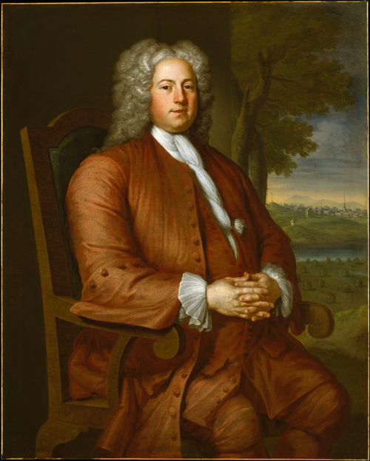

Fig. 1 John Smibert, Francis Brinley, 1729

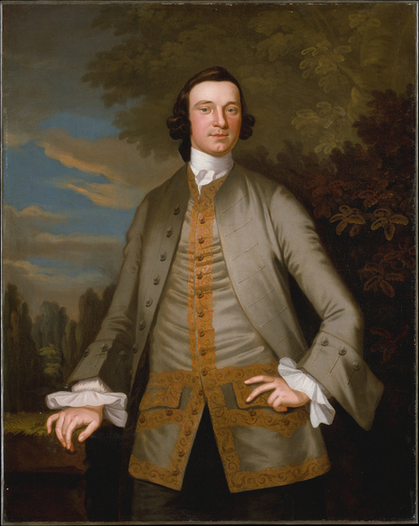

Fig. 2 John Wollaston, William Axtell, 1749-1752
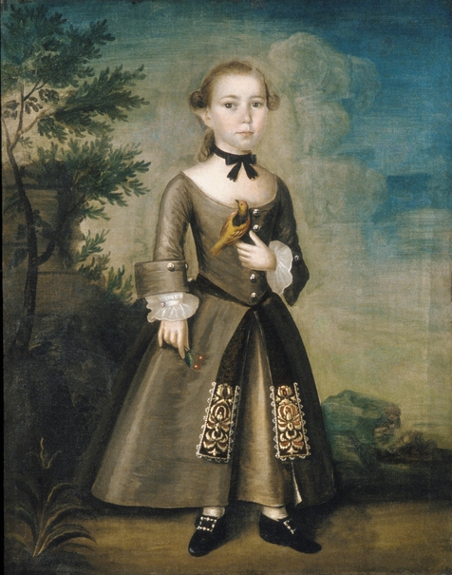
Fig. 3 Joseph Badger, James Badger, 1760

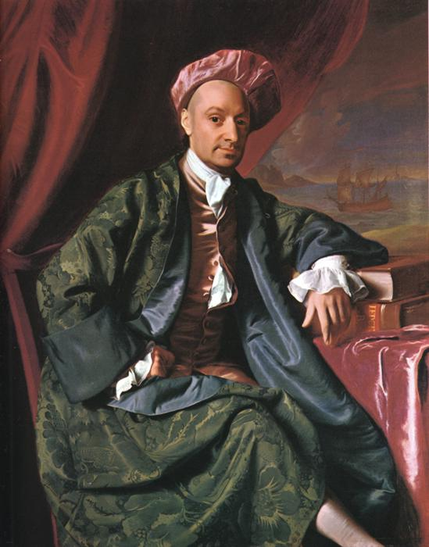

Fig. 4 John Singleton Copley, Nicholas Boylston, c1769

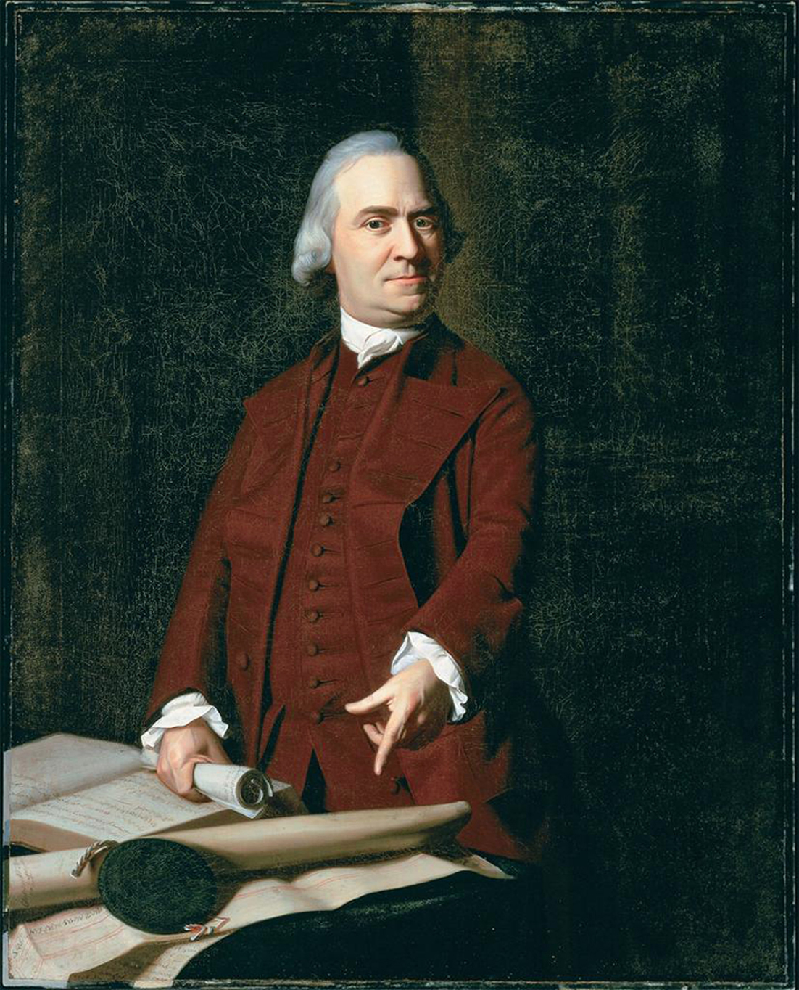
Fig. 5 John Singleton Copley, Samuel Adams, c1772

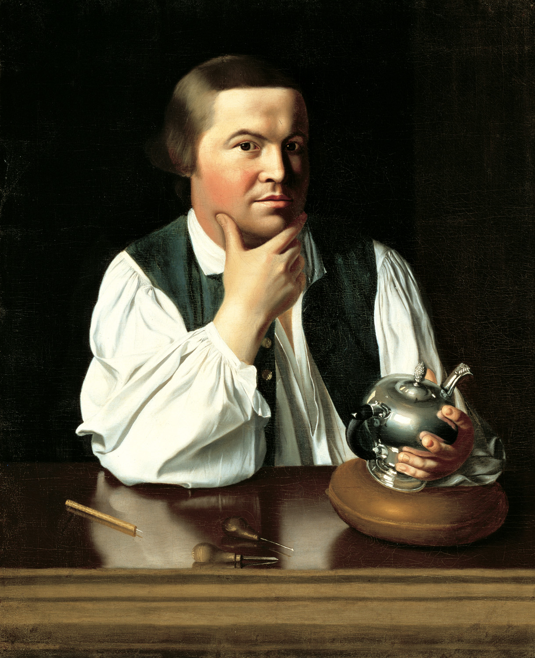

Fig. 6 John Singleton Copley, Paul Revere, 1768

Barratt, Carrie Rebora, 2003.
Linda Welters writes that the end of feudalism and the rise of the merchant class led to a new bourgeoisie who amassed wealth. In Europe, this new middle class conveyed their status by imitating court styles of dress and behavior. The Colonists did not have a court to attend, but instead emulated British fashions as aspiring members of the British aristocracy.
Chrisman-Campbell, 19; Baumgarten, 2002.
Baumgarten, 76-78.
Chrisman-Campbell, 2007; Baumgarten, 2002.
Barratt, 2003, 5.
Barratt, 2003, 10; Bayley, 335-336.
Barratt, 2003.
Carrie Rebora Barratt, 2003, indicates that the cabriole, or curved, arm suggests an old style Queen Anne chair, but is actually invented, like the compiled, contrived setting, meant to convey wealth. Having one chair, much less a set of chairs (a similar chair is used in the pendant or paired portrait of Brinley’s wife Deborah with their newborn son Francis), in the Colonies at this time, was a demonstrable show of wealth and elegance.
Barratt, 2003; Tortura and Eubank, 1989.
Tortura and Eubank, 1989; Baumgarten, 2002; Barratt, 2003.
Baumgarten states that the clothing worn on the frontier of the Colonies was both multicultural and multiracial and was tactically adopted by George Washington during the Revolutionary War to clothe the troops.
Prendergast and Prendergast, 2004; Tortura and Eubank, 1989.
Baumgarten, 2002.
Chrisman-Campbell indicates that men and women wore white linen next to their skin to protect expensive outer garments from sweat and to protect the body from itching, dirt and vermin; the wearer’s personal cleanliness was suggested by the state of the collar and cuffs, 7.
Baumgarten, 108.
As quoted in Baumgarten, 52.
Staiti, 1998.
Barrett, 2003.
Van Horn, 2009.
Prendergast and Prendergast, 560; Baumgarten, 226.
Prendergast and Predergast, 531-534.
Bushman, 64-66; Staiti, 1998.
Barrett, 2003, 11-15.
Chrisman-Campbell, 10-11, 18.
Tortora and Eubank, 1989, Chrisman-Campbell, 10-11; Baumgarten, 164-171.
Baumgarten also suggests that skirts symbolized children’s dependence, just as adult women wore skirts and were dependent on the men of their family; when boys were breeched, it symbolized leaving the woman’s sphere and entering a world where men wore the pants in the family.
Bayley, 1-4.
Chrisman-Campbell, 10-11.
Baumgarten writes that children’s garments featured the same corseting as adult clothing, which at this time were worn by men as well as women; little boys would move out of stays when they were breeched, while girls would use stays into adulthood; part of what Rousseau advocated for was freedom of movement in garments, eliminating the use of stays, and resulted in fashion trends for children that are still in use today.
Baumgarten, 160; Chrisman-Campbell, 10-11.
Bushman, 1992.
Tortora and Eubank, 203.
Van Horn, 17; Barratt, 1998.
Rebora and Staiti, 1995; Barrett, 2003.
Ibid.
Staiti, 1998.
Swain, 1976; Ribeiro, 1979; Cunningham, 1984; Fukai, et al, 2002.
Barratt, 2003.
Rebora and Staiti, 224-229; Copley painted 3 portraits of Boylston, one for a Harvard College, as a thank you to Boylston for a donation that established a professorship of rhetoric and oratory in his name; two of the three portraits feature different banyans.
Rebora and Staiti, 224-229; Weinberg and Barratt, 2009.
Ribeiro, 1995, 113.
Cunningham, 1984; Barratt writes that so beautiful were Copley’s portraits of businessmen in leisurewear that strict etiquette rules were bent by hanging these private portrayals in public spaces in the home, Barratt, 2003, 19.
Ribeiro, 1995, 112.
Staiti, 1998.
Rebora and Staiti, 1995.
Wilson, 1979; Baumgarten, 2002; Rebora and Staiti, 1995; Fukai, et al, 2002.
Wilson, 1979.
Ribeiro, 1995, 103; Rebora and Staiti, 1995.
Rebora and Staiti, 1995
Barrett, 2003, 24.
Rebora and Staiti, 275.
Barratt, 2003.
Ibid.
Ibid.
Miller, et al., 2008.
Ribeiro, 1995; Rebora and Staiti, 1995.
Rebora and Staiti, 1995; Miller, et al., 2008; Weinberg and Barratt, 2009.
Miller, et al, 124-125.
Weinberg and Barratt, 2009.
Ibid.
Miller, et al., 2008; Rebora and Staiti, 1995.
Rebora and Staiti, 1995. Bibliography Barratt, Carrie Rebora. John Singleton Copley and Margaret Kemble Cage: Turkish fashion in 18^{th-}Century America. San Diego: Putnam Foundation, 1998. Barratt, Carrie Rebora. “Faces of a New Nation: American Portraits of the 18th and Early 19th Centuries.” The Metropolitan Museum of Art Bulletin, New Series, Vol. 61, No.1 (2003): 3- 56. Baumgarten, Linda. What Clothes Reveal: The Language of Clothing in Colonial and Federal America. Williamsburg, VA: The Colonial Williamsburg Foundation, in association with Yale University Press, 2002. Bayley, Frank W. Five Colonial Artists of New England. Privately Printed: Boston, 1929. Bushman, Richard L. The Refinement of America: Persons, Houses, Cities. New York: Vintage Books, 1992. Cunningham, Patricia A. “Eighteenth Century Nightgowns: The Gentleman’s Robe in Art and Fashion.” Dress, Vol. 10 (1984): 2-10. Kimberly Chrisman-Campbell. “From Baroque Elegance to the French Revolution, 1700-1900” in Linda Welters and Abby Lillethun, Eds., The Fashion Reader: 6-19. Oxford: Berg, 2007. Fukai, Akiko, et al. Fashion, the Collection of the Kyoto Costume Institute: a History from the 18th to the 20th Century. Köln: Taschen, 2002. Miller, Angela L. et al. American Encounters: Art, History, and Cultural Identity. Upper Saddle River, NJ: Pearson Prentice Hall, 2008. Prendergast, Sara and Tom Prendergast. Fashion, Costume, and Culture: Clothing, Headware, Body Decorations, and Footwear Through the Ages. Detroit: Thomson Gale, 2004. Rebora, Carrie and Paul Staiti, Eds. John Singleton Copley in America. New York: Metropolitan Museum of Art, 1995. Ribeiro, Aileen. “The Whole Art of Dress: Costume in the Work of John Singleton Copley” in Carrie Rebora and Paul Staiti, Eds., John Singleton Copley in America: 103-113. New York: Metropolitan Museum of Art, 1995. Ribeiro, Aileen. “Turquerie: Turkish dress and English Fashion in the Eighteenth Century.” The Connoisseur, Vol. 201 (1979): 16-23. Swain, Margaret H. “Nightgown into Dressing Gown, A Study of Mens’ (sic) Nightgowns Eighteenth Century.” Costume, Vol. 6 (1976): 10-21. Staiti, Paul. “Character and Class: The Portraits of John Singleton Copley” in Marianne Doezema and Elizabeth Milroy, Eds., Reading American Art. New Haven: Yale University Press, 1998. Tortora, Phyllis and Keith Eubank. A Survey of Historic Costume. New York: Fairchild Publications, 1989. Van Horn, Jennifer. “The Mask of Civility: Portraits of Colonial Women and the Transatlantic Masquerade.” American Art, Vol. 23, No 3, (2009): 9-35. Weinberg, H. Barbara and Carrie Rebora Barratt, Eds. American Stories: Paintings of Everyday Life 1765-1915. New York: Metropolitan Museum of Art, 2009. Welters, Linda. “Introduction” to Welters, Linda and Abby Lillethun, Eds. The Fashion Reader. Oxford: Berg, 2007. Pp. 3-5. Wilson, Kax. A History of Textiles. Boulder, CO: Westview Press, 1979.

