Mourner’s Consolation:
The Power of Belief in Spirit Photography
By
Rena Tobey

©Rena Tobey, 2011
In the culture of loss following the American Civil War, yearning to reconnect with the deceased—a soldier never returned home, an infant who died, or a wife lost in childbirth—prompted the popularity of postmortem photographs and a passion for spirit photography. Spirit photographs portrayed a ghostly image near or seemingly touching a full-bodied sitter in a photographic portrait. For the sitter, this spirit extra often captured the essence, and even the resemblance, of a dearly missed relative. Despite the sensational 1869 New York trial of spirit photographer William H. Mumler, who was accused of fraud, spirit photography soared in popularity. Mumler himself, reputation in tatters in New York, returned to Boston, the place he initiated his practice, to resume his career.
What made mourners in the 1870s and beyond not only invest their money in this expensive photography, but also their beliefs in its outcome, results from a panoply of social and cultural phenomena of the Postbellum era. Close examination of a set of three photographs and related letters presents the case of Robert Bonner. Bonner, a widower, joyously believed in the veracity of the spirit extra in his portrait, recognizing his deceased wife Ella. To better understand why Robert Bonner believed so intently involves teasing out the dynamics and complexity of mourning practices, particularly in post-war periods, varying beliefs about photography as a medium of truth, post-Civil War religious phenomena, and the explosion of scientific invention and discovery. Melding these factors suggests why sitters wanted to be amazed and willingly suspended their doubt to believe in the results of spirit photography.
By the 1870s, when Robert and Ellla Bonner had their portraits made, photography was part of everyday life. Robert Bonner, though seemingly lost to history, lives through his spirit photograph (Fig. 3) and remarkable letters (Appendix A) that survive through Mumler’s self-justifying memoir. His spirit extra story begins after the death of his wife Ella. In 1872, Mumler’s wife Hannah, a medium and faith healer, was in a trance to treat a patient, when she reported that Ella appeared to her. Ella indicated she wanted to reach her husband through Bronson Murray. Murray then went to Mumler for his portrait and was “overcome by a trance,” during which Ella appeared as a spirit extra (Fig. 2). Robert Bonner saw the portrait at the home of Murray’s acquaintance Mrs. Baker, who showed him the spirit photograph.
Robert recognized his wife “as natural as life” and was “astonished and pleased.” He wrote Ella a letter and took it to a medium named Dr. Flint. Robert received the letter back, believing it unopened. It now contained Ella’s 7-page reply. She assured her husband that his brother and friend were well with her in heaven and urged him to go to Mumler for a portrait, where she would appear. Ella precisely described how she would pose in his portrait and that she would hold flowers (Fig. 3a, note differences from Ella in her own portrait, Fig. 1 and Fig. 3b). Rather absurdly to contemporary eyes, she also explains why she appeared in the portrait of “Bronson Murray, of your city, No. 238 West 52nd street (sic)….I did this, darling, in order to have it reach you.” To reiterate her message, Ella’s post-script includes, “Remember, darling, go and see the spirit-artist.”
He did go. Although Robert did not identify himself at the time of the sitting, he provided Hannah, Mumler’s wife, a letter of introduction after the exposure was made. Like most sitters, he likely did not know or understand the photographic process. He would only have experienced the iron rests to keep his head from moving during the relatively long exposure time. He would not see the glass or tin plate treated with chemicals. He would not see what happened in the dark room. He would not understand how a double exposure or combination print from several different plates would be created. What Robert did not realize was that the spirit extra would be chosen in the dark room to appear in his photograph. By providing his identity, even after the exposure was made, Robert ensured that Mumler could select the correct spirit extra to combine with his sitting.
For contemporary critics, Robert Bonner’s story manages to be both creepy and ridiculous all at once. Great care was taken to ensure that Robert was convinced of the likeness of Ella as his spirit extra. Gettysburg, PA photographer Del Hilbert uses 19th century technology to produce period-authentic glass plate and tintype photographs. He cleared up some of the mystery of the Bonner case. Since Mumler made Ella’s portrait while she was still living (Fig. 1), then she likely bought prints in the popular cabinet card size, for the mantle, photo album, or wall, or cartes de visite, small prints in affordable multiples, to share with others. Hilbert said Mumler would have kept the original glass plate, in case Ella wanted additional prints. Perhaps Mumler saw Ella’s obituary, or otherwise learned of her death, and then initiated the lure to bring Robert to the studio. Perhaps the complex ruse worked for Mumler because it resulted in a lucrative sitting fee.
Mumler’s technique had become so subtle and sophisticated that expert witnesses at his trial were unable to explain how he created his images. No matter how convinced they were that Mumler was fraudulent, without proof, the judge could not sentence him. Most spirit photographers used generic figures, such as young children or the elderly, and the faintness of the image supported recognition by the patron and other family members. Mumler’s images display remarkable subtlety these lack. Close examination of Ella’s portrait (Fig. 1)—her facial structure, the slightly hooded eyes and down-curve of her lips, the rigidity of her arms—may be seen in Murray’s portrait (Fig. 2). Tilted slightly so that her arms rest on Murray’s shoulders, her hand now holds Mumler’s favored device of a flower bouquet in the shape of an anchor, indicating steadfast love. The face is clearly Ella’s. Mumler would have combined another dress onto the figure, since Hilbert said the dark lace trim from Ella’s portrait could not have been removed. Instead the dress now is plain, except for a faint lace collar.
Even more intricate combination printing was required for Robert’s portrait with the spirit extra (Fig. 3a). As Ella described in her letter, now one hand points upward, another favored Mumler pose, indicating the couple’s reunion in heaven. In her portrait made while living, Ella holds her hat and is bareheaded, while as a spirit extra for Robert, she is crowned in flowers. Mumler needed a different arm and wreath to combine with Ella’s portrait, or as Hilbert suggested, he used a different model. If so, Mumler would have used a cutout of Ella’s face.
According to Robert’s letter, Ella’s likeness was sufficient to be recognized by relatives. He also experienced spirits beyond this sitting, with Ella and children apparently gaining the strength to materialize to him, which they previously lacked. “My wife often appears to me, and my dear little children have sat in my lap and taken my watch out of my pocket and placed it in my hand. These are stubborn facts, and no mistake.” What led Robert Bonner to be so wholly convinced of the authenticity of the spirit appearing in his portrait? A combination of cultural customs, beliefs about the nature of photography, religious values, and scientific advances primed sitters like Robert to profoundly want to believe in his spirit photograph.
In the middle of the 19th century, virtually all Americans not only followed proscribed mourning rituals, but also had to deal with the prevalence of death. Infant mortality rates were so high, estimated at 1 of 5 infants dying before their first birthday, that babies were sometimes not given names until they passed that milestone. Death beyond infancy was commonplace as well, with death rates up to 2/5 of children before age 5. Youthful Ella Bonner may have succumbed in childbirth or from disease, other common causes of death in young adults like her. Virtually all members of the family would be familiar with death and its appearance. Only the rare person had not witnessed a death.
Social customs and roles for mourners developed, with symbolic clothing and jewelry and the growing importance of cemeteries. While men were expected to control their feelings, women were emotionally, intimately, and practically involved in the culture of loss. Women sat with the sick and dying, prepared bodies for burial, wrote condolence letters, and created communities of solace for other bereaved women. Importance was placed on final words of the dying. Children were encouraged to think about death and hear cautionary words from the deathbeds of a family member.
Death and photography were connected from the beginning. Hippolyte Bayard’s witty play on the acceptability of the mourning portrait, Self-Portrait as a Drowned Man from 1840 (Fig. 4), served as a Romantic protest from the suffering artist over the lack of recognition for his role in the invention of photography. The educated viewer privileged enough to see this early image was invited to doubt the veracity of the camera, but not its acceptability as a medium for portraying death. Photography became part of the mourning ritual, targeting women in particular. For example, mothers, perhaps lacking a portrait of the deceased child while living, would now be desperate for a visual remembrance.
In this context, post-mortem photography consoled, preserved memories, reunited the family, and provided a vehicle for sharing the news of the death with others. The function of the image was not so much to keep the dead alive, but to facilitate accepting the loss. Cartes de visite of post-mortem and spirit photographs were produced to readily share with others and were much more affordable than painted portraits for the middle class. Over time, post-mortem depictions became more elaborate, progressing from simple imagery, such as a mother holding a deceased child (Fig. 5) to depicting the child in a parlor at peace (Fig. 6) to posed beautified scenes with mementos, flowers, and mourners. Whether simple or complex, the sentimental images served as a memento mori, a reminder that death will come to all. This idea in the Victorian era was not morbid, but an effort to replace painful memories of illness and death with images of comfort. This conversion allowed the photograph to serve as a therapeutic tool, promoting movement through the stages of grief.
Death of a soldier prevented this more usual kind of grieving for the family at home. Photography adapted to serve that need. During its 60-year window, spirit photography spiked in popularity around the Civil War and World War I. War meant that families of soldiers lost in battle sought closure in lieu of proper burials or the ability to say goodbye in person. The use of Civil War tintype portraits made for soldiers at the battlefield to send home, demonstrating that they were still living, meant photography already played an important role in communication with absent family members.
The rise of the commercial portrait as the predominant form of photography for the typical middle class home in part resulted from the belief that photographs captured the living quality, the selfhood of the sitter. The family might pose with a portrait of the missing person, completing the family unit (Fig. 7). By hanging that person’s portrait or placing a photograph in an album, lovingly reviewed, some essence of that person remained with the family.
These beliefs sparked deeper questions about the nature of truth in photography. Could a camera deliver a picture of reality that was truthful? Could a representation—a photograph—ever be true? Common sense suggested that photographs had a direct relationship to the world portrayed. From its invention, the camera was perceived as a scientific tool for capturing truthful, unmediated images. The photographer was considered superfluous. But the photographer was the one who paid close attention to the real thing, composing the image, while viewers were removed from that real thing. Instead viewers encountered an aesthetic image that had been framed by the photographer. The photograph became an art object, recognized as a likeness of but different from the real—a kind of illusion. Truthfulness in photography was a murky issue.
In 19th century portrait photography, whether or not the photograph was true to the character of the sitter was less important than whether the image was convincing. Sitters often appeared with stilted facial expressions and poses held during long exposures and standardized objects and costumes that might or might not have represented their personality. Since photographs were understood as illusions, offering a representation of reality, viewers willingly suspended their disbelief. By receiving a tintype made during a soldier son’s absence, the family at home could be convinced that he was still living, whether or not that was true.
During and after the devastating war, a spirit photograph similarly convinced viewers that the essence depicted was a beloved person. Questions of truth were raised again, including can photographs image a soul? Can viewers see a spiritual truth? In 1863, skeptical Oliver Wendell Holmes charged that spirit photography sitters suffered from wishful thinking or delusion. But what was irrelevant to the patron of spirit photography was whether the image was true to others. What mattered was that the sitter was convinced by the representation.
The camera had already evolved into an expressive medium, rather than one that presented the literal truth. By the 1850s, Henry Peach Robinson artfully placed figures at a deathbed, suggesting a coherent scene. The image actually combined several poses and settings, from a recognizable repertoire (Fig. 8). During the Civil War, photographers reached many more viewers with their images. Alexander Gardner moved corpses and arranged scenes of the aftermath of battles, manipulated for drama and composition. These images were understood by the public as true in a larger sense. They were presented an approximation of the real thing, an abstraction of the real world, all with convincing verisimilitude. Spirit photography used this understanding of representation, joining the repertory of visual imagery facilitating healing after loss. The disembodied spirit embodied truth for the patron. The photographer’s role was to find that truth and represent it, to “fix” the image by whatever means. The spirit photograph consoled mourners with an image of connection, peace, and hope for reunion in heaven, as Ella indicated to Robert—a truth more esoteric than literal.
Similar needs during and after wartime, on top of childhood disease and death, drove the popularity of less traditional religious beliefs and practices that offered consolation to those left behind. In this culture of grief, mourning, and loss, Spiritualist and Swendenborgian beliefs strengthened after the Civil War. They espoused specific values that comforted mourners with visions of the afterlife. Photography helped mourners accept God’s will of death and loss, while symbolically keeping the dead alive.
The inherent contradiction of accepting death while keeping the dead alive was at the heart of both these religious practices. Followers of Emanuel Swendenborg believed that only a veil divided heaven and earth and that for believers, heavenly life began immediately after death. Swedenborgians believed that the deceased continued to engage in activities of spiritual development, an endless process. Spirit photography was readily seen as capturing this process of life shifting into the beyond. Spiritualism, which gained tremendous popularity after the Civil War, shared beliefs about an afterlife. Spiritualists posited that spirits inhabited an invisible world as immaterial entities. The soul’s journey between the present world and the afterlife could be materialized through mediums with trance or mesmerism to increase sensitivity and power to communicate with spirits. Spiritualist experiences were not far removed from Christianity’s tradition of visitations, prophecy, and visionary miracles.
With the prevalence of these religious practices, the photography studio became a place of spiritual revelation. The camera itself served as a natural extension of the medium’s sensitivity, with the magical ability to record elements the eye could not see. Spiritualist mediums in the studio were often women connecting to a woman spirit, symbolic of the Separate Sphere ideology that recognized women as moral and spiritual authorities in their domestic sphere.
Gender ideologies created a schism between the dominant philosophies of the era—the Enlightenment and Romanticism. Enlightenment scientists, most often men, were considered rational and knowledge-driven, opposed to anything lacking proof. Romanticism centered on emotional expression, associated with feminine sensibility. Even though men, like Robert Bonner suggests in his letters, held Spiritualist beliefs, and women may have pursued science, the two worlds were strongly gendered. Competing attitudes provoked tension between religion and art with science, linked to these entrenched gender roles. The middle class family ideal embraced both the rational and the sentimental, the Enlightenment and the Romantic, through the co-existence of the Public and Private Spheres.
Cracks did appear in the entrenchment, and Spiritualism and spirit photography played a part. Women mediums expanded the scope of Spiritualism beyond the home into the Public Sphere of commerce, such as Hannah Mumler assisting her husband to connect with spirits. With more women taking up photography as a hobby, and even as a profession, they became both the makers and consumers of photographs. Further, Spiritualists used spirit photography to bring modern technology together with religious belief, reconciling reason with faith—the paradoxical joining of the scientific with the ineffable.
With technological advances, the scientific community again used the camera for its “indifferent eye and unerring ability to arrest the truth,” resurrecting early beliefs about the medium. Faster shutter speeds allowed photographs to record observations, scrutinize experimental results, and create proof. Different from the aesthetic understanding viewers brought to the post-mortem photographs, scientists trusted photography to make an authentic, reliable record.. Spiritualists used that attitude to create scientific experiments to rationally prove their belief systems. They employed spirit photography as proof of the afterlife, closing the gap between rational and spiritual phenomena with this evidence. Consequently, both religion and science had vested interest in the outcome of Mumler’s 1869 spirit photography trial. Each side, faith versus skepticism, became more rooted in their stands. Like Oliver Wendell Holmes, scientists argued that spirit photography defied credibility and that only the grieving would be vulnerable enough to be tricked.
Yet scientists themselves had a hard time explaining burgeoning technological developments. Scientific photography could now capture the invisible—photo-microscopy of bacteria, radiographs, and in the 1890s, most spectacularly, the X-ray. X-rays demonstrated the seemingly impossible, fascinating viewers at fairs, theatrical spectacles, and high society parties with the ability to reveal the concealed.
Ironically, these scientific developments made spirit photography more credible. Each advance generated renewed interest in the claims of Spiritualists that photography acted as a medium for capturing invisible essences, allowing viewers to see the unexplainable. No wonder, when the photographic process was still mysterious, it was called a ‘black art’ by the resistant. This era of suspicion and demystification also was dominated by the appeal of novelty, the strange, and the awesome found in technological wonders. Fascination with making the invisible visible kept interest in spirit photography alive, whether as a photographic amusement or by joining the dialogue about “haunted media” like the telegraph. Scientists expected objective truth in photography and believed sitters for spirit photographs were gullible. But science itself taught viewers to believe in the invisible.
The real power of spirit photography came from a conflation of cultural and social forces into a passion of belief. The viewer interpreted or was led to make meaning of the truth of the image. To assume that 19th century viewers were less discerning or naive is simplistic. Instead, on some level, spirit photography patrons understood the images to be aesthetic abstractions, providing profound comfort. Sitters wanted to be amazed and wanted relief from grief. Whether Robert Bonner willingly suspended his disbelief or had faith in the spirit afterlife, the photographs convinced him. He wanted to believe in their veracity, and consequently, he did believe. Whether or not the image was real was irrelevant.
For others, the seemingly inexplicable spirit images reunited their family, intact once more, captured for eternity on glass, tin, or in paper prints. Perhaps the survivors could finally give solider spirits rest in lieu of a proper burial. Grieving parents could take comfort in a child’s happiness in heaven. No matter what religious platform propelled the patron to spirit photography—the Christian memento mori, reminding viewers that all must die, or Spiritualist proof of the soul’s immortality—the comforting images showed the spirit at peace. Prejudices melted in the emotional sentiment of the image, and psychological healing of the trauma of loss could begin in earnest. So even as science improved and life expectancy rose with each decade in the 19th century, old beliefs of fatalism about death could still dominate over new technologies. Spirit photography maintained its captivating appeal.
Its popularity continued into the new century, peaking after World War I. As the technology developed, so too did the depictions of spirits in the images. At the end of the 19th century, images captured fluids, representing the struggle of the medium with the spirit. Into the 20th century, before the glut of images dampened the persuasive power of spirit photography, it took yet another new form. The spirit’s message as ectoplasm burst out of the medium’s mouth or other body parts. Were these images credible? Were they objectively derived depictions of scientific experiments as Spiritualists argued? The schism between skeptics and believers did not really matter. What mattered was how much believers wanted to believe. A combination of aesthetic, cultural, philosophical, religious, and scientific factors conspired, just like the combination print utilized by spirit photographers, to create the conditions for belief. Believe they did. Even today, that belief carries on.

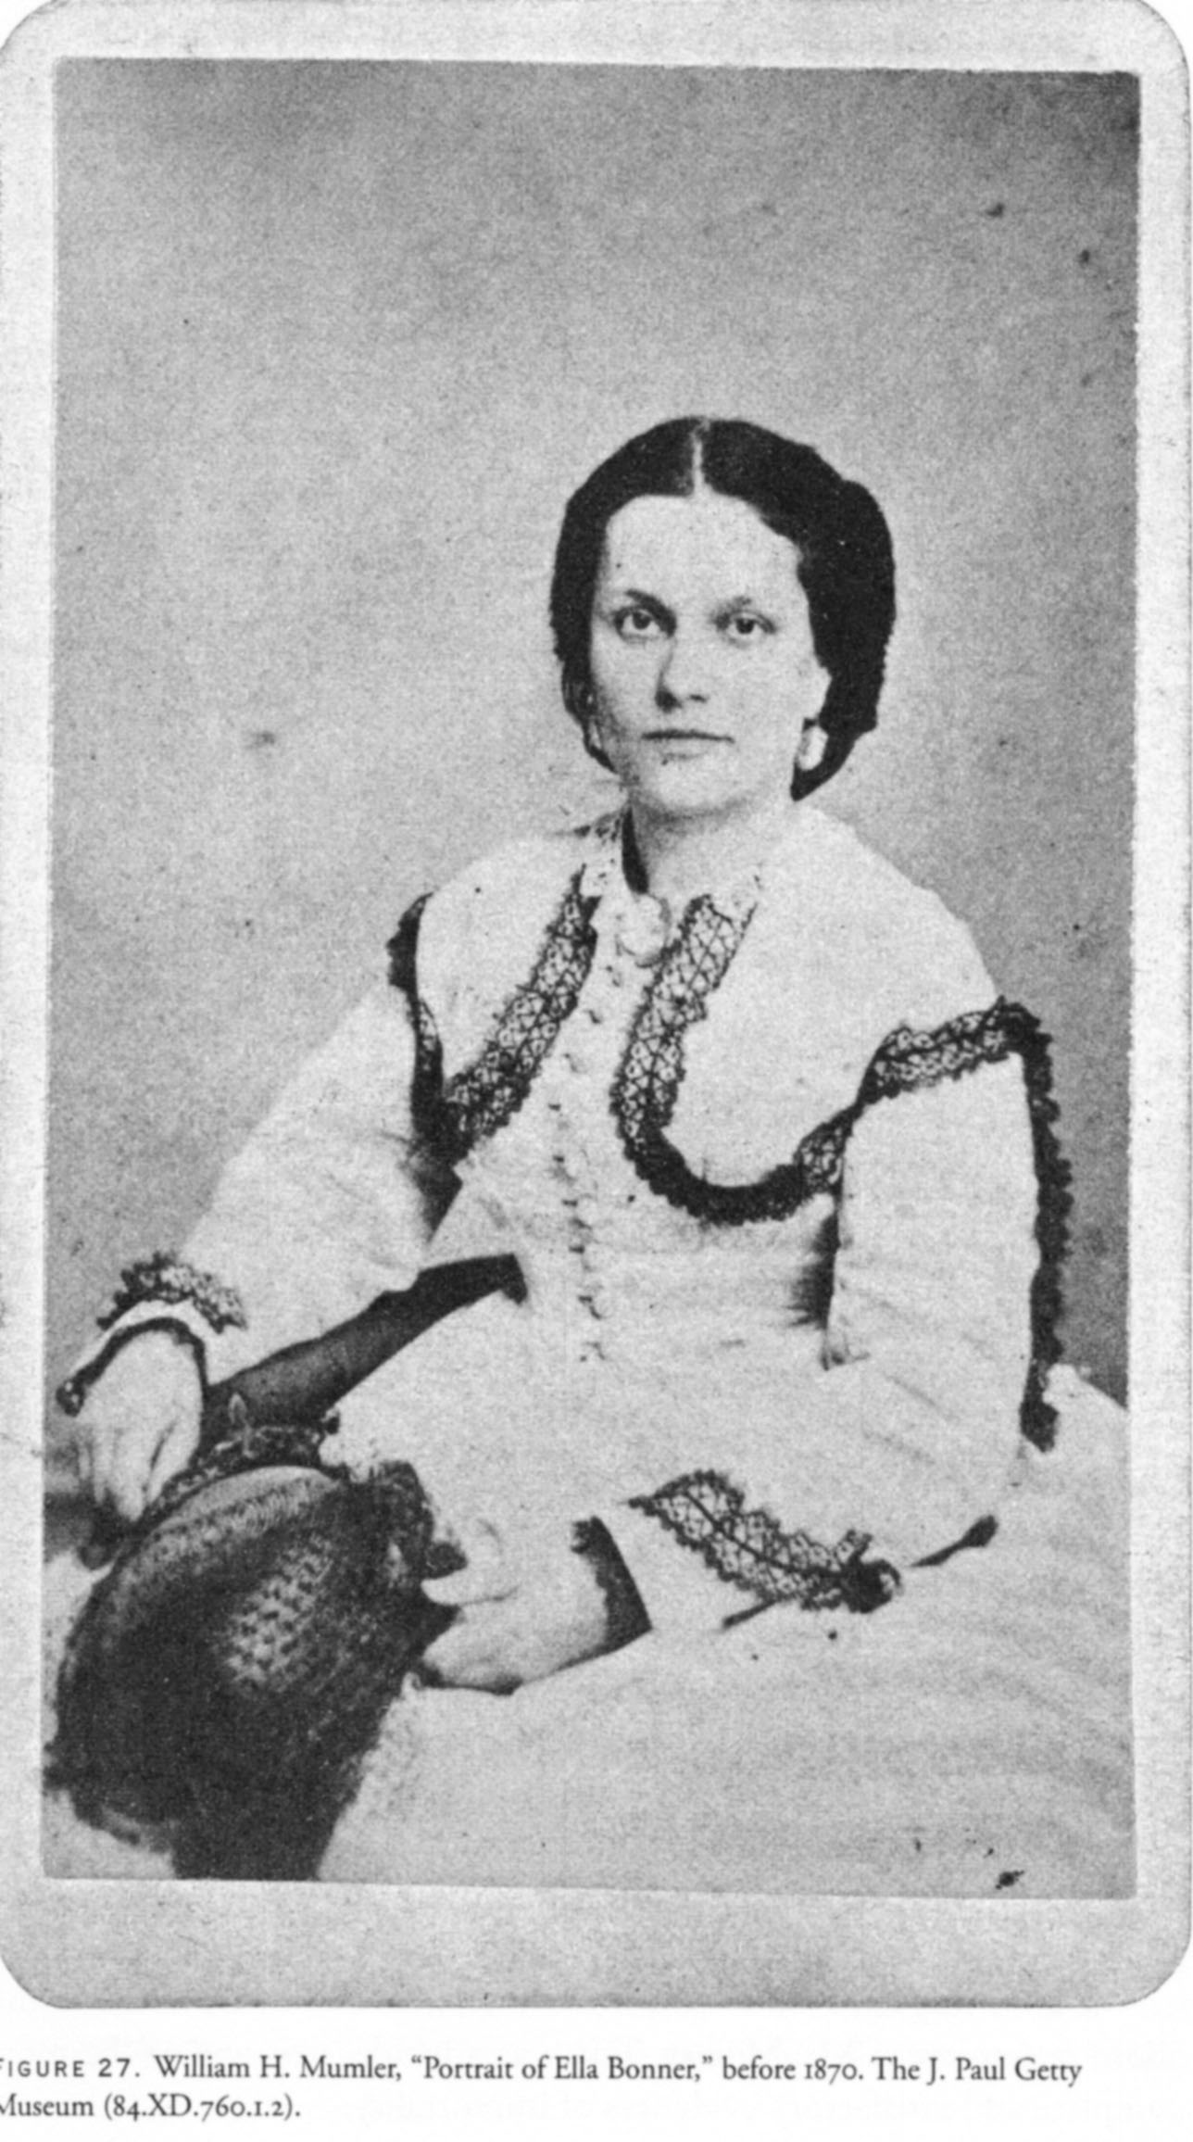
Fig. 1 William H. Mumler, Portrait of Ella Bonner, before 1870

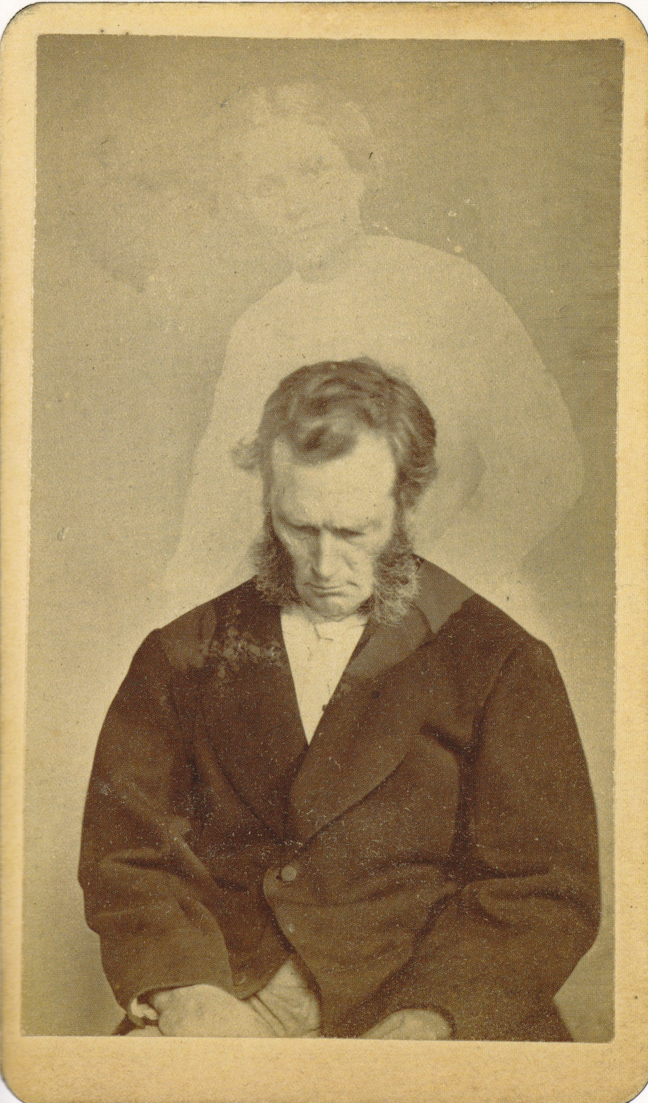
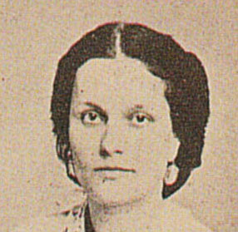

Fig. 2 William H. Mumler, Bronson Murray in a Trance with the Spirit of Ella Bonner, 1872
With inset of Ella’s head from her Mumler portrait

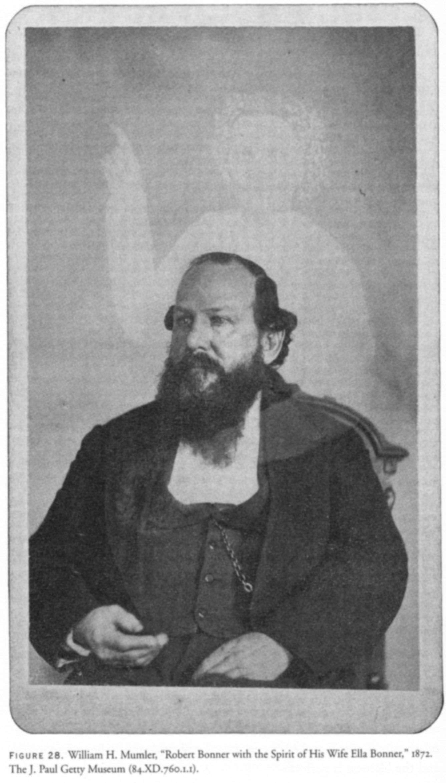
Fig. 3a (left)
William H. Mumler,
“Robert Bonner with the Spirit of his Wife Ella Bonner”
1872

Fig. 3b (below)
Side by side comparison of Ella Bonner portrait and portrait of Robert Bonner with spirit extra

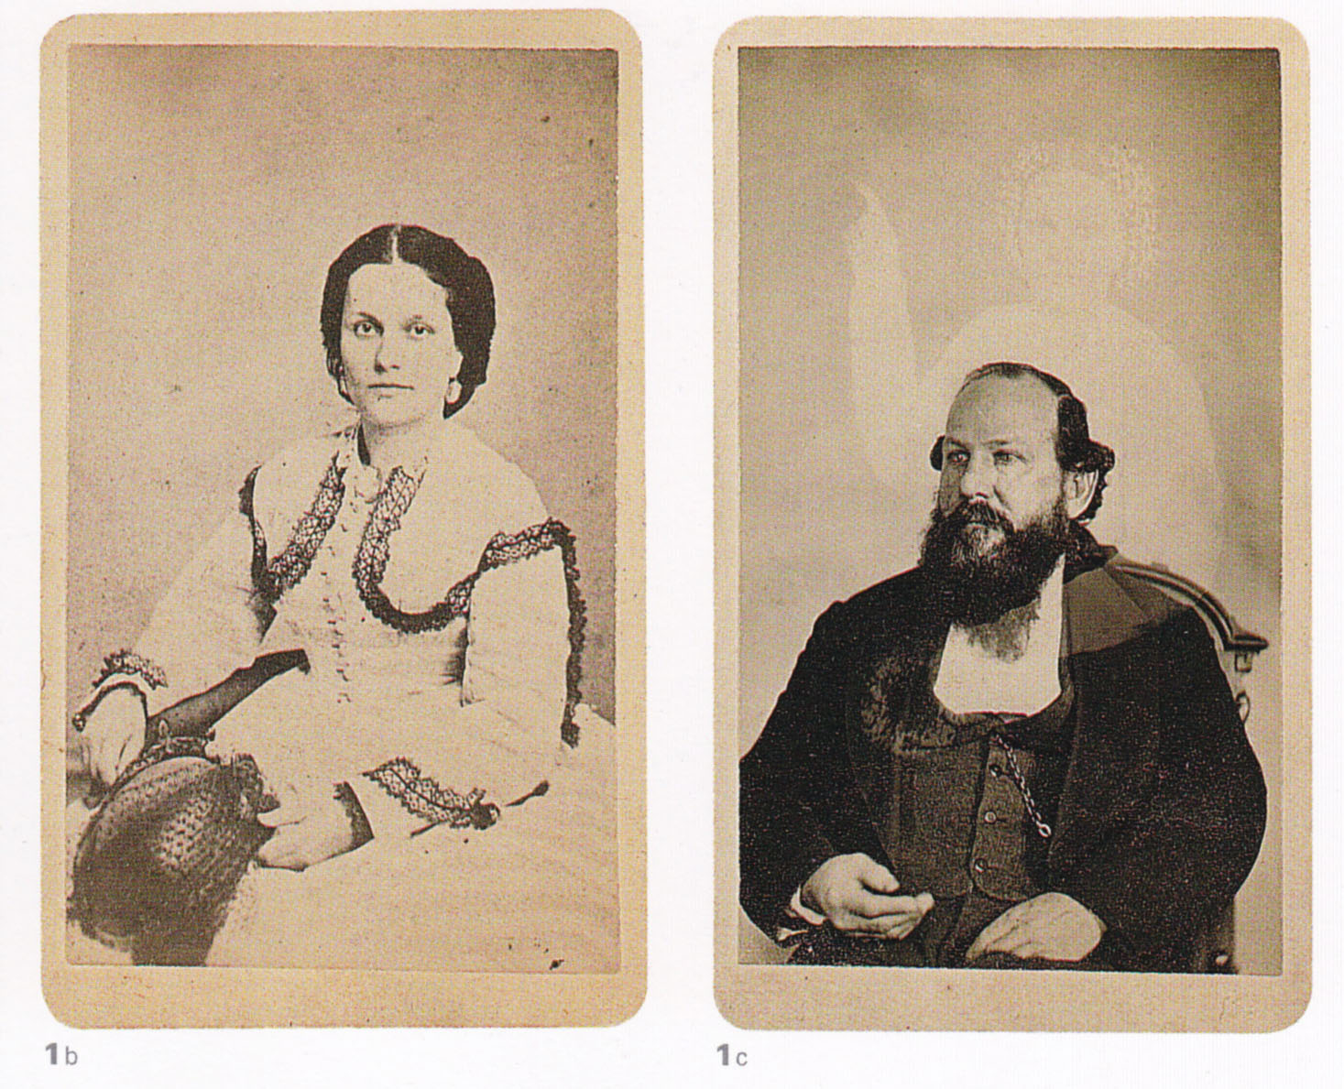

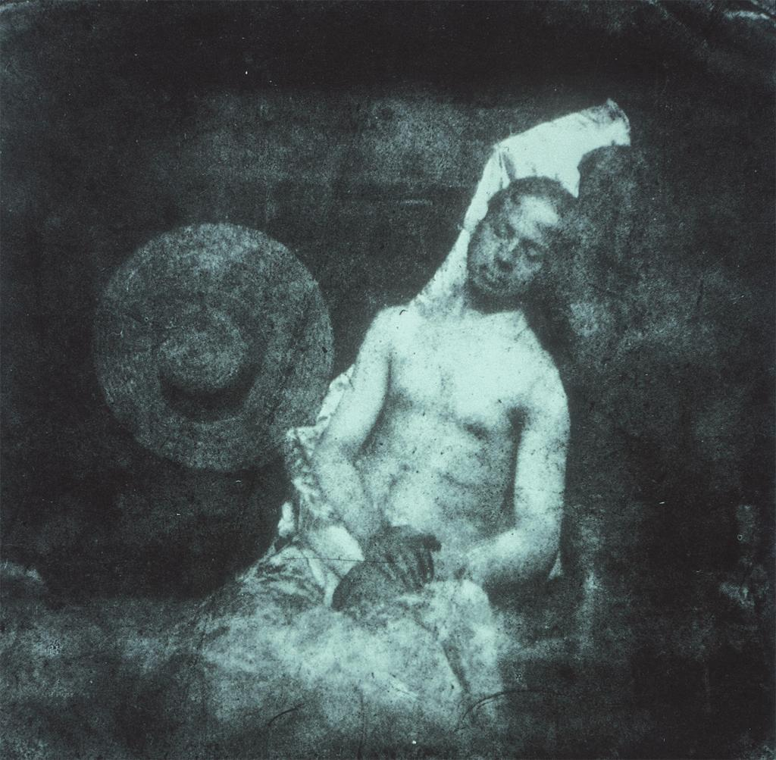

Fig. 4 Hippolyte Bayard, Self-Portrait as a Drowned Man, 1840
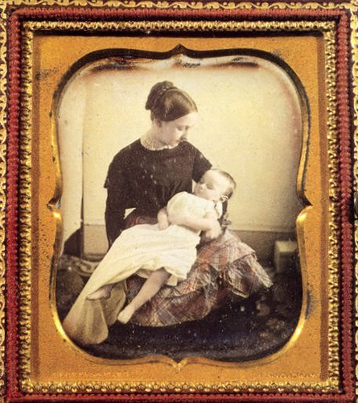

Fig. 5 Daguerreotype of young mother holding her dead baby

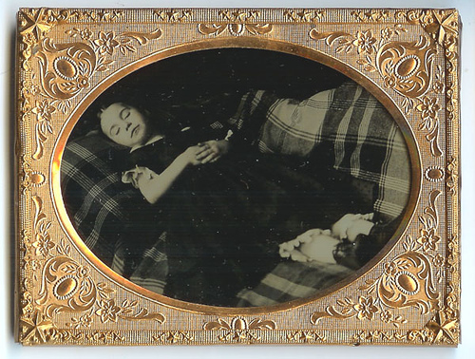
Fig. 6 Postmortem ambrotype, c1850s, of a dead young girl about age 4 or 5, placed on a plaid covered bed

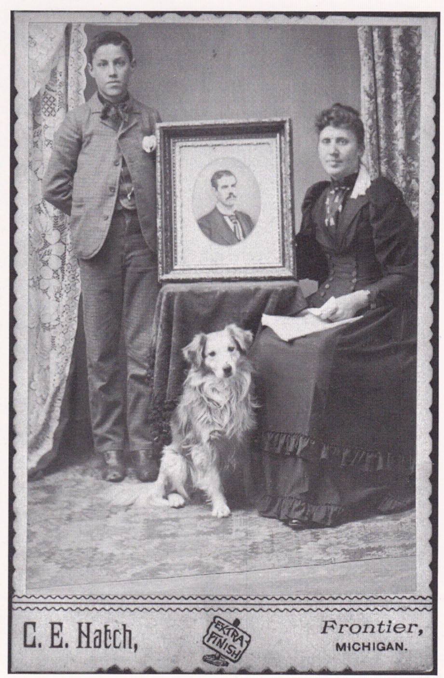
Fig. 7
Gelatin silver print on cardboard mount, cabinet card, c1880s

Creating/completing a family unit with a photograph, don’t know if the man is missing, away on business, or deceased

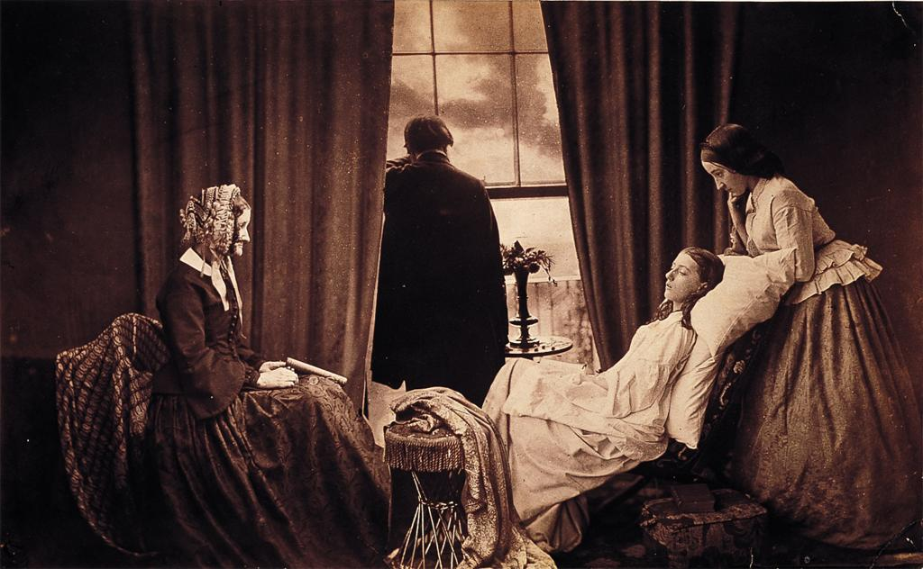

Fig. 8 Henry Peach Robinson, Fading Away, 1858
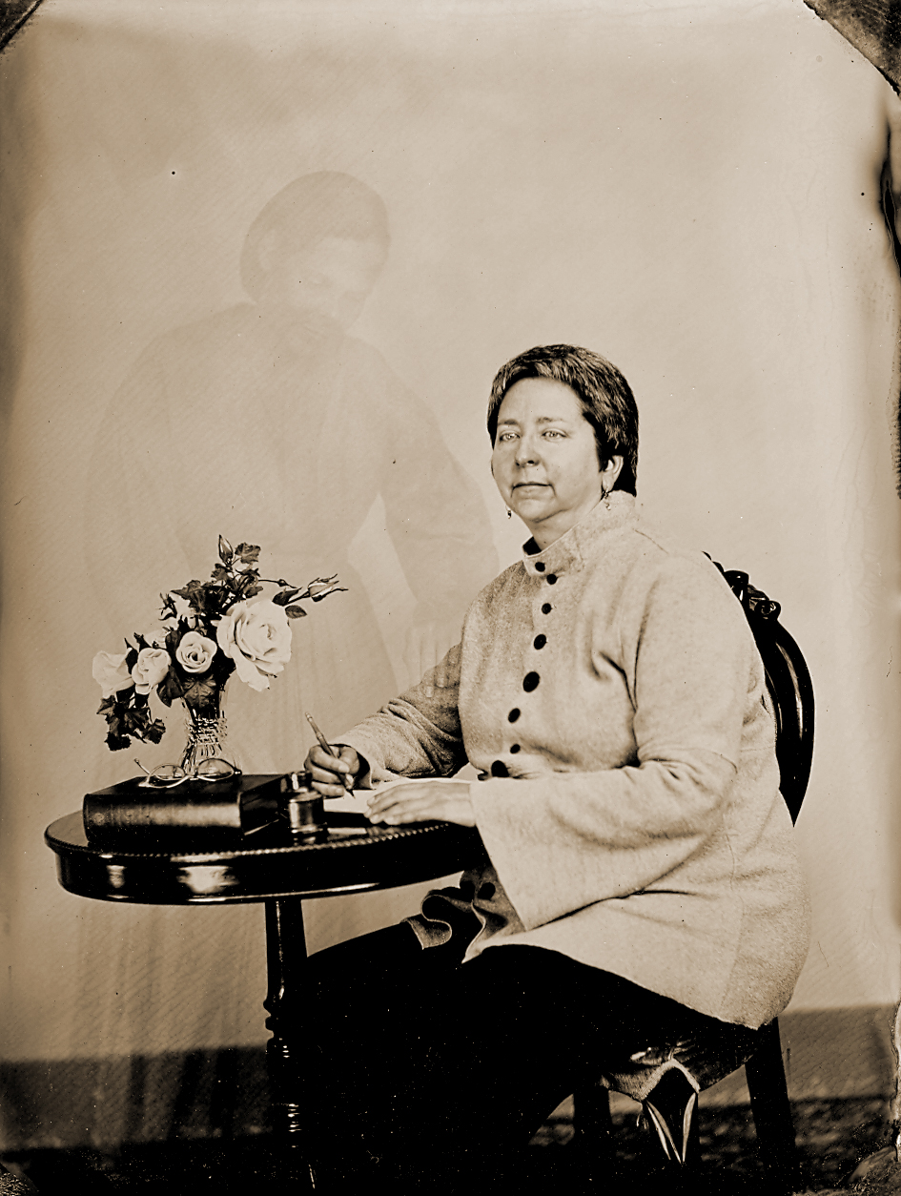
Fig. 9 Rena Tobey is visited by a spirit extra while writing this paper, tintype, 2011

Kaplan, 2008, provides primary documents from Mumler’s trial and a transcript of his memoir; Kaplan suggests only 3 original copies of his memoir are known.
Quoted in the transcript of Mumler’s memoir in Kaplan, 2008, 122, see Appendix A for full transcript.
Quoted in the transcript of Mumler’s memoir in Kaplan, 2008, 125, see Appendix A for full transcript.
Quoted in the transcript of Mumler’s memoir in Kaplan, 2008, 127, see Appendix A for full transcript.
Ibid.
The author’s experience of having a tintype made involved a 25 second exposure.
Several discuss how spirit photographs were made in the dark room, perhaps starting with an accidental double exposure from an insufficiently cleaned glass plate, such as Mumler, progressing to more sophisticated combination prints: Coates, 1973; Fraprie and Woodbury, 1973; Kaplan, 2008; Leja, 2006; and Permutt, 1983.
Del Hilbert, Victorian Photography Studio, Gettysburg, PA, graciously answered technical questions while also demonstrating every aspect of creating a tintype for the author. The method for having a spirit extra appear on the direct-to-positive tintype was different from what was used for Bonner. Combination printing used by Mumler required several glass plates and the ability to print portions of those plates onto one paper print. The author’s spirit extra appeared in the image at the beginning and left during exposure, creating a photographic amusement, rather than the deceptive illusion of the spirit extra appearing without the sitter’s knowledge.
Leja reports that Mumler charged $10 for 12 cartes de visite, about five times the going rate.
Hearn, 29-30; Schoonover, 33.
Quoted in the transcript of Mumler’s memoir in Kaplan, 2008, 127, see Appendix A for full transcript.
Ruby, 160; Norfleet, 11-12, estimates much high death rates, up to 1/3 for the same age range, since unrecorded infant deaths made more statistical calculations difficult.
Ruby, 60; Tucker, 87; Van Setten, 820, 830.
Kaplan, 2008, 4; Norfleet, 11-12; Ruby, 7, 104-110.
Ruby, 60; Tucker, 87.
Marien, 16.
Kaplan, 2008, 10.
Ruby, 43-44; he also notes that even pets were commemorated with post-mortem photos, 89.
Norfleet, 11-12.
Ibid; Kaplan, 2003, 22; Norfleet, 11-12, 95-96; Ruby, 27, discusses how the availability and relatively affordable pricing of photography drove more expensive painted mortuary and mourning portraits out of business; Van Setten, 820-823, 829-830.
Ruby, 9.
Spirit photography was prevalent between 1870 and 1930. Before 1870, photography was considered too complex for investigating the occult, and after 1930, its use in scientific research had become routine, Chéroux and Fisher, 14-15; Permutt, 1983, also suggests interest waxes and wanes depending on wars; Kaplan, 2008, 227-234.
Marien, 2006.
Orvell, 88-89.
Crary and others raise these questions, but Crary writes that spirit photography is outside the bounds of questions of the “reality effect,” 122-124.
Hall-Duncan, 7.
Edgar Allen Poe in 1840 famously wrote about the supreme perfection of the daguerreotype as “a more absolute truth, a more perfect identity of aspect with the ting represented” from text reprinted from Alexander’s Weekly Messenger, January 15, 1840, http://www.eapoe.org/works/misc/dgtypea.htm
Ruby, 61, writes that photo portraits were recognizable reproductions revealing little personal about the sitter, but instead showed sitters in stock poses in their Sunday best clothing; also on pages 160-162, he suggests that placing the photo on a mantel, placing it in an album, converts these photos to art objects that loose their meaning outside the family and the context of the home; Hall-Duncan, 7-8.
Schoonover, 33.
Orvell discusses the illusion created by photography as a form of fantasy and entertainment popular with Victorians rather than truth, suggesting that viewers become immersed in the “artificial realism” and “conscious simulacrum” of the world of images, 77-86.
Kaplan, 2003, 19-20.
Kaplan, 2003, 21.
Marien, 110-111.
Hall-Duncan, 7.
Orvell, 89, 95-99.
Ruby, 174.
Kaplan, 2008, Spiritualism also emerged to counteract the urbanized, industrialized society, 4.
Tucker, 76-77.
Harvey, 27-28; Kaplan, 2008, 3-6, discusses how Spiritualism was aligned with progression reforms and championed women’s rights, supporting the power of women as mediums.
Harvey, 27-28.
Harvey, 9; Schoonover, 31-33.
Tucker, 84-86, 124.
Tucker, 124-125; Van Setten, 822-823.
Harvey, 7.
Schoonover, 36.
Hall-Duncan, 7.
Kaplan, 2008, 4-9, Harvey, 128.
Leja and Chéroux and Fisher provide detailed accounts of the trial, and Kaplan, 2008 suggests that Spiritualism was really on trial, in both the courtroom and tabloids, more than Mumler himself, accounting for his acquittal; he also discusses how each side hardened their stances. Hearn and Coates typify the skeptic and faith arguments respectively, each advocating with conviction their take on Mumler. Tucker on Mumler and scientists, 76-83.
Permutt, 21-24.
Case, 43; Chéroux, 114-116; Coates, xx; Kaplan, 2003, 19; Norfleet, 12-14; Pamboukian, 56.
Kaplan, 2008, 211-212, includes radio and television in their early invention eras, called ghosts in a machine.
Hall-Duncan, 7-9.
Orvell, 88-89; Tucker, 165-169.
Norfleet, 12-14.
In the Chéroux and Fisher, 2004, introductory essay, the authors recount the history of spirit photography, dividing the images into these phases of development.
Tips on Spirit Photography by Dale Kaczmarek, a believer for photographing ghosts: http://ghostresearch.org/ghostpics/articles/tips.html Selected Bibliography Case, Charles. “The Ghost and Mr. Mumler: Immersed in Death and Sorrow, 1860s America was fertile ground for a man who claimed the power to photograph spirits.” American History, Vol. 43, No. 1: 42-49. Chéroux, Clément and Andreas Fisher. The Perfect Medium: Photography and the Occult. New Haven: Yale University Press, 2004. Chéroux, Clément. “Ghost Dialectics: Spirit Photography in Entertainment and Belief” in Clément Chéroux and Andreas Fisher, Eds., The Perfect Medium: Photography and the Occult: 45-71. New Haven: Yale University Press, 2004. Chéroux, Clément, “Photographs of Fluids: An Alphabet of Invisible Rays” in Clément Chéroux and Andreas Fisher, Eds., The Perfect Medium: Photography and the Occult: 114-167. New Haven: Yale University Press, 2004. Cloutier, Crista. “Mumler’s Ghosts” in Clément Chéroux and Andreas Fisher, Eds., The Perfect Medium: Photography and the Occult: 20-27. New Haven: Yale University Press, 2004. Coates, James. Photographing the Invisible: Practical Studies in Spirit Photography, Spirit Portraiture, and other Rare but Allied Phenomena. New York: Arno Press, 1973. Crary, Jonathan. Techniques of the Observer: On Vision and Modernity in the Nineteenth Century. Cambridge, MIT Press, 1990. Fraprie, Frank R. and Walter E. Woodbury. Photographic Amusements: Including Tricks and Unusual or Novel Effects Obtainable with the Camera. New York: Arno Press, 1973, 10th edition (first edition 1896). Hall-Duncan, Nancy. Photographic Truth. Greenwich, CT: Bruce Museum Associates, Inc., 1988. Harvey, John. Photography and Spirit. London: Reaktion Books, 2007. Hearn, Lafcadio. Spirit Photography: How Intelligent People May be Humbugged, the Method Wherein a Cincinnati Artist Carries on Business. Los Angeles: John Murray, 1933. Kaplan, Louis. The Strange Case of William Mumler Spirit Photographer. Minneapolis: University of Minnesota Press, 2008. Kaplan, Louis. “Where the Paranoid Meets the Paranormal: Speculations on Spirit Photography.” Art Journal, Vol. 62, No. 3 (Autumn, 2003): 18-29. Leja, Michael. Looking Askance: Skepticism and American Art from Eakins to Duchamp. Berkeley: University of California Press, 2006. Marien, Mary Warner. Photography: A Cultural History, Second Edition. Upper Saddle River, NJ: Pearson Prentice Hall, 2006. Norfleet, Barbara P. Looking at Death. Boston: David R. Godine, Publisher, Inc., 1993. Orvell, Miles. The Real Thing: Imitation and Authenticity in American Culture, 1880-1940. Chapel Hill: University of North Carolina Press, 1989. Pamboukian, Sylvia. “Looking Radiant: Science, Photography and the X-ray Craze of 1896.” Victorian Review, Vol. 27, No. 2 (2001): 56-74. Permutt, Cyril. Beyond the Spectrum: A Survey of Supernormal Photography. Cambridge, England: Patrick Stephens Limited, 1983. Ruby, Jay. Secure the Shadow: Death and Photography in America. Cambridge, MA: MIT Press, 1995. Schoonover, Karl. “Ectoplasms, Evanescence, and Photography.” Art Journal, Vol. 62, No. 3 (Autumn, 2003): 30-43. Tucker, Jennifer. Nature Exposed: Photography as Eyewitness in Victorian Science. Baltimore: Johns Hopkins University Press, 2005. Van Setten, Henk. “Album Angels: Parent-Child Relations as Reflected in 19th-Century Photos, Made After the Death of a Child.” Journal of Psychohistory, Vol. 26, No. 4 (1999), 819-834.

