Modern Girls by the Modern Artists
Sofonisba Anguissola and John Singer Sargent
By Rena Tobey
November 2012

©Rena Tobey
Times may have changed politically, economically, technologically, and even socially from Renaissance Italy to late 19th century France, but the role of women and girls in society remained essentially the same. Despite this stasis, artists of each era prod the boundaries that define women’s place, creating depictions that are fresh and modern even today. Sofonisba Anguissola (1532-1625), the best-known 16th century, Italian woman artist, with The Chess Game, 1555 (Fig. 1), and John Singer Sargent (1856-1925), the American ex-patriot painter in France in The Daughters of Edward Darley Boit, 1882 (Fig. 2), paint breakthrough works for their era.
Each painting, created early in the artist’s career, suggests a freshness unencumbered by success and its resulting patronage. Anguissola innovates with content and by inventing a new genre of painting. Sargent, through provocative composition and style, presents a new way of looking at a familiar subject, inviting interpretations threaded with symbolism that shift with each philosophical reading. A close look at the paintings unveils the layers of meaning, both projected by the artist and by those who followed, resulting in the revelation that Anguissola’s painting is as modern and compelling as the better known Sargent work.
Despite the double barrier of being a woman artist depicting women, Anguissola matches Sargent’s bravura, stroke for stroke, literally, metaphorically, and symbolically. Sargent’s painting, acknowledged as a masterwork of modernity, can serve as a backdrop for understanding Anguissola’s ‘avant-garde’ portrayal of women in The Chess Game. Each painting centers on young girls, sisters who represent their time and place, and each work comments more broadly on the role of women in society. Each formally innovates in the art world. Comparing the content reveals daring narrative elements, including how the girls are portrayed, the relationships among them, and how that affects reading the central action.
Anguissola was a standout in a family of remarkable women. Her progressive parents provided a classically-derived Humanist education for all six daughters and the late-in-marriage son. In a time when many thought women were incapable of learning, the Anguissola sisters were considered marvelous for their ability to read Latin, play instruments, and excel at art. The eldest, Anguissola, demonstrated such strong artistic potential, that her father Amilcare apprenticed her and her sister Elena to two well-known male artists. Amilcare hoped that their resulting skills would earn prominence for the family, as well as money desperately needed for marital dowries. Anguissola’s career, which included working at the Court of Spain, did bring recognition, and even fame, to her birthplace Cremona, as well as Palermo and Genoa, where she resided later.
In her own day, she achieved recognition from Giorgio Vasari, the first art historian, in his famous volumes of artist biographies. His attention brought broader interest in her, repeating the compliment from the Spanish court that called Anguissola a miracolo. He praises her womanly graces, equal to, if not more important than, her exceptional painting skill. By commenting on her feminine virtues, Vasari assured his readers that Anguissola was in harmony with societal mores.
Women’s roles in the Italian Renaissance were defined and refined in Baldassare Castiglione’s Book of the Courtier, from 1528. He emphasized the importance of women receiving Humanist education to develop charm. For Castiglione, charm was a key attribute for any woman, along with modesty, patience, and virtue. Similarly, Anguissola’s works were often noted for their charm. She signs her work “Virgo,” to clearly declare her virginity and moral purity, dispelling any doubt about her virtuousness in a profession that might have suggested otherwise. On The Chess Game, her signature states “Maiden, daughter of Amilcare,” again proclaiming her appropriate roles and status, constructing her image as a virgin and daughter.
In a time when women’s identities were connected with the prominence of their marriage and the inability to meet dowry pressures led women into convents, Anguissola stands out as a woman who established her career long before she ever married. Independent enough to live as a single woman in a foreign country, bold enough to declare her work worthy of attention with her signature, Anguissola asks to be considered beyond her charm. She presents herself as comparable to any male artist, notable for her dazzling painterly skill. She pushes the customs of her day, redefining women’s ability to be considered a fine artist, not simply a craftsperson, and serves as a model for her younger sisters and generations of women artists to come.
Little had changed by the late 19th century, when Sargent was embarking on painting in society. Women still vied for powerful marriages, cultivating the charms necessary to secure their futures. Even as psychology as a field was growing in societal awareness, women’s identities were fluid enough to shift when entering a new family system. Early in his career, Sargent has the freedom to paint a very modern picture of four modern girls, daughters of his friends Ned and Isa Boit. Perhaps unwittingly, he gives a peek into the shadows and interiority behind the societal demands of upper-class girls growing up.
Both Anguissola and Sargent allow viewers into a world of privilege, of well-born girls, protected by class and leisure, with the resulting expectations on their future choices. For these types of girls to be featured in a portrait had precedents. Because the sitters are known and recognizable, and each artist would become known as a portraitist, the paintings suggest themselves as group portraits, or conversation pieces. However the paintings are also more complex than conventional portraiture. The artists have made unusual choices in how the figures are portrayed.
Anguissola is forced to paint within the confines of her protected world. Not being allowed an artistic education that included life drawing, she naturally turns to a subject she knows well—her family, in their intimate surroundings. The authority on her subjects, the artist presents them poignantly, particularly, and insightfully. The painting is not just a static portrait, stiffly absent of emotion, but suggests the figures have been interrupted in the middle of action.
In this snapshot of stopped action, Anguissola is credited with inventing a new type of painting—scenes of everyday life, or genre scenes. She layers the familiar and the personal, not the heroic, on top of the conventions of formal portraiture. The informal figures are shown as individual portraits unified by the action, by the narrative, so that meaning beyond formal portraiture conventions becomes possible. Anguissola converts a potential liability, restrictions placed on her as a woman artist, into an asset. Beginning with The Chess Game, she pioneers this new type of painting in a series of remarkable family genre scenes made in the 1550s.
Her ‘invenzione’ demonstrates her intellect through the ability to conceive and enact something new. In addition, her drawing skill, as praised by Michelangelo, was also considered an intellectual achievement, more typical of male artists. Even so, focusing on the enjoyment of an everyday moment, the heart of genre painting in the 16th century, led some to dismiss Anguissola’s work as sentimental.
Not so with Sargent’s scene, in which he is also credited with inventing a new type of painting—the blending of portraiture with interiors, a subcategory of genre painting. Even so, his central compositional element, figures in an interior, references familiar art of the past. The unconventional composition of The Daughters of Edward Darley Boit is what bothered critics more. But far from dismissed, the painting’s asymmetrical placement of figures and objects in space sparked discomfort and negative commentary, the kind of recognition that makes reputations.
The striking composition and the relationship among the sisters in both Anguissola’s and Sargent’s family genre scenes create the narrative. Anguissola’s sumptuous painting, which has been described as a Female Eden, depicts three of Anguissola’s sisters and their servant-companion. The figures are all pushed right up to the picture plane, so zoomed in that the servant is cropped at the right edge. The girls are grouped around a table covered by an expensive Holbein rug, topped by a chess set, game in progress.
The lush background landscape of blue-green mountains in a smoky sfumato is more romantic than real, as Cremona is situated in the flatlands of the Po River Valley. Anguissola suggests the girls are playing chess outside, as if in an enclosed garden. The tight cropping creates not only an intimacy with the viewer, and artist, but also a sense that the girls are protected in this space. They are able to enjoy nature and their pursuits, even as they are removed from the outside world of mystery and potential danger.
As in traditional portrait convention, costume is essential for determining status and class. Anguissola pays great attention to painting the dresses, each finely detailed. Cremona was known for its textile industry, notably exquisite bolts of fabric and silk, as well as woolen, silver, and gold thread. The artist sells her artistic ability to render the details of textiles, an expensive ornament for any noble household and a symbol of taste and refinement.
These girls are wearing elegant gowns, befitting their status as nobleman’s daughters. Lucia, the eldest sister portrayed, on the far left, wears an elegant orange dress of cut-velvet with gold thread and turned-back lace cuffs. The sleeve cap features a scalloped edging, and she wears an over-gown in blue-green, cutaway to suggest a kind of bustle. Her white chemise, next to her skin for cleanliness, is also edged in pleated lace. She wears three gold rope chains. Her hair is worn in a braided crown, topped with a gold and pearl-encrusted tiara. Europa, the youngest girl portrayed, at the center, has the same hairstyle and tiara. She wears a chemise of gathered linen, decorated on the front panel with blackwork embroidery and gathered smocking stitches, also seen on her cuffs and ruffled collar. She wears a chocker necklace of carnelian, a semiprecious stone from the quartz family.
Anguissola shows Lucia and Europa in lively colors, contrasting with Minerva’s more somber elegance. Minerva sits to the right of the small table and is dressed in a black velvet gown, decorated with gold and a high scalloped collar. The same black scallops embellish her over-sleeves, on top of gold and brown velvet long sleeves, edged with white lace. She wears a pearl necklace with a jeweled pendant and in her hair a pearl, jeweled, and gold hairband situated between her braids. Minerva’s black gown is reminiscent of Anguissola’s choice in dress as seen in many of her self-portraits (one example appears in Fig. 3). Anguissola may have equated the black dress with modesty, piety, and the refinement and achievement of a Castiglione courtier, presenting herself, and Minerva, as forcefully as any noble man.
Since clothing is a clear symbol of self-presentation, Anguissola may have been making a comment about the range of choices her sisters had, that perhaps she lacked. Dressing in lively colors with clear demonstrations of wealth, the girls appear unhampered by the financial need to support the family. Whereas Anguissola’s talent was singled out and promoted by her ambitious father, the artist seems to suggest that these sisters could make choices based on their temperaments and preferences.
All three girls enjoy youthful complexion in contrast to the servant, Giovanna, who plays an important role in the scene. Anguissola’s choice to even include her in the painting, and the servant’s physical closeness, suggest a strong bond with the girls. The elder woman also sets up a contrast with their youth and beauty. Beauty was an ideal of womanhood. In art, anonymous beauty could also be associated with sexuality or the sublime. While Anguissola was barred from participating in this painterly dialogue, she does present a world, her private world, of lush beauty not only in the landscape, but also with the girls themselves. Although the presence of a servant was unusual for 16th century portraiture, Giovanna’s role as chaperone also demonstrates the girls’ status. Even on the periphery, she is there to protect their chastity.
Anguissola paints Giovanna with as much particularity as she does her sisters. Unlike the girls, Giovanna is dressed simply, with a white cap covering her hair and white fichou disguising her bodice, appropriate to her role. Her face is depicted with sensitivity. Giovanna’s darker skin, the creases around her eyes suggesting laugh lines, the parted lips in half smile or mid-comment, all suggest an intimacy Anguissola must have felt with her. This dignified, sober figure, setting off the youth, beauty, and status of the girls, sets up another convention in portraiture, with the figures as allegories of youth and old age.
Though the painting uses characteristic portraiture traditions, the figures are not static as in the typical portrait. As much as the chess game itself unifies the figures, they are also linked by gestures, body posture, and eye contact, creating the animation that Vasari admired. Women in portraits were typically shown with elbows tucked, straight bodies, and unsmiling, closed mouths. In The Chess Game, Lucia shifts her body and turns her head to coolly gaze at the viewer. Europa smiles with teeth clearly visible. Minerva is caught mouth open. The servant Giovanna dives in on the diagonal at the right edge. Peering over Minerva’s shoulder, Giovanna’s glance is toward the action on the chessboard, sending the viewer’s eyes back to the center. Europa looks toward Minerva, and Minerva focuses directly on Lucia, placing the glances in age-order for the siblings; Lucia looks out at Anguissola, the eldest. These gazes and the hand gestures lock the figures together with the viewer and the central action.
Sargent uses space very differently to present the four figures, this time all sisters, with no adult presence, except the unseen artist. The girls seem erratically arranged in a wide, open space, the foyer of the Boit home. Its size suggests that the house would have had many rooms and servants, although neither is viewable here. As a public space, rather than in the girls’ private play area, the foyer is suitable for display, and viewer inspection. The girls appear arranged as carefully as the red-orange screen and as breakable as the Japanese vases, each to be looked at appraisingly for consumption. They do not appear grounded in their space, weighty and substantial, like the figures in The Chess Game.
The viewer has been admitted into the house, but not into the private rooms, as if being kept from family secrets and revelations. The vaguely defined space is oddly proportioned with intense light from the left, and a cavernous darkness at the center rear. Into the dark background, the viewer can make out a sketchy fireplace and over-mirror, flanked by two smaller Japanese vases. Compared to the diaphanous, unending landscape of Anguissola’s fantasy, this background is murky and vaguely ominous. The backgrounds in both the Anguissola and Sargent paintings are inaccessible. The girls are not invited.
The foreground becomes the attention point. Sargent’s oversized foyer still has the confinement of Anguissola’s garden, even though the figures are more scattered in the space. Attention is drawn to the corners and sides of the painting, in the asymmetrical composition. The repeated motif of four—figures, vases, and sides and corners of the room—is reminiscent of a box, as if a play on the Boit name (box is boîte in French). The girls become doll-like, particularly as they are dwarfed by the monumentally sized vases. They seem to occupy a dollhouse. The painting has been called haunting and “four corners and a void,” creating a very different kind of fantasy world from Anguissola’s luminous scene.
The room offers little to comfort the girls. The space is bare, cold, and formal. The colors are muted, both in the empty space and the depictions of the girls, compared to the exuberant detail and color in the Anguissola painting.
The Sargent sisters are dressed alike, not unusual for Victorian siblings, wearing the uniform of well-to-do girls. Instead of dressing up in their best clothes for the portrait, as suggested by Anguissola and her sisters, the Boit girls are wearing their everyday dresses, stockings, sturdy shoes, and white pinafores for apron-like cleanliness. The clothes are plain and simple, more reminiscent of the servant in The Chess Game, than the wealthy sisters.
But the Boit girls are from an upper-class family. They are the well-groomed, well-behaved, well-bred daughters of an American family wealthy enough to live abroad in Paris, as their father pursues his passion for painting. They would have been schooled at home, learning several languages. The sisters would have gone with their mother to visit friends, to play in the park, to go driving. They would have enjoyed swimming and dancing lessons and read books written especially for children. Even so, they lived protected, tightly controlled, insular lives, suggested by their clean pinafores.
Like the figures in The Chess Game, each of the girls is identifiable. However, the ambiguity of the light, placing the two girls in the rear in shadows, and the odd placement of each, suggests that the painting is not quite a portrait of the sitters, as much as it is a portrait of the space, of an interior. The girls’ relationships to each other are unclear, unlike the Anguissola sisters and their companion.
Three of the Boit girls look out at the viewer; the fourth, more in relationship with a vase, has an indeterminate gaze. Julia, the youngest, sits in the center foreground, with her doll between her splayed legs and pigeon toes. Mary Louisa, or Isa, stands at the left, feet in a ballet third position, arms forming an A, hands tucked behind her back. Jane, at the back right, arms down, has her lips open, as if speaking. Florence, or Florie, the eldest, leans back against the curve of the vase, hands folded in front of her. Despite their relative proximity, the two oldest girls in the rear, do not seem to be in an intimate moment, especially as compared to the Anguissola sisters. The Boit daughters seem alone, as if they had their portraits painted separately, to be assembled later.
Whereas the Boit sisters are isolated, the Anguissola girls and their companion, unite over the game of chess, a game typically associated with male intellect. The lavishly detailed depictions of the Holbein carpet and the costuming suggest women’s work, such as embroidery. Consequently, the picture may also be understood as juxtaposing gender, as well as class. While women were praised for purity and chastity, men cultivated the virtues of heroism and intellectual accomplishment. Through these separate virtues, women remained unthreatening to male power and prowess. Similarly, artists used chess to demonstrate male intellect and rationality, as seen in Paris Bordone’s Two Chess Players, from 1550-1555 (Fig. 4), showing two male players, with women relegated to the distant background of the classical landscape.
Because bets were not allowed in chess, Castiglione permitted women to play. As a game requiring skill, memory and strategy, considered superior to games of chance, chess provided women the rare opportunity to challenge an opponent, including men. It appealed to noble Renaissance women, like the Anguissola sisters. Anguissola as an artist also competed in a male domain and would have vied for recognition for her masculine skills.
For Anguissola to show her sisters playing chess without men present was unique in art, another example of her invenzione and advanced modernity for her period. She displays her sisters’ skill and intelligence, while also showing the game as virtuous, chaperoned entertainment. Their proficiency makes a statement about the intellectual standards of the girls’ Humanist education as well.
Chess, an ancient game often compared with war, also metaphorically plays out the battle of the sexes in society. It was associated with the mythological Amazon maidens, since the queen was a powerful game piece, so the Anguissola’s sisters may be read as strong, virginal Amazonian queens. Further, the rules were reshaped in the late 15th century, to increase its playing speed, an attribute associated with modernity. The rules changed the capability of several game pieces. The queen became the most powerful piece on the board, with the ability to move unlimited spaces in any unimpeded direction. In a game ruled by queens who had more power than society’s male leaders—kings, bishops, and its warriors, knights and pawns—women surely enjoyed the metaphor of power otherwise denied them.
No surprise that artists were attracted to this metaphoric potential. Chess could be used as a game of seduction. In the battle of love like Two Chess Players (Fig. 5), the figures are alone, and the man focuses on the game while the woman stares at him—an indirect sign of sexual advance. Chess could also represent a competitive battle of wits or a dangerous encounter, as in the detail from The Chatelaine of Vergi (Fig. 6).
The game could stand for an assertion of mastery, as with Liberale da Verona’s The Chess Players (Fig. 7). In it, the men stand on one side and the women on another. The scene implies that the woman player has lost the game through lack of focus, indicated by turning her head away. The man wins the game of reason, asserting his Christian virtues and noble status against lustful, lazy womanhood. Around 1508, Lucas van Leyden paints his version (Fig. 8), in which a man advises the meek woman player, while her opponent looks on bored or more concerned with unrelated conversations going on around them.
Guilio Campi may have seen van Leyden’s painting and borrows from Liberale’s composition, turning away the female player’s head and body from the board, in his Game of Chess (Fig. 9). This painting, which Anguissola likely saw because she apprenticed with Campi, sparks different interpretations. One version suggests the painting acts as a warning for the viewer to turn away from desire and temptation. These vices are embodied by the woman player, as indicated by the plucked rose that labels her a prostitute. In her elegant attire, she has also been interpreted as victorious, pointing to her opponent’s king that she has taken. This more feminist view reads the painting as a victory of Venus over Mars, represented by the soldier, and implied by the new powers of the queen game piece.
Anguissola would have wanted to distance herself from the implications of these paintings, creating her version with a very different tenor. She eliminates the presence of men, subverting that convention, and impropriety, dressing the girls in elegant yet modest clothes. The game becomes chaste, with Giovanna’s presence, as well as intellectual. Instead of the comic or cautionary, Anguissola celebrates female intelligence, rationality, determination, and focus. Even young Europa understands the game’s action and can participate in the scene.
Giovanna, the servant, is the only figure not making eye contact with another person connected to the scene; she gazes at the game. Her odd placement, severely cropped on the diagonal at the periphery of the painting, also separates her from the girls clustered around the table. She sets up a potential juxtaposition with the intellectual sisters, interpreted as less aware, perhaps illiterate. Yet Giovanna’s gaze and slightly parted lips, plus her nearness to Minerva’s ear, suggests that she perhaps is whispering something to the girl. Is Giovanna more than a companion, but maybe also a mentor, transcending her lower class status? Could she be advising Minerva on how to gracefully concede to Lucia?
Not only an intellectual pursuit, chess is a competitive game, with winners and losers. The girls may have developed a gentle rivalry, with the game, and perhaps their other accomplishments, such as art and music. Any large household would have its webs of alliances and rivalry, which Anguissola hints at here. Perhaps Giovanna sides with Minerva, so much like Anguissola in style and temperament.
Readings of the Sargent painting suggest the Boit girls were at play, too. American author, and fellow expatriate to Sargent and the Boits, Henry James wrote that the sisters were engaged in a game that may have inspired the awkward composition. He called the foyer a happy place where the children played. The girls’ positions have also been described as playing the four-corners game, like musical chairs, and their expressions called lively and natural.
But with the scene’s dissipated energy, the contemporary viewer has no indication that the girls are having fun together or are engaged in a joint activity. Sargent has not chosen to show the girls obviously at play together, nor situated them in the space for play, like a playroom. While the viewer has no doubt of the closeness of the Anguissola sisters, questions and fragility pervade the Boit scene. These girls, with their absent parents, seem like characters from a Henry James novel, out-of-sorts with the modern world.
The only recognizable sign of play is Julia’s doll. Her doll is a new and modern type, called a baby doll, manufactured in the mid 19th century in both France and Germany. These dolls were relatively inexpensive and popular. Julia even named her doll, Popau, the nickname of a French politician and journalist Paul de Cassagnac, a very grown-up decision. No other toys or pets appear in the scene.
Unlike with the Boit sisters, much can be learned about the Anguissola girls and their relationships through their chess game. Their gazes and hand gestures are open enough to invite interpretation, key to any long-lasting story. Europa is laughing, but at what? Minerva has her hand raised, as if acquiescing to Lucia, but Lucia is still in the process of making a play, heightening the suspense. Lucia and Europa both cup a chess piece in the curved-c or square-u of their fingers, a hand gesture Anguissola favors. Lucia has a queen, Europa a pawn. What is Anguissola indicating about her sisters with these pieces? Has Lucia won, turning to share a moment of victory with the artist, unseen, but very present?
Because the action is not straightforward, a myriad of interpretations are projected upon the scene. For example, the girls have been considered intimate rivals, with Lucia asking for admiration from Anguissola and the viewer, while Minerva raises her hand to make her next devastating move. Europa anticipates Minerva’s victory and laughs, while the chaperone sides with Minerva. Lucia has been accused of not paying attention, while Minerva speaks, asking her to make her move. Lucia and Minerva have been read as disagreeing about the black queen, which Lucia holds. Perhaps Minerva has said something to catch Giovanna’s attention and caused Europa to smile. The interplay of gestures and glances suggests that the girls are arrangers, or chess players, of their own world.
The Anguissola sisters correspond roughly in age to the Boit siblings, inviting further comparison. Europa at the center, short enough to have to stand to see the tabletop, is taking delight in the scene. By showing her sister joyful, Anguissola may have been defying a comment by Michelangelo, who suggested in a letter to her father that portraying tragedy was more difficult and noble than happiness. Her smile is central to interpreting the scene in a variety of ways, to wonder what just happened and what will happen next. Europa would go on to be a painter of religious scenes and portraits. Only two Anguissola sisters, the youngest Anna Maria, too little to be pictured in The Chess Game, and Europa, marry. Perhaps the choices and successes of her older sisters freed the younger to take more conventional routes.
Roughly comparable to Europa in age is Julia, sprawled on the floor at the center of The Daughters of Edward Darley Boit. Those legs seem natural and childlike today, but would have been considered inappropriate in the late 19th century, just as Europa’s laugh tested decorum in her era. Julia’s posture is reminiscent of a loose-limbed doll, plopped on the floor in play, reinforced by her holding a doll not dissimilar in appearance. Perceiving Julia as a beloved doll was consistent with the notions of the cherished child of 19th century society. The ‘cult of childhood’ grew based on the cultural debates involving John Locke (1632-1704) of England and Jean-Jacques Rousseau (1712-1778) of France on the nature of childhood. The doll also can stand in as an actual baby for this girl, who mimics adult behavior and absorbs social conventions.
As the only seated sister, Julia could be considered special, sitting on the expensive Oriental rug like royalty on a throne. Like Europa, Julia, at age 4, also is the lowest in height in the painting, suggesting her status in the household’s hierarchy as the youngest child. Together, these interpretations suggest Julia is both a princess and powerless. While Europa shares even lighting with her enlightened sisters, equally understanding of this chess game and its complexities, Julia is the only sister in her painting in direct, full light—a sign of reason, clarity, openness, and a sunny disposition. Julia’s poise in gazing directly at the viewer, and the artist, is likened to a lack of self-consciousness and innocence, not yet marred by societal expectations.
Julia becomes an artist. She studied informally with her father and was considered talented. As if inspired by the Anguissola sisters over 300 years earlier, who for propriety’s sake could not take money for their paintings, Julia refuses professional status, although her reasoning was different. She could have become a paid illustrator, a career path opening up for women in the late 19th century, but chose not to work for money. Due to her social standing, she argued that others needed the income more. Instead she limited herself to ‘amateur’ status, making charming drawings as additions to letters and as keepsakes for her family. Never married, she was the last of the Boit sisters to pass way, at age 91 in 1969, remembered as vivacious and fun. The obituary headline read “Miss Julia Boit, An Artist, Dies.”
Without enlightened philosophies of childhood, the Anguissola sisters had to make due on their own, along with the support of a liberal father. Minerva, the middle daughter in age of the three sisters depicted, sits with hand raised, earnest and serious. She reaps the benefits of her classical education, becoming noteworthy as a scholar. Minerva is more like Anguissola in appearance and seeming temperament that either Lucia or Europa. Not only does her sober costuming resemble Anguissola’s choice of attire, but her intensity and directness also resemble the painter, as Anguissola presents herself in self-portraits (Fig. 3). Consistent evidence is also found in Anguissola’s portrait of Minerva, made four years after The Chess Game (Fig. 10). Minerva has been described in The Chess Game as unemotional and decorous, but in comparison to the Anguissola 1559 portrait, new understandings are revealed.
In this portrait, the older Minerva wears a pendant showing her namesake. Minerva is the goddess of wisdom and the arts. Anguissola’s focus on the pendant, placing it at the center of Minerva’s figure, and consequently the composition, validates Minerva as honoring her namesake. The younger Minerva of The Chess Game demonstrates a calm, confident assurance, no matter how the action of the game is interpreted. Anguissola may have identified that quality in herself and cultivated it in her younger sister.
If so, as the marginalized child in Anguissola’s other famous genre scene, Family Portrait (Amilcare, Asdrubale, and Minerva), from 1557 (Fig. 11), Minerva’s gifts seem ignored. Her status in the Anguissola household, and indeed the larger world, is especially poignant. In the 1557 genre scene, Minerva’s stance is modest, deferential, and graceful, befitting a woman, with little indication of her own scholarship and contribution to the family’s honor. Although she, too, painted, Minerva was considered a woman of letters, with talent for rhetoric, the byproduct of her Humanist education. Her gaze at her brother, the long awaited, beloved heir, has been described as emotional and intense, perhaps at being so wholly ignored for her inherent gifts.
The two middle girls of the Boit family, Mary Louisa or Isa, age 8, and Jane, age 12, reflect an awareness of societal convention, as Minerva does in Family Portrait. Isa stands on her own, partly lit by the sharp light from the left. The red of Isa’s dress, distinct from the other girls, is balanced by the orange-red screen on the right of the painting. The reds grab and bounce the viewer’s eyes, creating brackets for the central figures and props. Sargent paints Isa with loose strokes, with her hair in impasto. She seems older than her 8 years.
The bold dress color, mirrored in Isa’s red lips on her pale face, belies her Minerva-like seriousness and slightly averted gaze. Like Minerva, Isa seems very self-contained. She is aware she is being watched and stands in the balletic pose appropriate for a well-raised girl. Her stance, with her arms arranged just so, is like a performance: she waits patiently, in the role of a ‘good girl’, for approval she has not quite gotten. The opposite may also be read of Isa—that she is vivid and energetic, marked by her flushed cheeks, but still polite and unselfconscious. Perhaps both come true for Isa. She, along with Julia, returns to the U.S. after living in Paris, with the advent of World War I, to reside in Newport, RI. Isa dedicates her life to charitable works, an appropriate pursuit for a well-heeled woman, before dying at 71.
Her sister Jane, or Jeanie, age 12 at the time of the painting, stands at the center rear, behind and at a distance from Julia. Like Isa, she seems posed, but her black dress and stockings almost dissolve into the dark background of the adjacent room, making her figure hard to read. Her lips are parted, with her teeth visible, perhaps in speech. Her arms hang at her side, suggesting her awareness of propriety. She is not painted with the same sensuousness as Isa. Her pinafore in the interior’s shadows seems grayish and muted. Her look has been interpreted as wary, her eyes unfocused. She seems lackadaisical, not interested in the painting process, and in stance has been compared to Antoine Watteau’s Pierrot, 1718-1719 (Fig. 12), which Sargent would have seen in Paris.
The way Jeanie seems to melt into obscurity is mysterious and evokes unease. In the 19th century, girls at the onset of puberty were considered susceptible to emotional disturbances and hysteria. Jeanie stands in half-light, neither in the brightly lit room with the children, nor in the darkened rooms beyond, where presumably the adults resided. She also is placed between the public part of the house, the foyer, and the inaccessible private realms. This in-between state makes Jeanie seem fragile, withdrawn, and alone. Sadly, Jeanie suffered from health problems all her life, including a nervous breakdown from which she never recovered. As with her other sisters, and the Anguissola girls, she loved music, a happy spot in her troubled, long life. She died at age 85.
Unlike the long-lived Boit sisters, Lucia only lived to be 29 years old. Anguissola was devoted to Lucia, who was known to have painted and played music beautifully, like her eldest sister. She also shared an interest with Anguissola in her sitters’ character. Vasari, who visited Cremona in 1566, said Lucia’s fame equaled her older, well-known sister. Anguissola’s depiction of Lucia’s serene assurance suggests as much, though only two known works by Lucia are extant.
Florence, or Florie, the eldest Boit sister, was 14 and the closest to womanhood, when Sargent painted her. Having passed through Jeanie’s troubling, adolescent, in-between stage, Florie is the most removed from the childhood world of Julia and Isa. She alone faces away from the artist and viewer, as if reluctantly offering her profile, and no more. Her face is obscured by shadow, and although she is the oldest, unlike Lucia, she does not dominate the scene or apparently her sisters. She clearly ignores the artist and viewer presence, leaning awkwardly against the gigantic Japanese vase, which towers over her.
Although it appears to support her, the vase is actually too fragile to do so. Such vases were luxury items from the East, signs of the intriguing exotic. They were show-off worthy, hence placed in the foyer, one place of grand display in the home.
Florie is enmeshed with the vase, as if she, too, were a precious object for viewer pleasure. The curves of the vase echo a woman’s curves, and as a container, acts like a fertility symbol or emblem of maternity. Even though Sargent does not show Florie with womanly curves or developed breasts, he draws the direct connection by fusing the girl and the vase. Closest in age to Jeanie and facing her, Florie seems disinterested in any relationship with her sister, so different from the Anguissola sisters and companion, closely knit, both spatially and emotionally. Instead Florie relates to and is equated with an ownable thing. She faces her future, perhaps as a possession, a future that lies in the shadows beyond the lit foyer.
Her moodiness distinguishes her from Jeanie’s and Isa’s compliance. Her mother complained of Florie’s rudeness and her unwillingness to participate in society, such as going to parties and gatherings. As an adult, Florie often acted as companion and caretaker for other family members, an appropriate role for an unmarried woman. Her lack of interest in marriage was unusual, but she was free to follow her own interests in travel, golf, and handicrafts, which she exhibited. Florie represented the social type the New Woman, active and independent, potentially threatening to men, not dissimilar to Anguissola. Florie had a Boston marriage—a committed, but not necessarily sexual relationship—with Jeanie Patten, a biologist.
Florie’s refusal to participate in the painting process or the viewer’s Gaze invites deeper reflection, making the painting more than a pretty picture of girls gathered for their portrait. Though he had no children, Sargent was sensitive to the complexities and individuality of each girl’s experience, the dramas of childhood. He could have modeled Anguissola and the portrayal of her sisters.
Both works inspire psychological interpretation, since the action is not clear, and the mysteries compound and confound with reflection. What is happening in the chess game? What does Minerva’s gesture mean? What are the Boit girls doing in the foyer? What effect does the male artist have on the girls’ demeanor? How would the painting have been different if a woman artist had painted it? Would the portrayal of the Boit girls resemble the frank intimacy of the Anguissola sisters? These open-ended questions invite interpretations of the painting, which give both enduring resonance and relevance.
Neither set of girls has a parent present. The Boit girls lack guidance completely, and the Anguissola girls honor Giovanna, the servant, in place of the absent parents. No men enter the Anguissola sanctum. Although unseen, Sargent’s presence can be interpreted as interfering with the Boit daughters’ ease in their girl-only space.
Both sets of girls have been described as representing the phases of girlhood to womanhood. The four figures in The Chess Game show the stages of a woman’s life, from child to elder, the latter represented by Giovanna. Anguissola demonstrates her sisters’ stages of development with increased levels of competence and confidence, as shown by the chess game. The girls advance from unguarded delight with Europa, to the seriousness that comes with learning a new skill, in Minerva. Lucia shows the confidence of professional competence to the unseen eldest Anguissola. With Lucia looking out of the picture space, Anguissola is confirmed as the ultimate role model, culminating the sequence.
Showing these stages of development represented by playing chess, a game of skill, Anguissola has created a metaphor comparable to the developed skill of painting. The artist first finds pleasure in discovering new skills—Europa who understands the game and is becoming ready to play. Minerva displays the seriousness of a committed amateur, looking for every opportunity to learn and improve. Lucia has practiced and deepened those skills and looks to the master, the painter of the scene.
The connecting glances and known biographies of the Anguissola sisters suggests even more. Anguissola also shows the family lineage of mentorship about painting, each sister in turn teaching the next. Lucia looks to her teacher Anguissola for approval and in turn will instruct Minerva, who looks on with avid respect. Europa sees Minerva as a role model. Anguissola reciprocates, proudly showing her capable apprentices in intellectual activity.
The Boit daughters have been interpreted not only as representing four stages from a girl’s childhood to the uneasy entry into adulthood, but also as several stages in one girls’ life. This understanding centers on the painting as a meditation on growing up from adorable innocence to obedience and fragility to knowing resignation. The emblematic girl becomes increasingly troubled and turns inward as she ages.
While unmarried women were not uncommon in the aftermath of the U.S. Civil War, which wiped out much of a generation of young men, the Boit girls’ choices still do not seem typical. Some women did not marry because they feared it would interfere with their professional careers. None of the Boit girls pursued a career. Perhaps all the girls’ were considered too cosmopolitan, too European, which would have seemed too foreign for American suitors. More hidden elements, hinted at in the painting, may have played a role, too: Florie’s disinterest in and resistance to convention, Jeanie’s illness.
Unlike the Anguissola’s girls, who are presented in a much sunnier and safer psychic space, the Boit sisters seem unsure, shaky. The Sargent painting causes viewer anxiety from its unbalanced composition, the challenges presented by each girl posed subjectively in the space, and the way easy assumptions are batted away. The girls are painted in a private home for public consumption, exposed as objects. This childhood is without sentimentality, play, or joy.
Both Anguissola and Sargent draw the viewer into the psychological space of their paintings, creating a palette for viewer projection and speculation. With The Chess Game, the viewer has interrupted the action at a pivotal moment, joining into this intimate scene, with Lucia’s direct glance. Quite different, the viewer remains the Other in the Boit sister scene with its posed artificiality and psychic distance. Anguissola freezes a moment that is fresh, detailed, and lively. The Sargent work seems muted, sad, off-putting, impressionistic. Anguissola’s sisters and Giovanna are vital, engaged, and empowered. The Boit girls are passive and static.
Both sets of girls operate under their era’s systems of restraint. But Anguissola demonstrates the ease of her sisters with their intellectual prowess, while Sargent shows the Boit girls’ dis-ease. Even as the majority of the girls depicted in the two paintings do not choose the typical marital route, the Boit girls grow up to largely opt-out of the world, while the less likely Anguissola sisters contribute and gain recognition for their efforts.
Both Anguissola and Sargent go on to more conventional portraiture in their mature careers, Anguissola with the Court of Spain and Sargent with elite society. But they established their reputations as cutting edge painters with these two early works. Each is modern, for the period, but which is more daring, more radical?
Sargent may be acknowledged as such, part of a zeitgeist exploring the anxieties of modernity. But his unmarried freedom provoked less comment than Anguissola’s. The controversy sparked by exhibiting The Daughters of Edward Darley Boit established the twenty-six year old painter’s reputation as an unconventional artist, rather than limiting him. While women battling for suffrage marked the late 19th century, the Boit sisters reflect no awareness of this time of social change. Instead, they seem regressed from the assured Anguissola sisters.
Perhaps Anguissola is the greater innovator, single-handedly pushing new boundaries. She earns the unusual status for a Renaissance woman of a fine artist, well regarded by the establishment, even as she does not earn money for her work. She becomes accomplished without the support of a family’s art workshop, but instead apprentices to male artists. With her stellar reputation, she shines glory on her region and forges the way for women to become artists in succeeding generations.
In addition, in her role as a creator, she does not succumb to the limitations placed on her as a woman. Although long skirts kept her from climbing on scaffolding to work on large-scale public and religious works, Anguissola broke through anyway, with her innovation of genre scenes as new, fresh, and alive as The Chess Game.
What she chooses to depict also pushes societal norms. In The Chess Game, the Anguissola girls have intellectual freedom and demonstrate women’s worth to be granted such, with dignity. She establishes the possibility that these girls will grow into women who can be independent and productive. Unlike her predecessors and contemporaries, Anguissola shows them with no man present as model, husband, tutor, parent, guide, suitor, or guardian, yet capably engaged in the manly activity of chess. As a group, they are complete unto themselves, giving viewers a new way to consider women’s potential. Anguissola, as a Renaissance New Woman, shows her sisters already using their voices through chess, and ultimately, the brush—very modern girls indeed.
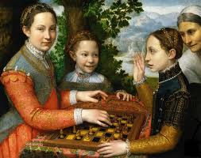
Fig. 1. Sofonisba Anguissola. The Chess Game. 1555.

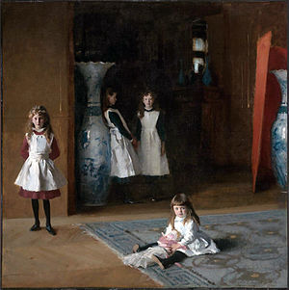
Fig. 2. John Singer Sargent. The Daughters of Edward Darley Boit. 1882.

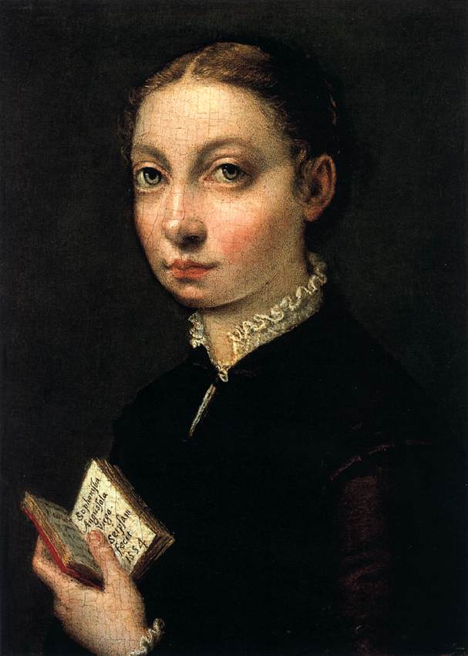
Fig. 3. Sofonisba Anguissola. Self-Portrait. 1554.

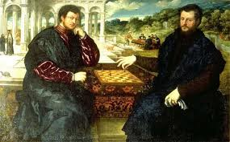
Fig. 4. Paris Bordone. Two Chess Players. 1550-1555.

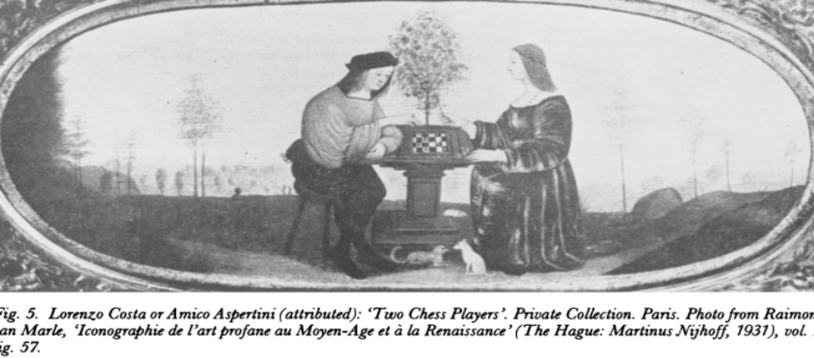
Fig. 5. Lorenzo Costa or Amico Aspertini. Two Chess Players. N.D.

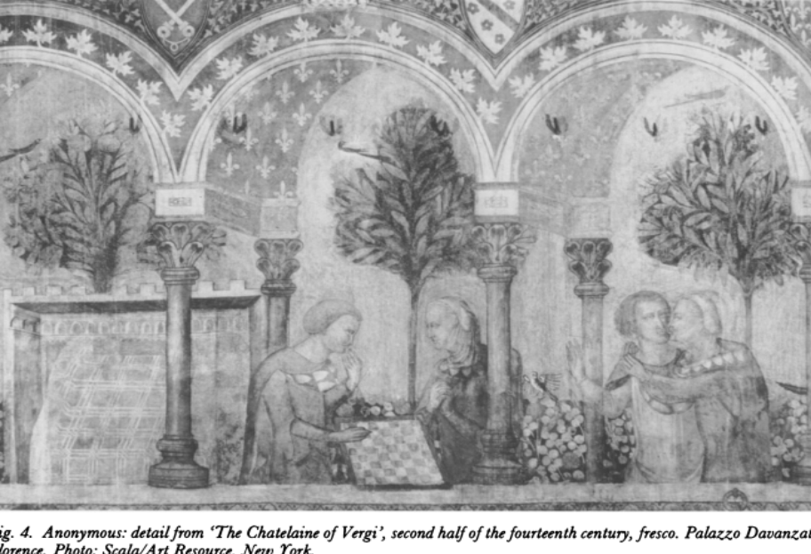
Fig. 6. Anonymous. Detail from The Chatelaine of Vergi. Second half of the 14th century.
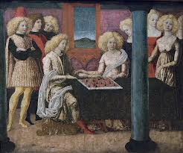
Fig. 7. Liberale da Verona. The Chess Players. 1470s.
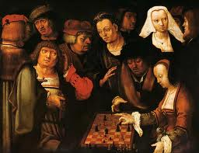
Fig. 8. Lucas van Leyden, The Chess Players, c1508.
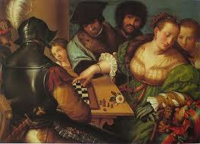
Fig. 9. Giulio Campi. Game of Chess. 1540s.
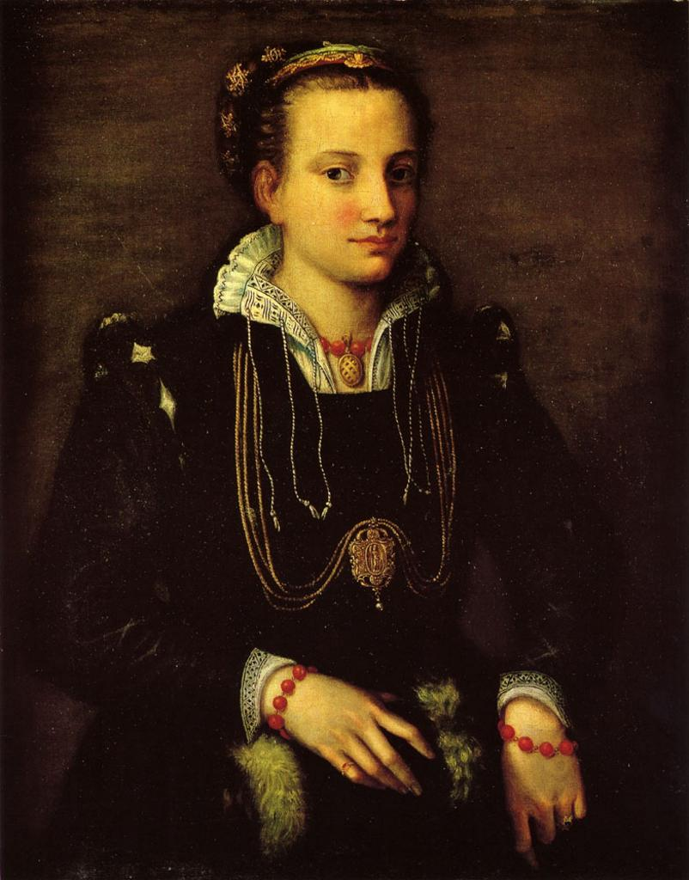
Fig. 10. Sophonisba Anguissola. Portrait of the Artist’s Sister Minerva. 1559.
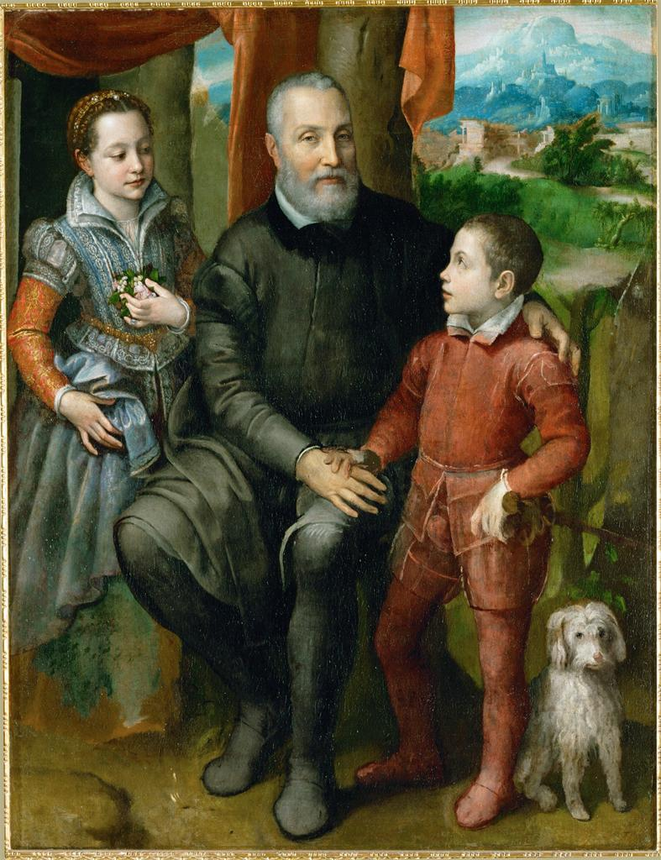
Fig. 11. Sofonisba Anguissola. Family Portrait (Amilcare, Asdubale, and Minerva). 1557.
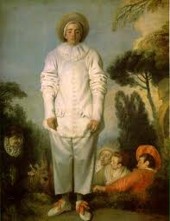
Fig. 12. Antoine Watteau. Pierrot. 1718-1719.

Chadwick on pages 32 and 77 suggests that Anguissola was not only accomplished and learned, but made it acceptable for other women artists to work; also worth noting that in the 16th century, Italy was really a collection of city-states, not a unified country, so Chadwick and others use a short-hand in calling Anguissola the best known woman artist in Italy.
To be clear, there is no indication that Sargent would have seen this Anguissola’s work, or that he was aware of her as an artist.
Jacobs, 1994, 94; Perlingieri, 82-83, Anguissola’s works were also owned by famous collectors, although its provenance is not entirely clear. Filippo Baldinucci mentions seeing The Chess Game in the Borghese Palace in Rome, and in 1902, Lulier commented it was owned by Lucian Bonaparte; Ferino-Pagden and Kusche, 31, document that the painting was owned by Fulvio Orsini in Rome, at the Farnese, in 1600 and by a Count in Paris in 1823; Miller, 160, clarifies that the Orsini collection would have descended to Cardinal Odoardo Farnese. These collections would have allowed many to see the work, increasing its influence.
Borzello, 47-48 on her signature and its significance, and Yavneh, 167, discusses her image construction as a virtuosa.
This introduction to Anguissola’s remarkable life and career draws on Borzello, 2000; Chadwick, 2002; Dobbs, 2009; Ferrino-Pagden and Kusche, 1995; Garrard, 1994; Harris and Nochlin, 1976; Oxford Art Online; Perlingieri, 1992; and Yavneh, 1998.
Fflolliott, 33-34.
Many authors write of Anguissola’s invention of the genre painting, including Bayer, 11; Chadwick, 78, 83-85; Dobbs, 6; Ferrino-Pagden and Kusche, 20; Garrard, 597; Harris and Nochlin, 50-52; Hartt and Wilkins, 623; Jacobs, 1997, 17, 54-55; Martin and Meyer, 18; Miller, 156, 161; Perlingieri, 88, 91; Saba Sardi, 20, 31, 45; Yavneh, 172; Northern European paintings in particular would go on to advance genre painting, with scenes of peasants, marketplaces, and families in interiors, in the second half of the 16th century.
Martin and Meyer, 18; even if her works were considered sentimental, The Chess Game had prestigious owners. Ferrino-Pagden and Kusche suggest that the painting was owned by Fulvio Orsini in Rome, seen in the Farnese in 1600, which then according Miller, passed through descent to Cardinal Odoardo Farnese, in Rome, where it would have been seen by many, leading to its broad influence. In the 19th century, the painting was bought by Luciano Bonaparte and Count Athanasius Raczynski, two great collectors, before ending up in the museum in Poznan, Poland.
Hirshler, 2009, 11, 49, 64; Ormond and Pixley, Hirshler, 2009, and Gallati, 2004, compare the composition of figures in space in Sargent’s painting to the work he copied in Spain, Velázquez’s Las Meninas.
Gallati, 81.
Garrard, 616, suggests the girls live in an Edenic world without men, which is sad and existential.
As identified in the signature of the painting, Borzello, 2000, 48; Perlingieri, 88, documents how the painting was once interpreted as including Anguissola’s self-portrait as the figure on the left, a conjecture dismissed by the sigature.
Rugs with eastern or oriental designs placed on tables are called Holbein rugs, referencing the painter who made such décor famous, Ferino-Pagden and Kusche, 31.
Yavneh, 173; Perlingieri, 83 and Miller, 160, write that Anguissola would have known Flemish landscapes which used the same blue-green tone and depicted mountains.
Yavneh, 173, 175, equates the Anguissola sisters in their garden with the walled garden of the Song of Songs which suggests Mary’s virginity.
Perlingieri, 30.
Frick, 70, 72; Perlingieri, 86, details how needlearts were considered a skilled craft, and like painters, the women who embroidered were in a guild; their craft required dexterity, composition and a sense of color, as with any artist.
The detailed description of the girls’ dress comes from Perlingieri, 86-87.
Borzello, 2000, 41-45; Garrard, 586, suggests that a black dress would present the artist like a man, as a woman of achievement; that is, she would be dressing for success.
Chadwick, 84; Garrard, 568, 570; Yavneh, 173.
Perlingieri, 87; Oxford Art Online.
Perlingieri, 87, attributes this sensitivity to Michelangelo’s influence on Anguissola.
Perlingieri, 87; Borzello, 1998, 45-46.
Jacobs, 1997, 54.
Borzello, 40.
Hirshler, 2009, 67, 75-77.
For a detailed description of the space in this painting, see Sidlauskas, Chapter 3, “John Singer Sargent’s Interior Abysses: The Daughters of Edward Darley Boit,” 61-90; Sidlauskas, 89.
Hirshler, 2009, 93, describes how impenetrable the scene is, beginning with its setting.
Lubin, 100-103, posits that the dark space in the rear of this painting is very different from the often-compared Las Meninas by Velazquez, which has a clearly readable background and mirror, which reflects the Infanta’s parents, the King and Queen of Spain.
Lubin, 94-99, 111.
Ormond, 60; Sidlauskas, 73-74 goes one to also call the space eerie and uncanny.
Lubin, 96.
Hirshler, 2009, 67, writes that the Boits moved their belongs with them as the moved from the U.S. to Europe, and their Paris foyer may have been barely furnished.
Hirshler, 2009, 93-94.
Sidlauskas, 66-67, on 76, also writes about Edith Wharton, who believed that upper class children were ignorant of their parents’ activities; Lubin, 83-84; Hirshler, 2009, 44-46.
Hirshler, 2009, 95-96.
Yavneh, 173; Giovanna’s presence suggests the class differential with the Anguissola sisters.
Garrard, 573-574; Yavneh, 167.
Simons, 61.
Yavneh, 175.
114, in the catalogue entry written by Ann Southerland Harris in Fortunati, et al.
Hartt and Wilkins, 623-624.
Simons,40-41; Bayer, 161, also draws the distinction of this virtuous scene from paintings with games associated with the erotic or unseemly, such as in the later painting by Caravaggio, The Cardsharps.
Simons, 63; Garrard, 602; Yavneh, 175; Dr. Elinor Richter in a Hunter College class 9/20/12 detailed that the game came to Europe from Persia and was invented to tell a queen that while her side had won a battle, her son had died; she also remitted that check mate in Persian means the king is dead.
Ferino-Pagden and Kusche, 31; Yavneh, 178.
Garrard, 597-600.
Simons, 65.
Simons, 66.
Ferino-Pagden and Kushe, 45; Garrard 601; Bora, 150.
Simons, 68-69.
Garrard, 9.
Simons, 71.
Yavneh, 178.
Simons, 70
Fortunati, et al., National Museum of Women in the Arts catalogue entry, p. 114.
Hartt and Wilkins, 623.
Hirshler, 2004, 157.
Sidlauskas, 72.
French critic and historian Henry Houssaye in Hirshler, 2009, 106.
Ormond, 57-58.
Hirshler, 2009, 45.
Fortunati, et al., 114; Yavneh, 178; Simons, 70, asserts that Lucia is victorious and Minerva is conceding.
Perlingieri, 87, points out that the same square-u hand style is seen in Anguissola’s Self-Portrait at the Clavichord.
Simons, 70, Yavneh, 172-173; Garrard, 603, writes that Anguissola cannot be objectified by the viewer’s Gaze, as long as she remains unseen.
Hartt and Wilkins, 623.
Saba Sardi, 39.
Ferino-Pagden and Kusche, 31.
Miller, 161.
Simons, 61.
Garrard, 612-615; Yavneh, 179-180.
Heller, 19; Ferino-Pagden and Kusche, 31.
Sidlauskas, 78, carries the argument of why Julia is seated even further: her legs have not evolved enough as reliable supports, touching off a primitive fear that children are like animals that cannot stand erect.
Gallati, 20-23, also suggests John Dewey’s educational theories were influential in the general thinking of the period, but Dewey’s first two books were published in 1887 and 1888, after the Sargent painting was made.
Sidlauskas, 79, also suggests that girls used dolls as objects to express their feelings, including aggressive tendencies demonstrated by throwing the doll around.
Lubin, 86, 88; he expands his argument into a highly controversial, sexualized interpretation of the rug as a protective layer, protecting Julia’s genitals.
Lubin, 88.
Hirshler, 2004, 157-158, also likens Julia to the Infanta in Velazquez’s Las Meninas, who also is placed in the center of the painting and resonates a cool authority in her surroundings.
Hirshler, 2009, 171-181, 188.
Yavneh, 178.
Ferino-Pagden and Kusche, 31, 35.
Garrard,605-609, goes on to suggest that the missing mother in the scene has been replaced by a dog and that the painting overall reflects the patriarchal system in which the Anguissola father Amilcare places not only the family fortune, but also his hopes in his son Asdrubale, to ensure the family’s financial future and status.
Sidlauskas, 71, 80-83, 90.
Lubin, 88, 90.
Sidlauskas, 71, 83-86, 90; she suggests that Jane’s lack of corporality results not only from Sargent’s difficulty in capturing her, but also from the threat she feels in understanding what her future holds for her as a woman trapped by social expectations.
Sidlauska, 86; Lubin, 88, 90.
Hirshler, 2009, 137, 188.
Fortunati, et al, 123; Ferino-Pagden and Kusche, 31, 35; Heller, 19.
Sidlauskas, 86-87; Lubin, 90-92.
Sidlauskas, 86.
Sidlauskas, 86-89; Lubin suggests the vase is a vessel waiting to be filled, like a woman waiting to become pregnant; he further suggests Julia has just delivered a baby, in the symbol of her doll, 114.
Ormond, 12
Hirshler, 135, 164-171.
Ormond, 58-60.
Extrapolated from Simons, 71.
Sidlauskas, 71, describes different stages of cognitive and emotional development of the Boit girls; Gallati, 84, talks about the web of relationships in a family system; Lubin, 92-94, 113-114; Jacobs, 94, about the Anguissola sisters.
Jacobs, 1994, 94.
Garrard, 604; Miller, 161, also writes that some find the linking of glances stilted, like the girls are mannequins.
Garrard, 603, Perlingieri, 53-55, Ferino-Pagden and Kusche, 35.
Yavneh, 172.
Lubin, 114.
Lubin, 92, 114; Sidlauskas, 77, 90; Hirshler, 2009, 8.
Hirshler, 182-183.
Simpson suggests that having the four girls scattered in the space, with a large blank areas, is unsettling as a composition.
Sidlauskas, 89
Garrard, 558; Hirshler, 2009.
Sutherland Harris, 50, writes that The Chess Game comes from Anguissola’s most productively innovative period of the 1550s, with her family genre scenes, and this is the period recognized by Vasari.
Hirshler, 2009, 130, 135.
Saba Sardi, 38. Selected Bibliography Bayer, Andrea. “Defining Naturalism in Lombard Painting” in Painters of Reality: The Legacy of Leonardo and Caravaggio in Lombardy, ed. Andrea Bayer, 3-21. New Haven: Yale University Press for the Metropolitan Museum of Art, 2004. Bora, Giulio. “Toward a New Naturalism: Sixteenth-Century Painting in Cremona and Milan” in Painters of Reality: The Legacy of Leonardo and Caravaggio in Lombardy, ed. Andrea Bayer, 147-155. New Haven: Yale University Press for the Metropolitan Museum of Art, 2004. Borzello, Frances. A World of Our Own: Women as Artists Since the Renaissance. London: Thames & Hudson, 2000. Borzello, Frances. Seeing Ourselves: Women’s Self-Portraits. New York: Harry N. Abrams, Inc., Publishers, 1998. Chadwick, Whitney. Women, Art, and Society, 3rd Edition. New York: Thames & Hudson, 2002. Dobbs, Julia Kathleen. Life Stories of Women Artists, 1550-1800: An Anthology. Farnham, England: Ashgate, 2009. Ferino-Pagden, Sylvia and Maria Kusche. Sofonisba Anguissola: A Renaissance Woman. Washington, DC: National Museum of Women in the Arts, 1995. Ffolliott, Sheila. “Wife, Widow, Nun, and Court Lady: Women Patrons of the Renaissance and Baroque” in Italian Women Artists from Renaissance to Baroque, ed. Vera Fortunati, et al, 31-39. Milan: Skira Editore S.P.A., 2007. National Museum of Women in the Arts exhibition catalogue. Fortunati, Vera, et al, Ed. Italian Women Artists from Renaissance to Baroque. Milan: Skira Editore S.P.A., 2007. National Museum of Women in the Arts exhibition catalogue. Frick, Carole Collier. “Painter Personal Identity: The Costuming of Nobildnone, Heroines, and Kings” in Italian Women Artists from Renaissance to Baroque, ed. Vera Fortunati, et al, 63-74. Milan: Skira Editore S.P.A., 2007. National Museum of Women in the Arts exhibition catalogue. Gallati, Barbara Dayer. “Great Expectations: An Introduction to John Singer Sargent’s Paintings of Children” in Great Expectations: John Singer Sargent Painting Children, ed. Barbara Dayer Gallati, 15-40. Boston: Bulfinch Press, 2004. Gallati, Barbara Dayer. “From Souvenir to High Art: Childhood on Display” in Great Expectations: John Singer Sargent Painting Children, ed. Barbara Dayer Gallati, 65-150. Boston: Bulfinch Press, 2004. Garrard, Mary D. “Here’s Looking at Me: Sofonisba Anguissola and the Problem of the Woman Artist.” Renaissance Quarterly, Vol. 47, No. 3 (Autumn, 1994): 556-622. Chicago: The University of Chicago Press for Renaissance Society of America, 1994. Harris, Ann Sutherland and Linda Nochlin. Women Artists: 1550-1950. New York: Alfred A. Knopf for the Museum Associates of the Los Angeles County Museum of Art, 1976 Hartt, Frederick and David G. Wilkins. History of Italian Renaissance Art: Painting, Sculpture, Architecture, 7th Edition. Upper Saddle River, NJ: Prentice Hall, 2007. Heller, Nancy G. Women Artists: An Illustrated History, Fourth Edition. New York: Abbeville Press Publishers, 2003. Hirshler, Erica E. Sargent’s Daughters: The Biography of a Painting. Boston: MFA Publications, 2009. Hirshler, Erica E. “’A Prince in a Royal Line of Painters’: Sargent’s Portraits and Posterity” in Great Expectations: John Singer Sargent Painting Children, ed. Barbara Dayer Gallati, 151-180. Boston: Bulfinch Press, 2004. Jacobs, Frederika H. Defining the Renaissance Virtuosa: Women Artists and the Language of Art History and Criticism. Cambridge: Cambridge University Press, 1997. Jacobs, Frederika H. Woman’s Capacity to Create: The Unusual Case of Sofonisba Anguissola” in Renaissance Quarterly, Vol. 47, No. 1 (Spring, 1994): 74-101. Chicago: The University of Chicago Press for Renaissance Society of America, 1994. Lubin, David M. Act of Portrayal: Eakins, Sargent, James. New Haven: Yale University Press, 1985. Martin, Elizabeth & Vivian Meyer. Female Gazes: Seventy-Five Women Artists. Toronto: Second Story Press, 1997. Miller, Robert S. “’Diversi personagii molto ridiculosi’: A Contract for Cremonese Market Scenes” in Painters of Reality: The Legacy of Leonardo and Caravaggio in Lombardy, ed. Andrea Bayer, 156-159. New Haven: Yale University Press for the Metropolitan Museum of Art, 2004. Ormond, Richard. “Sargent’s Childhood” in Great Expectations: John Singer Sargent Painting Children, ed. Barbara Dayer Gallati, 41-64. Boston: Bulfinch Press, 2004. Ormond, Richard and Mary Pixley. “Sargent after Velázquez: The Prado Studies” in The Burlington Magazine, Artists Abroad, Vol. 145, No. 1206 (Sept, 2003): 632-640. Perlingieri, Ilya Sandra. Sofonisba Anguissola: The First Great Woman Artist of the Renaissance. New York: Rizzoli, 1992. Saba Sardi, Francesco. Sofonisba Anguissola. Milan: Spirali, 2007. Sidlauskas, Susan. Body, Place, and Self in Nineteenth Century Painting. Cambridge: Cambridge University Press, 2000. Simons, Patricia. “(Check) Mating the Grand Masters: The Gendered, Sexualized Politics of Chess in Renaissance Italy” in Oxford Art Journal, Vol 16, No. 1 (1993): 59-74. Oxford: Oxford University Press, 1993. Simpson, Marc, with Richard Ormond and H. Barbara Weinberg. Uncanny Spectacle: The Public Career of the Young John Singer Sargent. New Haven: Yale University Press, 1997. Strinati, Claudio. “On the Origins of Women Painters” in Italian Women Artists from Renaissance to Baroque, ed. Vera Fortunati, et al, 15-18. Milan: Skira Editore S.P.A., 2007. National Museum of Women in the Arts exhibition catalogue. Tanzi, Marco. “Sofonisba Anguissola” in Oxford Art Online. Oxford: Oxford University Press, 2007-2012: http://www.oxfordartonline.com.proxy.wexler.hunter.cuny.edu/subscriber/article/grove/art/T003005pg1?q=sofonisba+anguissola&search=quick&pos=1&_start=1#firsthit Vasari, Giorgio. Le vite de’ piu eccellenti pittori scultori et architettori translated in Lives of the Most Eminent Painters, Sculptors, and Architects. G. du C. de Vere, Trans. New York: Everyman’s Library, 1996. Yavneh, Naomi. “Playing the Game: Sisterly Relations in Sofonisba Anguissola’s The Chess Game” in Sibling Relations and Gender in the Early Modern World: Sisters, Brothers, and Others, eds. Naomi J. Miller and Naomi Yavneh, 166-181. Burlington, VT: Ashgate Publishing Company, 1998.

